POSITIVE PARTNERSHIPS · PARENTS AND CARERS
Facilitator Guide
Parents and Carers · Secondary
SESSION  1 | SESSION  2 | SESSION  3 | SESSION  4 | SESSION  5 | SESSION  6

One page for every slide. Each page shows the slide, what it is for, what to do and say, the activity and how long to spend.
Workshop day 9:30 - 2:30 · Timings are indicative

How to use this guide
The guide follows the six slide decks exactly. Every visible slide has its own page, in deck order, so you can keep the guide open beside the presenter view and turn one page per slide.
Each session opens with a planning page: the intent, what participants will leave with, what to prepare, and a run sheet with clock times.
EVERY SLIDE PAGE HAS
Header strip | The session colour, the session name and the slide number in the deck.
Slide and facts | A picture of the slide, the suggested minutes, the running clock, the grouping, and the Workbook page if there is one.
Purpose | One line on why the slide is there.
What to do | Numbered steps, in order.
Key messages | What participants should take from the slide.
You might say | Wording you can use or adapt, where the team has written it.
Activity card | Format, grouping, time, the prompt, steps, how to bring the room back and how to close.
Keep in mind | Cautions and what to avoid.
Background and thread | Context for you, and how the slide links to other sessions.

SESSION COLOURS
Each session keeps the colour used in the Workbook, so the page a participant has open matches the colour on your page.

The day at a glance
Time | Session |  | Slides | Page
9:30 - 10:15 | 1 | Supporting your Autistic young person to flourish | 18 slides | p. 6
10:15 - 11:00 | 2 | Understanding Autistic Experience: Sensory and Thinking | 23 slides | p. 25
11:00 - 11:15 |  | Morning tea
11:15 - 12:15 | 3 | Communication, Connection and Managing Daily Capacity | 21 slides | p. 49
12:15 - 12:45 |  | Lunch
12:45 - 1:30 | 4 | Home and Community | 14 slides | p. 71
1:30 - 2:10 | 5 | Partnership with the School | 16 slides | p. 86
2:10 - 2:30 | 6 | Full Circle | 7 slides | p. 103

The thread through the day
Participants are parents and carers. They keep their own young person in mind all day. A few Workbook pages carry forward:
- Session 1: What I love and value about my young person (returned to in Session 6).
- Sessions 2 and 3: sensory, thinking, communication and capacity, always linked back to their own young person.
- Session 4: the after-school crash, homework and assessment, growing independence, sleep and screens, and what works at home.
- Session 5: Prepare for a conversation with school (brought to Session 6).
- Session 6: Three small things: one to try at home, one for school, one strength to name.

Ways of working
- Parents and carers are the experts on their own young person. Invite their knowledge; never lecture.
- Some families are going through a very hard time. Keep it warm, never blaming, and let people pass.
- Keep other families' stories in the room. Discuss situations, not identifiable young people, staff or schools.
- Every activity has an option to pass. Participants may move, write, listen or step out as they need.
- Look at the environment, routine and demands before asking a young person to change. Include strengths, interests and joy.
- Participants write in their Workbook. Nothing in it needs to be shared.

Before the day
☐ Workbooks and pens for every participant, and tables set for pair and small-group work.
SESSION 1 · SUPPORTING YOUR AUTISTIC YOUNG PERSON TO FLOURISH
☐ Local Traditional Custodians name confirmed and Acknowledgement of Country prepared in your own words.
☐ Young people's voices video tested with sound, captions on and transcript available.
☐ Venue details for housekeeping: exits, facilities, quiet space, breaks and evaluation arrangements.
SESSION 2 · UNDERSTANDING AUTISTIC EXPERIENCE: SENSORY AND THINKING
☐ Overwhelm and sensory joy video clips cued and tested with sound and captions.
☐ Autistic thinking video clip cued (once sourced).
SESSION 3 · COMMUNICATION, CONNECTION AND MANAGING DAILY CAPACITY
☐ Purple, blue and orange Post-it notes on each table, and wall or board space for notes grouped by colour.
☐ Three videos tested with sound: Communication experiences (slide 5), Being social (slide 11) and Masking (slide 17).
☐ Edited captions switched on and transcripts available for each video.
☐ Slide 21 closing script read through beforehand so it can be delivered slowly.
☐ Lunch arrangements confirmed so the close on slide 21 is not rushed.
SESSION 4 · HOME AND COMMUNITY
☐ A visible timer for the two table activities (slides 12 and 14).
☐ Quiet space available: burnout and School Can't may be raised and some parents may need a moment.
☐ Information ready on where families can find further support, to give at a break if someone raises a current crisis.
SESSION 5 · PARTNERSHIP WITH THE SCHOOL
☐ Sticky notes and pens on every table; butcher's paper on the wall headed Home, School and Solutions.
☐ Student voice video (Adon) tested with sound, captions on and transcript available.
☐ Copies or a clear view of the Partnership tools shown on slide 12.
☐ The NCCD Meetings Tool Kit link (https://www.nccd.edu.au/wider-support-materials/meetings-toolkit) and the Department of Education plain-language guides for families.
☐ Helpline numbers on slide 14 checked as current.
☐ A quiet option for participants who find the power discussion difficult.
SESSION 6 · FULL CIRCLE
☐ Titles and dates for the family webinars and deep dives, once confirmed (slide 4 shows "Titles and dates to confirm").
☐ Link and QR code for the online Community of Practice, once available (slide 4 shows "Link and QR code TBA").
☐ The feedback link (TBA) and QR code added to slide 6 and tested; paper or verbal alternative available.
☐ Local follow-up and contact arrangements confirmed.
☐ Protected time: at least 4 minutes for feedback.

SESSION  1 | 9:30 - 10:15 · 45 MINUTES · 18 SLIDES  Supporting your Autistic young person to flourish

SESSION INTENT
Welcome parents and carers, establish an accessible way of working together and begin with each young person as a whole person. Participants are positioned as the experts on their young person, hear from Autistic young people and are introduced to a neurodiversity-affirming frame, fluctuating capacity and flourishing in the secondary years, a time of growing independence and a developing sense of identity.
PARTICIPANTS LEAVE WITH
- Name three things they love or value about their young person as a reference point for the day.
- Understand the language used in the workshop and the value of following their young person's lead.
- Describe neurodiversity, neurodivergence and a neurodiversity-affirming approach in their own words.
- Recognise autism as a dynamic disability, where capacity can change across the day, week and term.

RUN SHEET
Clock | Segment | Slides | Minutes
9:30 - 9:35 | Opening and acknowledgements | 1-4 | 5
9:35 - 9:44 | Welcome, housekeeping and introductions | 5-7 | 9
9:44 - 9:48 | Workshop overview and language | 8-9 | 4
9:48 - 9:55 | Your young person and your knowledge | 10-11 | 7
9:55 - 10:04 | Young people's voices | 12-13 | 9
10:04 - 10:11 | Neurodiversity and the whole young person | 14-16 | 7
10:11 - 10:15 | Dynamic disability, joy and flourishing | 17-18 | 4

PREPARE
☐ Local Traditional Custodians name confirmed and Acknowledgement of Country prepared in your own words.
☐ Young people's voices video tested with sound, captions on and transcript available.
☐ Participant Workbooks and pens for every participant.
☐ Venue details for housekeeping: exits, facilities, quiet space, breaks and evaluation arrangements.
☐ Tables set for small-group sharing.

SESSION 1 | Supporting your Autistic young person to flourish | SLIDE 1 of 18

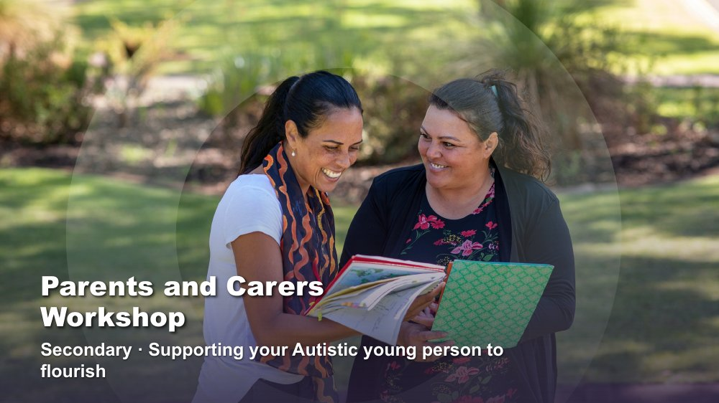 | Parents and Carers Workshop | Secondary - Supporting your Autistic young person to flourish  SUGGESTED TIME  1 min  CLOCK  9:30 - 9:31

Open the day and name the workshop focus for parents and carers.
WHAT TO DO  - Have the title slide on screen as participants arrive and settle.  - Welcome participants and introduce the facilitation team.  - Name the day as a chance to build shared language, look closely at your own young person and leave with some practical next steps.  - Frame the day around understanding and support, not fixing young people or making them appear less Autistic.  - Acknowledge that the secondary years bring their own changes: more teachers and classes, growing independence, friendships that matter more and a young person who wants more say in their own life.  - Keep this opening brief so introductions and the first reflection have enough time. | KEY MESSAGES  - The day is about understanding Autistic experience and helping young people and families flourish.  - Everything today adds to what parents and carers already know about their young person; it does not replace it.  - Young people in the secondary years want privacy and a say. Supporting them includes listening to them.

KEEP IN MIND
- Some families arrive after a hard morning or a hard term. A warm, unhurried welcome matters more than starting exactly on time.

SESSION 1 | Supporting your Autistic young person to flourish | SLIDE 2 of 18

 | Acknowledgement of Country  SUGGESTED TIME  2 min  CLOCK  9:31 - 9:33

Acknowledge the Traditional Custodians of the land on which the workshop is taking place.
WHAT TO DO
- Deliver the Acknowledgement of Country in your own words, following organisational protocol.
- Name the Traditional Custodians of the land where the workshop is being held, where this has been confirmed.
- Allow a brief pause before moving on.

KEEP IN MIND
- Do not read a generic script you have not prepared; take time before the day to learn the local Country and custodians.
- Keep the Acknowledgement respectful and unhurried, even if the session is running late.

SESSION 1 | Supporting your Autistic young person to flourish | SLIDE 3 of 18

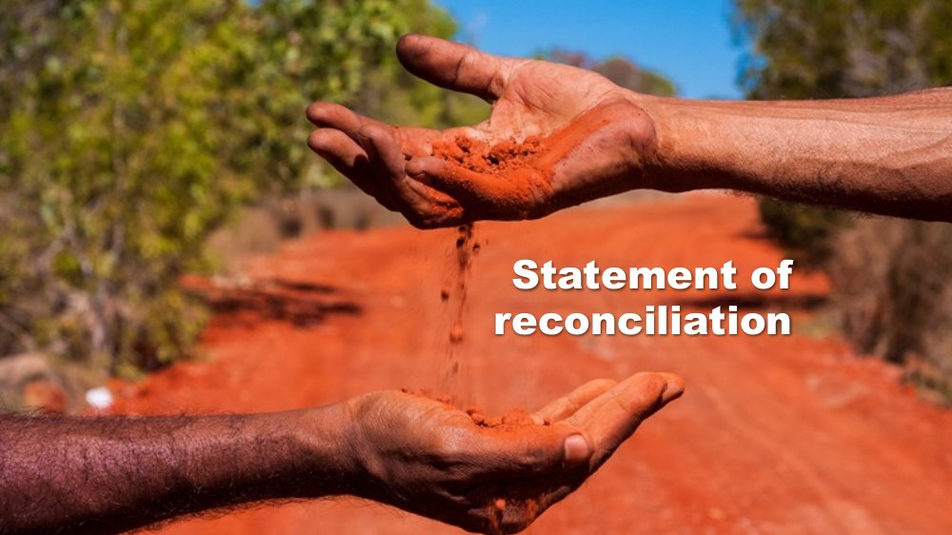 | Statement of reconciliation  SUGGESTED TIME  1 min  CLOCK  9:33 - 9:34

Share the organisation's commitment to reconciliation.
WHAT TO DO
- Share the organisation's statement of reconciliation as provided, following organisational protocol.
- Move on without adding commentary or discussion.

YOU MIGHT SAY
We at Positive Partnerships value and recognise the diversity of Aboriginal and Torres Strait Islander cultures and heritage and their proud part in Australia’s national identity. We acknowledge and continue to learn about Australia’s colonial past and the historic and ongoing impacts on Australia’s First Nations people. We believe in and strongly support the Truth-telling of Australia’s colonial history and in moving forward as a nation we must encourage open, honest dialogue and build relationships built on respect and trust.

SESSION 1 | Supporting your Autistic young person to flourish | SLIDE 4 of 18

 | First Nations advisory  SUGGESTED TIME  1 min  CLOCK  9:34 - 9:35

Advise First Nations participants that the workshop may contain images and voices of people who are no longer with us.
WHAT TO DO
- Read the advisory aloud or leave it on screen long enough for everyone to read it.
- Move on without further comment.

SESSION 1 | Supporting your Autistic young person to flourish | SLIDE 5 of 18

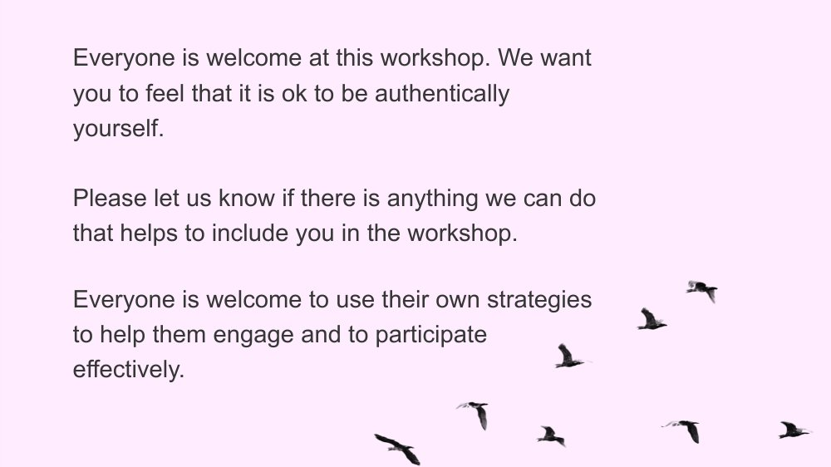 | Everyone is welcome  SUGGESTED TIME  2 min  CLOCK  9:35 - 9:37

Set an inclusive tone and invite participants to engage in whatever way works for them.
WHAT TO DO  - Read or paraphrase the welcome: everyone is welcome to be authentically themselves and to use their own strategies to engage.  - Let participants know they can move, stand, step out, fidget, write, listen or pass at any time.  - Invite participants to let the team know, at any point in the day, if there is anything that would help include them.  - Acknowledge that some parents and carers in the room may be Autistic or neurodivergent themselves, and that this is welcome too. | KEY MESSAGES  - Different ways of participating are welcome.  - Participants can ask for what they need at any time.

SESSION 1 | Supporting your Autistic young person to flourish | SLIDE 6 of 18

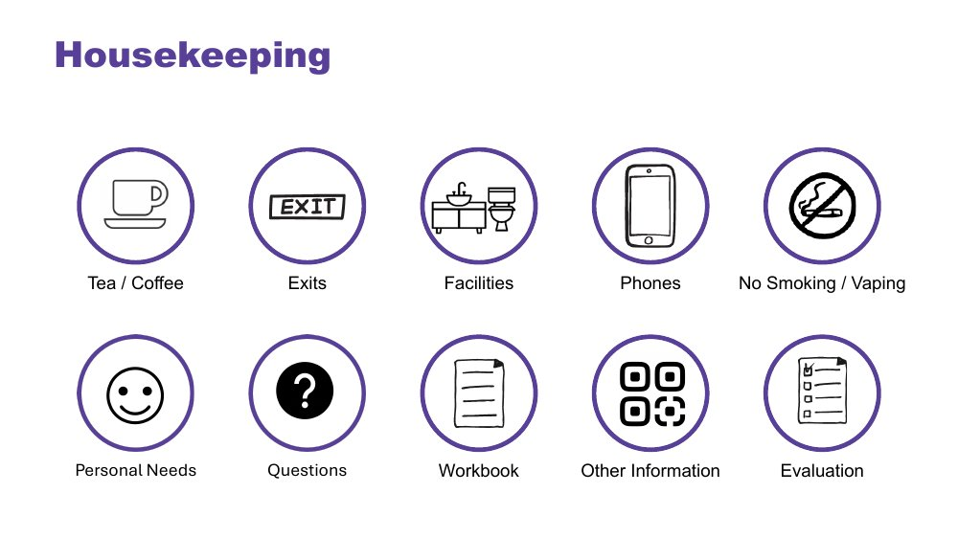 | Housekeeping  SUGGESTED TIME  2 min  CLOCK  9:37 - 9:39

Cover the practical arrangements for the venue and the day.
WHAT TO DO
- Cover tea and coffee, exits, facilities, phones, no smoking or vaping, personal needs, questions, the workbook, other local information and evaluation arrangements.
- Point out any quiet or low-sensory space available at the venue.
- Explain how and when questions can be asked, including in writing or privately at a break.
- Let participants know they can keep their phone on if they need to be contactable by their young person or their young person's school.

SESSION 1 | Supporting your Autistic young person to flourish | SLIDE 7 of 18

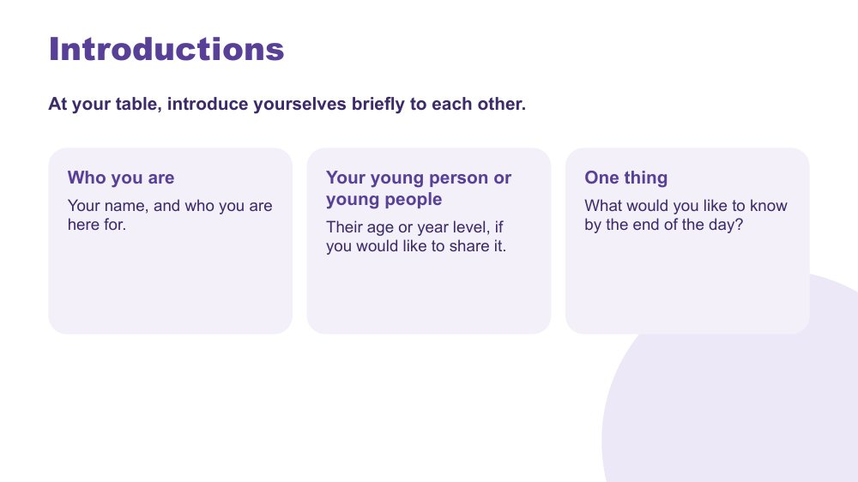 | Introductions  SUGGESTED TIME  5 min  CLOCK  9:39 - 9:44  GROUPING  Table groups  WORKBOOK  Workbook - One thing I would like to know today

Help participants meet the people at their table and think about what they hope to take from the day.
WHAT TO DO  - Introduce yourself briefly, then hand over to the tables.  - Invite brief introductions at each table: each person shares their name, the young person or young people they are here for (age or year level if they would like to), and one thing they would like to know by the end of the day. | KEY MESSAGES  - Participants bring useful knowledge and many different experiences.  - Meeting other parents and carers is part of the day.

ACTIVITY | Table introductions table groups · 4 minutes
Your name, the young person or young people you are here for, and one thing you would like to know by the end of the day.
- Introduce yourself briefly, then hand over to the tables.
- Tables introduce themselves. Keep the round moving so no one feels pressure to share more than they want to.
Close: Invite participants to note their one thing in the Workbook.

KEEP IN MIND
- Do not ask about diagnosis, school or family circumstances. Some parents may share a lot quickly; thank them warmly and offer to talk more at the break.
- Keep introductions at the tables so everyone gets a turn in the time.

Thread Participants can look back at their one thing in Session 6 (Full Circle).

SESSION 1 | Supporting your Autistic young person to flourish | SLIDE 8 of 18

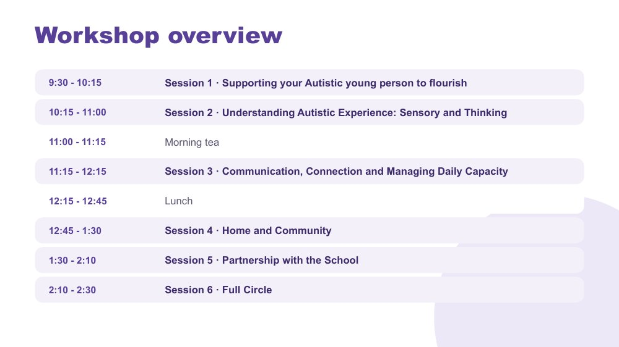 | Workshop overview  SUGGESTED TIME  2 min  CLOCK  9:44 - 9:46

Orient participants to the shape of the day.
WHAT TO DO  - Walk through the six sessions and the breaks on the slide without turning it into a detailed agenda.  - Point out Morning Tea at 11:00 - 11:15 and Lunch at 12:15 - 12:45.  - Explain that the morning builds understanding of Autistic experience and the afternoon moves to home, community and partnership with the school.  - Let participants know that timings are indicative. | KEY MESSAGES  - The six sessions form one connected day.  - The day moves from understanding your young person to practical steps at home, in the community and with school.

SESSION 1 | Supporting your Autistic young person to flourish | SLIDE 9 of 18

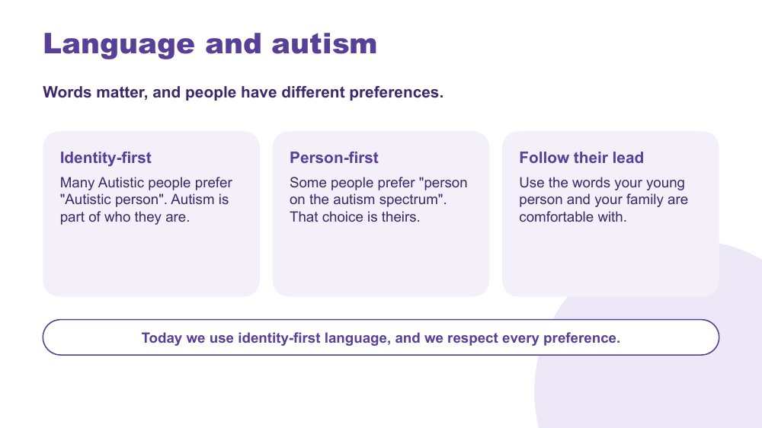 | Language and autism  SUGGESTED TIME  2 min  CLOCK  9:46 - 9:48

Introduce the language used in the workshop and respect for each person's own preference.
WHAT TO DO  - Explain that the workshop uses identity-first language, such as "Autistic young person", because many Autistic people prefer it.  - Acknowledge that some people prefer person-first language, such as "person on the autism spectrum", and that this choice is theirs.  - Encourage parents and carers to follow their young person's lead and use the words their young person and family are comfortable with.  - Mention that many teenagers have their own views about the words used to describe them. Where it fits, parents can ask their young person what they prefer.  - Keep this practical and brief; avoid turning it into a debate about one correct term. | KEY MESSAGES  - Words matter, and people have different preferences.  - The workshop uses identity-first language and respects every preference.  - A person's own language for themselves should be respected.

KEEP IN MIND
- Some parents may still be getting used to the word "autism" for their young person. Reassure them there is no test on language today.
- Some young people are identified or diagnosed in the secondary years, and some are still working out how they feel about the word. Keep this respectful of wherever each family is.

SESSION 1 | Supporting your Autistic young person to flourish | SLIDE 10 of 18

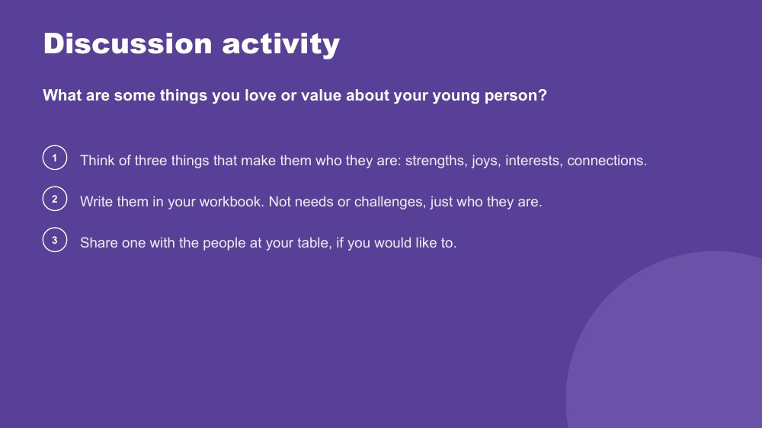 | Discussion activity - What do you love or value about your young person?  SUGGESTED TIME  5 min  CLOCK  9:48 - 9:53  GROUPING  On your own, then tables  WORKBOOK  Workbook - What I love and value about my young person

Begin the day with the young person as a whole person: strengths, joys, interests and connections.
WHAT TO DO  - Ask participants to think about their young person and write three things that make them who they are.  - Offer examples: strengths, joys, interests, connections, things that make them laugh.  - Ask them to leave needs and challenges aside for now; there will be time for those later.  - Give quiet thinking and writing time before inviting sharing at tables.  - Keep sharing voluntary. | KEY MESSAGES  - The day starts with the young person as a whole person, not with a list of needs or challenges.  - Strengths, interests and joy stay part of every later conversation.

ACTIVITY | Private reflection with optional table sharing on your own, then tables · 5 minutes
What are some things you love or value about your young person?
- Invite participants to write three things in their workbook.
- Give two or three minutes of quiet writing time.
- Invite participants to share one with their table if they would like to.
Close: Ask participants to keep this page handy and to keep this young person in mind for the rest of the day.

KEEP IN MIND
- For some parents this is hard to do in a difficult season, and the teenage years can bring tense times at home. If someone is stuck, suggest one small moment from the last week that they enjoyed, or something their young person knows a lot about.

Thread The young person held in mind here is the reference point for Sessions 2 to 6, and returns in Session 6 when participants name one strength to share with their young person.

SESSION 1 | Supporting your Autistic young person to flourish | SLIDE 11 of 18

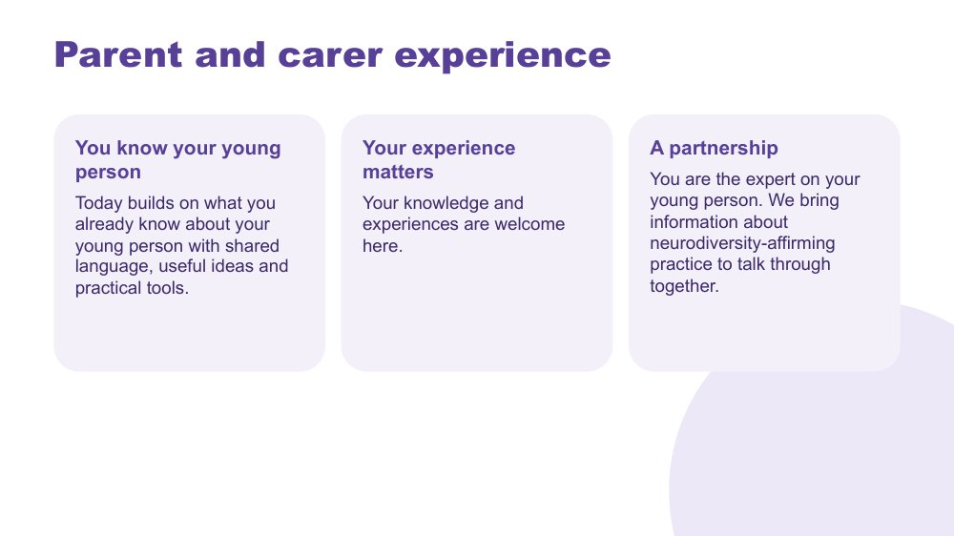 | Parent and carer experience  SUGGESTED TIME  2 min  CLOCK  9:53 - 9:55

Position parents and carers as experts on their young person and as partners in the day.
WHAT TO DO  - Acknowledge that participants know their young person in ways no one else does.  - Explain that the day adds shared language, useful ideas and practical tools to that knowledge.  - Frame the day as a partnership: parents bring knowledge of their young person, the team brings information about neurodiversity-affirming practice, and we talk it through together.  - Acknowledge that as young people get older, they also become experts on themselves. Part of the secondary years is bringing their voice alongside yours. | KEY MESSAGES  - You are the expert on your young person.  - Your knowledge and experiences are welcome here.  - Today builds on what you already know.

SESSION 1 | Supporting your Autistic young person to flourish | SLIDE 12 of 18

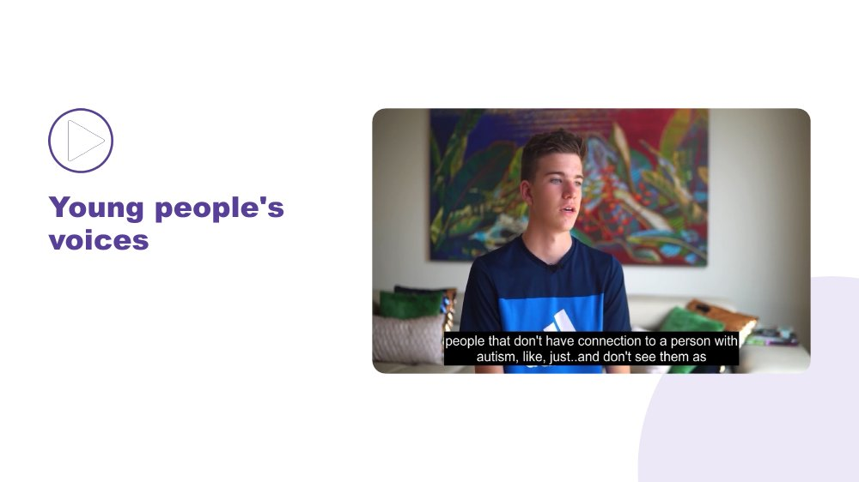 | Young people's voices  SUGGESTED TIME  5 min  CLOCK  9:55 - 10:00

Make space for Autistic young people to be heard in their own words.
WHAT TO DO  - Introduce the video as a chance to listen to Autistic young people directly, not to compare them with your own young person.  - Make sure captions are on and a transcript is available.  - Play the video without interrupting.  - Allow a short pause when the video ends before moving on. | KEY MESSAGES  - Young people's voices belong in the decisions and supports that affect them.  - In the secondary years, young people want a say in decisions about their own lives. Hearing their voices directly helps us listen well.  - Each young person's account is their own; no single account speaks for every Autistic young person.

SESSION 1 | Supporting your Autistic young person to flourish | SLIDE 13 of 18

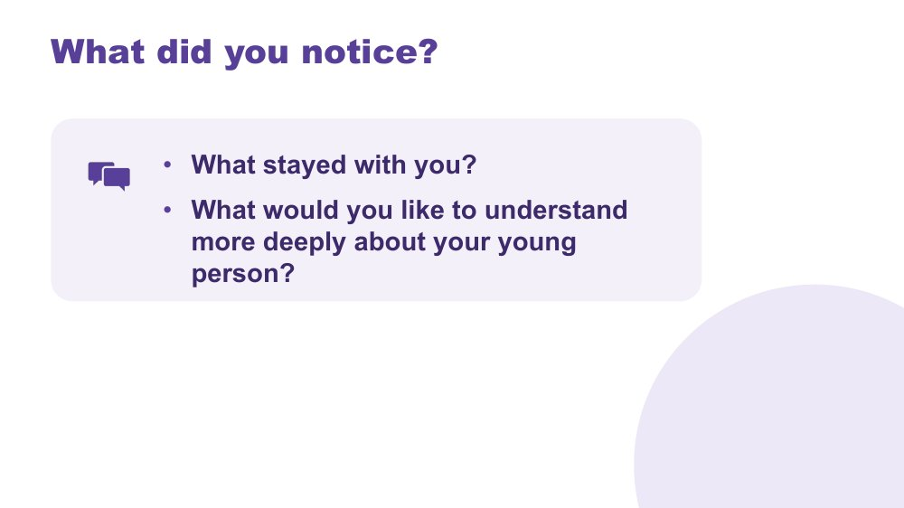 | What did you notice?  SUGGESTED TIME  4 min  CLOCK  10:00 - 10:04  GROUPING  On your own, then whole room  WORKBOOK  Workbook - Young people's voices

Support reflection on the young people's voices and link it to participants' own young person.
WHAT TO DO
- Invite brief private reflection on the questions on screen before any discussion.
- Invite observations grounded in what the young people said.
- Ask what participants would like to understand more deeply about their own young person.
- Record a few recurring words or questions on the board without forcing agreement.

ACTIVITY | Think, write and optional share on your own, then whole room · 4 minutes
What stayed with you? What would you like to understand more deeply about your young person?
- Give a minute of quiet thinking or writing time.
- Invite a few optional contributions from the room.
Close: Link the questions to the sensory, thinking and communication content that follows.

KEEP IN MIND
- A young person's words can bring up strong feelings for parents. Acknowledge this simply and keep sharing optional.

SESSION 1 | Supporting your Autistic young person to flourish | SLIDE 14 of 18

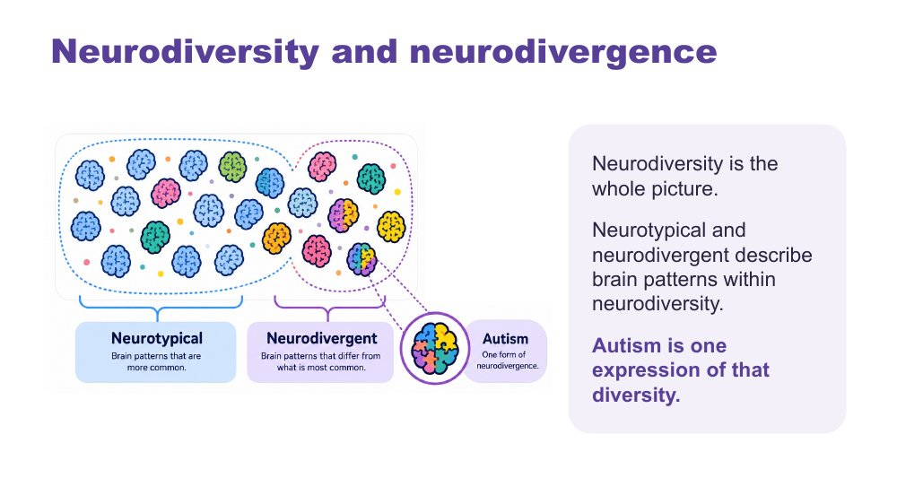 | Neurodiversity and neurodivergence  SUGGESTED TIME  2 min  CLOCK  10:04 - 10:06

Introduce the language of neurodiversity, neurodivergence and autism.
WHAT TO DO  - Explain that neurodiversity is the whole picture and includes everyone.  - Name neurotypical and neurodivergent as brain patterns within neurodiversity.  - Name autism as one expression of that diversity, and remind participants that every Autistic young person is different.  - Keep the explanation brief and connected to the young person they are holding in mind. | KEY MESSAGES  - Neurodiversity includes all brains.  - Autism is a valid neurotype, not something to fix, change or hide.  - The workshop offers common patterns, while each young person remains an individual.

SESSION 1 | Supporting your Autistic young person to flourish | SLIDE 15 of 18

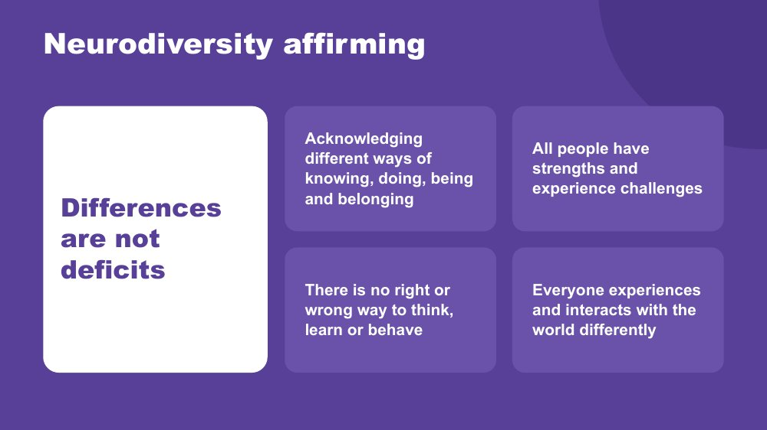 | Neurodiversity affirming  SUGGESTED TIME  3 min  CLOCK  10:06 - 10:09

Explain the neurodiversity-affirming approach used throughout the day.
WHAT TO DO  - Walk through the points on the slide without adding a long definition.  - Connect the points to the strengths and joys participants wrote about their young person earlier.  - Clarify that a strengths-based approach does not ignore difficulty, support needs or hard days.  - Model language that describes what the environment and support need to look like, without blaming the young person or the family. | KEY MESSAGES  - Differences are not deficits.  - All people have strengths and experience challenges.  - There is no right or wrong way to think, learn or behave.  - Everyone experiences and interacts with the world differently.

SESSION 1 | Supporting your Autistic young person to flourish | SLIDE 16 of 18

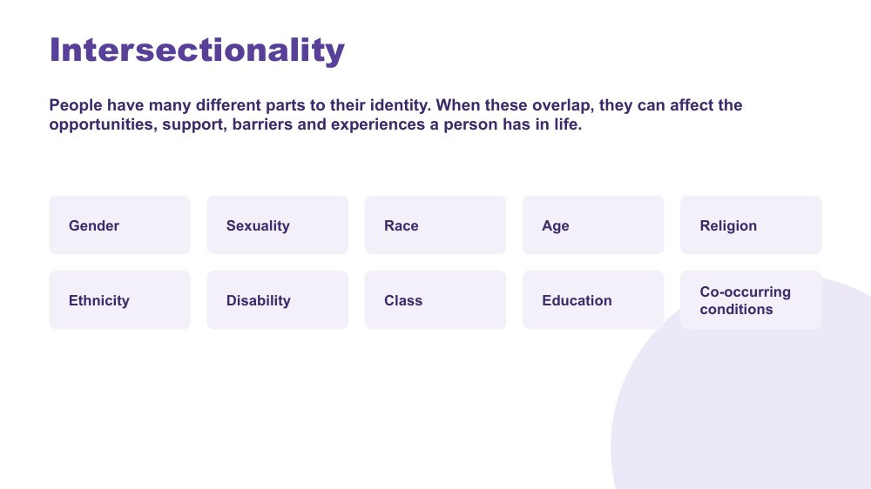 | Intersectionality  SUGGESTED TIME  2 min  CLOCK  10:09 - 10:11

Recognise that autism is one part of a young person's identity and experience.
WHAT TO DO  - Explain that people have many parts to their identity.  - Use the examples on the slide as prompts, not a checklist.  - Name that adolescence is a time when identity is taking shape, and autism is one part of that. Keep examples plural and light-touch, such as a bilingual home, a young person exploring their gender or sexuality, or a faith community.  - Explain that when these parts overlap, they can affect the opportunities, support, barriers and experiences a person has.  - Do not ask participants to share personal or family identity information. | KEY MESSAGES  - A young person is more than one label or identity.  - Support needs to take account of the whole young person, the whole family and their context.  - Overlapping parts of identity can bring both challenges and benefits.  - Belonging can be found in many places: family, cultural community, online communities and Autistic community.

KEEP IN MIND
- Some young people are exploring parts of their identity that they have not shared with family. Keep the tone open and do not ask participants to share personal details.

SESSION 1 | Supporting your Autistic young person to flourish | SLIDE 17 of 18

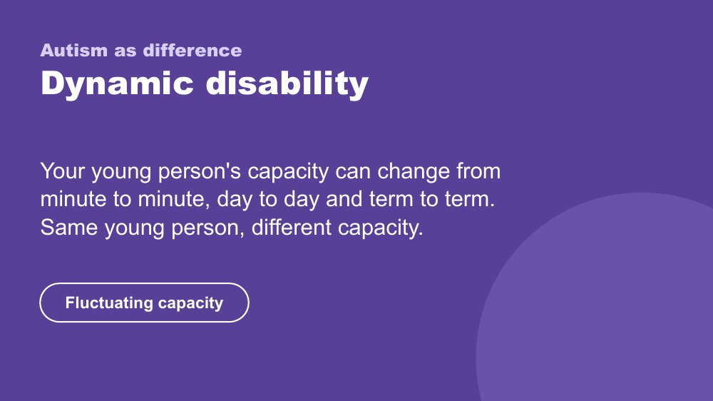 | Autism as difference - Dynamic disability  SUGGESTED TIME  2 min  CLOCK  10:11 - 10:13

Introduce autism as a dynamic disability and the idea of fluctuating capacity.
WHAT TO DO  - Explain that a young person's capacity can change from minute to minute, day to day and term to term: same young person, different capacity.  - Give a home example: something your young person managed easily on Saturday may not be possible on a Monday after a full day of periods, different teachers and moving between classrooms. Assessment periods and the end of term can also lower capacity.  - Connect this to curiosity: when capacity changes, ask what else is going on rather than assuming the young person is choosing not to.  - Let participants know that capacity comes back in more detail in Session 3. | KEY MESSAGES  - Autism is a dynamic disability.  - Capacity can fluctuate: same young person, different capacity.  - Support should respond to the young person and the situation, not a fixed idea of what they can do.

KEEP IN MIND
- Avoid presenting one pattern of ability, need or capacity as universal.
- Do not add clinical, diagnostic or legal claims.

Thread Fluctuating capacity is developed in Session 3 (managing daily capacity) and Session 4 (the after-school crash).

SESSION 1 | Supporting your Autistic young person to flourish | SLIDE 18 of 18

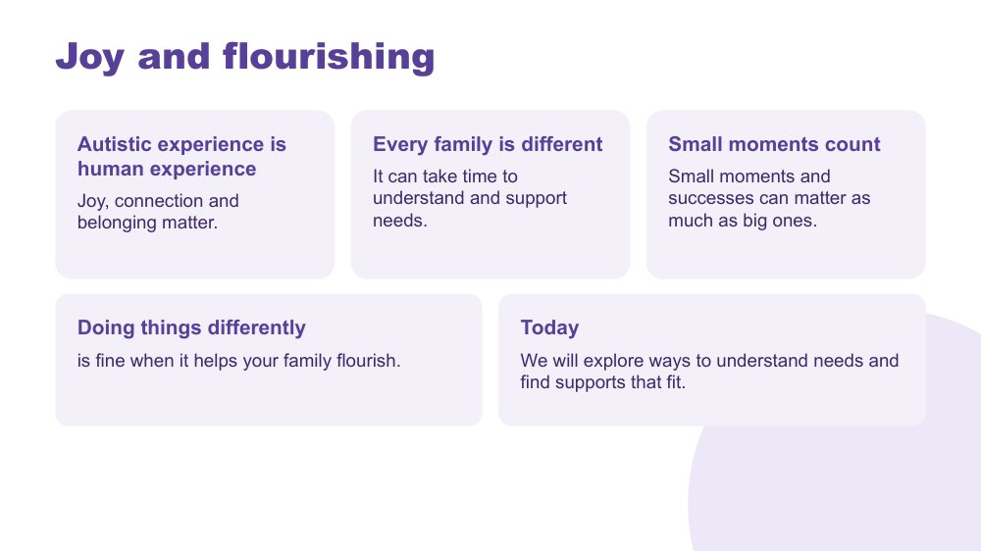 | Joy and flourishing  SUGGESTED TIME  2 min  CLOCK  10:13 - 10:15

Close the opening session with a whole-person view of flourishing and move into Session 2.
WHAT TO DO  - Connect the points on the slide to the young person participants wrote about at the start.  - Acknowledge that every family is different and it can take time to understand and support needs.  - Name small moments and successes alongside bigger goals.  - Introduce Session 2: sensory experience and Autistic thinking. | KEY MESSAGES  - Autistic experience is human experience.  - Joy, connection and belonging matter.  - Small moments and successes can matter as much as big ones.  - Doing things differently is fine when it helps your family flourish.

SESSION  2 | 10:15 - 11:00 · 45 MINUTES · 23 SLIDES  Understanding Autistic Experience: Sensory and Thinking

SESSION INTENT
Build a picture of each participant's young person through three lenses: sensory experience, Autistic thinking and internal signals. The session is strengths-based: participants hear from Autistic people directly and apply each idea to their own young person and home routines.
PARTICIPANTS LEAVE WITH
- Name the eight senses and describe sensory processing as a response that is not a choice.
- Recognise the four sensory profiles as a map, not a label, see stimming as authentic expression, and look at one home routine through a sensory lens.
- Describe detail-first processing and deep focus (monotropism), and see the strengths they bring in their own young person.
- Understand interoception and alexithymia and begin mapping their young person's early signs of overwhelm.

RUN SHEET
Clock | Segment | Slides | Minutes
10:15 - 10:16 | Opening frame | 1 | 1
10:16 - 10:22 | The eight senses and sensory processing | 2-5 | 6
10:22 - 10:26 | Sensory overwhelm and sensory joy | 6-7 | 4
10:26 - 10:36 | Sensory profiles, stimming and home routine activity | 8-10 | 10
10:36 - 10:42 | Detail-first and deep focus | 11-13 | 6
10:42 - 10:46 | Executive functioning | 14-16 | 4
10:46 - 10:51 | Autistic thinking video and discussion | 17-18 | 5
10:51 - 10:59 | Internal signals and reading the signs | 19-22 | 8
10:59 - 11:00 | Close and Morning Tea | 23 | 1

PREPARE
☐ Overwhelm and sensory joy video clips cued and tested with sound and captions.
☐ Autistic thinking video clip cued (once sourced).
☐ Participant Workbooks open to Session 2.
☐ Tables set for pair and small-group discussion.

SESSION 2 | Understanding Autistic Experience: Sensory and Thinking | SLIDE 1 of 23

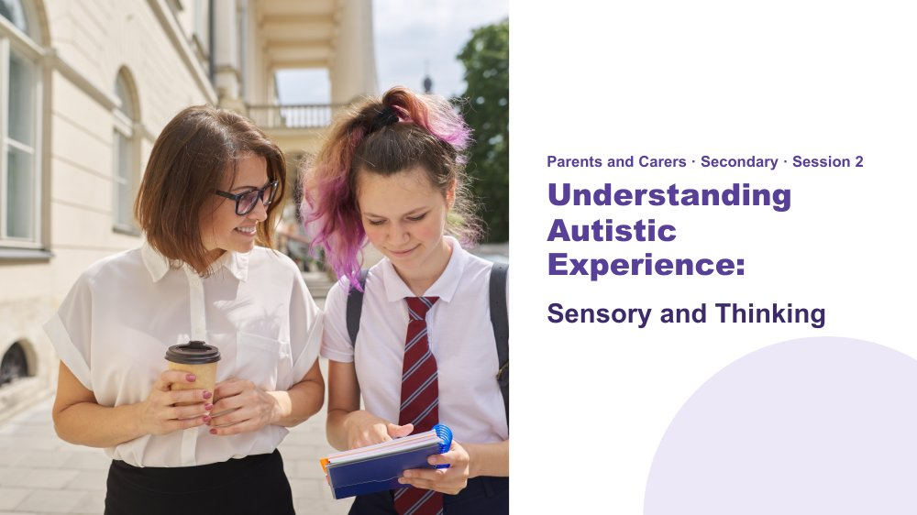 | Understanding Autistic Experience: Sensory and Thinking  SUGGESTED TIME  1 min  CLOCK  10:15 - 10:16

Orient the room: this session builds a picture of each participant's young person.
WHAT TO DO  - Orient the room before starting.  - Invite participants to keep in mind the young person they introduced and wrote about in Session 1. | KEY MESSAGES  - This session is strengths-based.  - The lenses are not deficit labels - they are tools for understanding.  - The goal is recognition and shared understanding of the Autistic experience.

YOU MIGHT SAY
In this session we are going to build a picture of your young person. Not a list of what is hard, and not a catalogue of traits. A picture.
Each idea we look at is a piece. As we move through Session 2 and Session 3, the picture will be clearer.
Keep that young person in mind. Everything today is about them.

KEEP IN MIND
- If you are running behind, keep the sensory profiles (slide 8) to the idea of a map, not a label, take one example only from the room after the sensory activity (slide 10), and cover the two executive functioning examples (slides 15 and 16) in a sentence each. Keep the reading the signs activity (slide 22), which carries into Session 5.

Thread This is the opening frame. The "coming into focus" image logic starts here - fragments that build into a whole. Return to it at the close of Session 3.

SESSION 2 | Understanding Autistic Experience: Sensory and Thinking | SLIDE 2 of 23

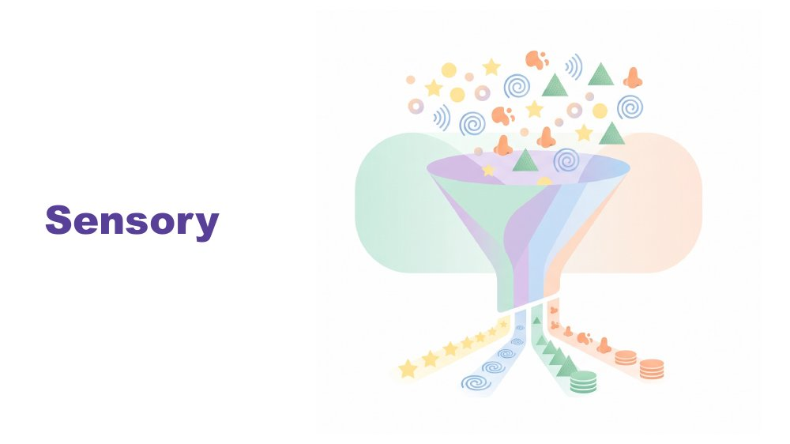 | Sensory  SUGGESTED TIME  1 min  CLOCK  10:16 - 10:17

Set sensory experience as the foundation for everything that follows.
WHAT TO DO
- Brief pause after speaking, then move to the senses.

YOU MIGHT SAY
Before we talk about thinking, or communication, or connection - we start here. With the senses.
Because before your young person has thought a single thought, the world has already arrived. And how it arrives matters.

Thread Sensory is the starting point: thinking, communication and connection all flow from it.

SESSION 2 | Understanding Autistic Experience: Sensory and Thinking | SLIDE 3 of 23

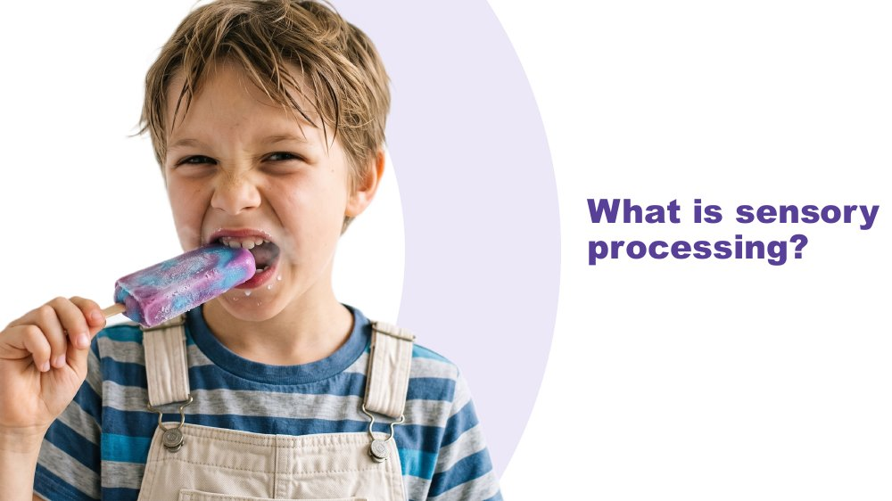 | What is sensory processing?  SUGGESTED TIME  1 min  CLOCK  10:17 - 10:18

Ask the room what sensory processing means before giving the definition.
WHAT TO DO
- Ask: What is sensory processing?
- Take one or two responses, then give the definition.

YOU MIGHT SAY
Sensory processing is the way the brain receives, processes and responds to information from the senses.

SESSION 2 | Understanding Autistic Experience: Sensory and Thinking | SLIDE 4 of 23

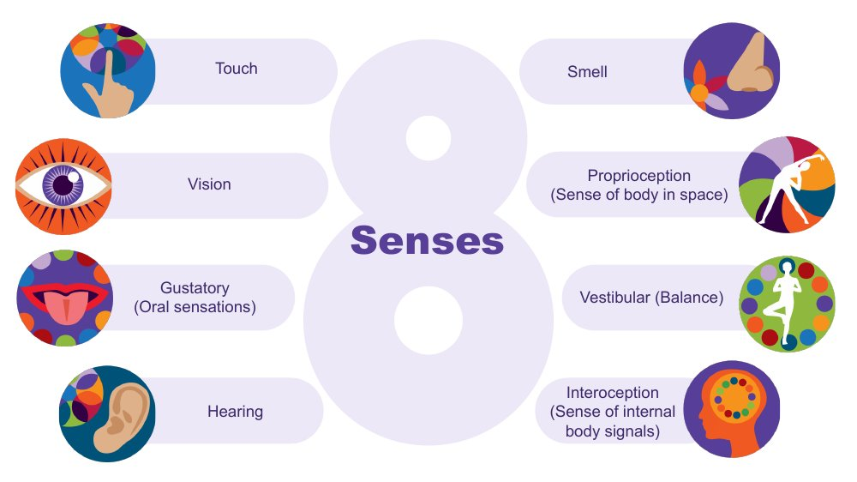 | Senses  SUGGESTED TIME  2 min  CLOCK  10:18 - 10:20

Introduce the eight senses, including the three less well-known senses.
WHAT TO DO  - Start with the five senses many of us were taught about: touch, vision, taste, hearing and smell.  - Ask the room: there are three more senses that are less well known. Can you name them? Give a moment for responses.  - Name proprioception, vestibular and interoception, using the descriptions on the slide.  - Flag interoception and park it: it returns later in the session. | KEY MESSAGES  - There are 8 senses, not 5.  - The hidden three are often where Autistic differences show up most, and they are easy to miss.  - Interoception is flagged here and developed later - plant that seed.

YOU MIGHT SAY
Proprioception is the sense of where the body is in space. Young people who bump into things, crash into things, seek heavy pressure, or need to feel their body may be seeking proprioceptive input.
Vestibular is balance and movement. A young person who needs to rock, pace, or keep moving may be regulating through this sense.
Interoception is the body's inside sense - and it is one of the most important for understanding your young person. Park it for now.
We will come back to interoception, it connects to a lot of what follows.

Background Touch (tactile) is received through the skin and gives information about texture, pain, pressure and temperature. Vision gives depth, colour, size, shape and where objects are in space. The gustatory sense is taste, and also other oral sensations such as texture, temperature, the size of food in the mouth and how much pressure is needed when chewing. Hearing (auditory) tells us how far away a sound is, how loud it is, its pitch and whether it is familiar. Smell (olfactory) can link strongly to emotional memory, so some smells trigger emotions more quickly than other senses. Proprioception comes through joints, muscles, ligaments and deep in the skin; differences may mean bumping into things. The vestibular sense sits in the middle ear and tells the brain how fast and in which direction the head is moving, and supports balance; a young person may love spinning, or may get car sick easily or feel off balance on stairs. Interoception helps answer "how am I doing?": knowing when to go to the toilet, when you are tired, hungry, thirsty, hot or cold, or becoming angry or upset, and it plays a part in self-regulation. There is lots of crossover between the senses: in any situation we use all or most of them.
Thread Interoception returns as a full section in slides 19 - 22.
RESOURCES
- Interoception webinar recording and resources - Positive Partnerships website

SESSION 2 | Understanding Autistic Experience: Sensory and Thinking | SLIDE 5 of 23

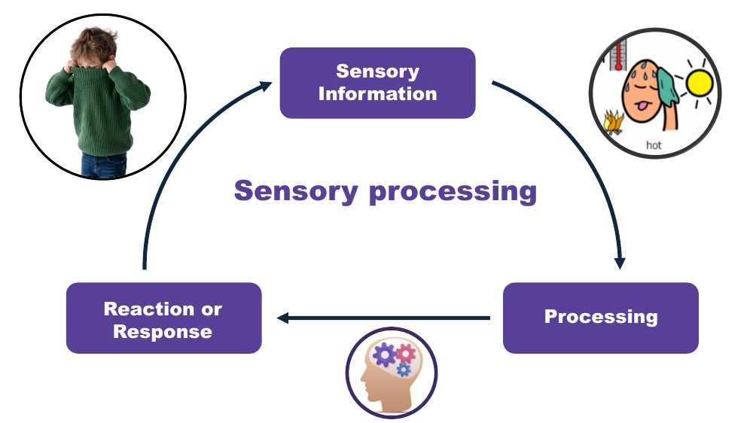 | Sensory processing  SUGGESTED TIME  2 min  CLOCK  10:20 - 10:22

Walk through the sensory processing cycle with an everyday example.
WHAT TO DO  - Walk the cycle on the slide: sensory information, processing, reaction or response.  - Use the jumper example. | KEY MESSAGES  - The way the brain processes and responds to sensory information is not a choice.  - A visible reaction is only one part of the full process.

YOU MIGHT SAY
If you think about what is involved in someone taking their jumper off when they get too hot: first, sensory information is received to tell them they are getting too hot. This is processed and related to previous experiences, like how they felt when they took their jumper off before. A response is generated - in this example, taking the jumper off.
Sensory processing helps us stay safe, keep track of what our body is doing, understand our environment, learn, and filter out information so we can pay attention and engage.
It is important to note that the way our brain processes sensory information and responds is not a choice.

SESSION 2 | Understanding Autistic Experience: Sensory and Thinking | SLIDE 6 of 23

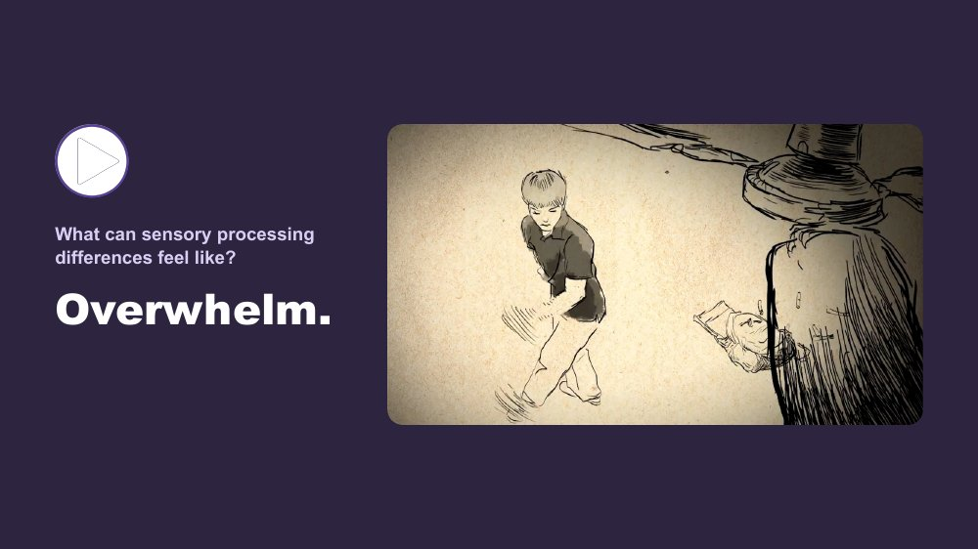 | What can sensory processing differences feel like? Overwhelm  SUGGESTED TIME  2 min  CLOCK  10:22 - 10:24

Shift from understanding to felt recognition through a first-person account of sensory overload.
WHAT TO DO
- Introduce both clips before playing the first one.
- Play the overwhelm clip.
- After the clip, give a moment. Do not speak immediately.

YOU MIGHT SAY
We are going to watch two short clips. One shows what sensory overload can feel like from the inside. One shows sensory joy - what it is like when the senses are working with you rather than against you. Both are real. Both belong in the room.
We do this in a few places today - we stop and hear from Autistic people directly. That is not an add-on. It is the evidence.
Some of you will have seen something you recognised. Some of you may not have. Both responses are fine.

KEEP IN MIND
- Parents may recognise their young person's hardest moments in this clip. Give the pause, and keep any comments optional.

Thread This video does the same job as the thinking video (slide 17) and the communication video in Session 3: moving from intellectual understanding to felt recognition.

SESSION 2 | Understanding Autistic Experience: Sensory and Thinking | SLIDE 7 of 23

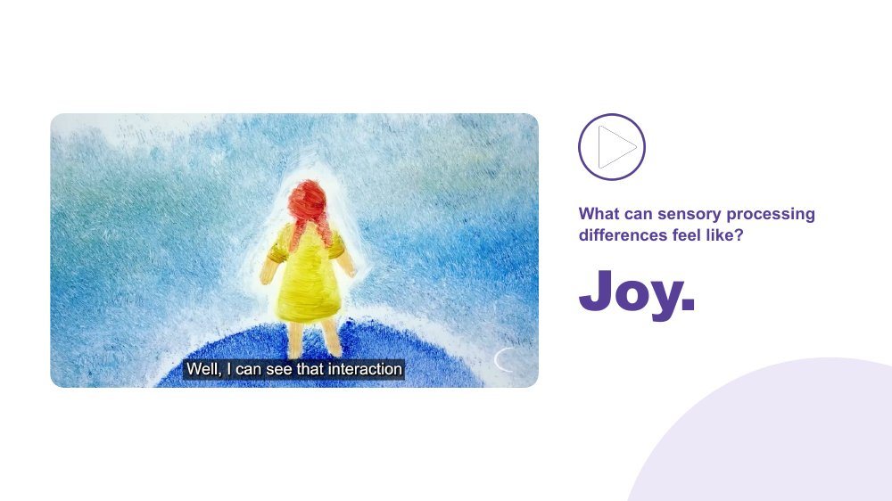 | What can sensory processing differences feel like? Joy  SUGGESTED TIME  2 min  CLOCK  10:24 - 10:26

Show that sensory experience is also a source of richness and pleasure.
WHAT TO DO  - Play the sensory joy clip.  - After the clip, speak to both clips together. | KEY MESSAGES  - Sensory experience includes both difficulty and joy.  - First-person accounts are more powerful than any explanation.  - Recognition - not information - is the goal here.

YOU MIGHT SAY
Sensory experience is not only a source of difficulty. For many Autistic people, it is also a source of richness, depth, and genuine pleasure.
The same nervous system that can be overwhelmed by sound can be transported by music. Both are true.

SESSION 2 | Understanding Autistic Experience: Sensory and Thinking | SLIDE 8 of 23

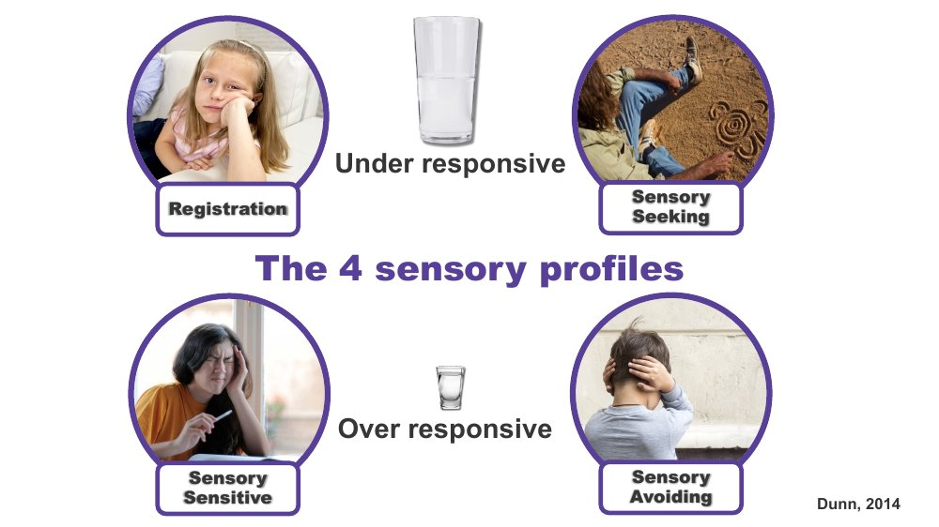 | The 4 sensory profiles  SUGGESTED TIME  3 min  CLOCK  10:26 - 10:29

Introduce four patterns of sensory response as a map, not a label.
WHAT TO DO  - Introduce the framework and talk through each profile briefly.  - Link to the Sensory Profile Questionnaire some families will have met through an occupational therapist.  - Name that a young person can show different patterns across different senses. | KEY MESSAGES  - Four patterns: registration, seeking, sensitive, avoiding.  - Young people can show different patterns across different senses.  - Patterns can shift with load and context.  - All patterns are the nervous system doing what it needs.

YOU MIGHT SAY
Winnie Dunn's research identified four patterns in how people respond to sensory input. These are not types of autism, they are patterns of sensory response. Your young person may show more than one, and the pattern may shift depending on the day, the environment, or the load they are already carrying.
Registration (under-responsive): may not register input that others pick up. May seem unaware, dreamy, hard to reach.
Sensory Seeking: actively looks for more input. Movement, touch, sound. The body asking for what it needs.
Sensory Sensitive (over-responsive, passive): notices everything. Distracted, finds busy environments very hard, but does not necessarily act on it.
Sensory Avoiding (over-responsive, active): actively works to reduce input. Covers ears, avoids crowds, refuses certain textures.
A young person can be seeking in some senses and avoiding in others. This is a map, not a label.

Background These four profiles are part of a sensory processing framework developed by Professor Winnie Dunn, an occupational therapist at the University of Missouri. Parents may have seen it if an occupational therapist has asked them to complete a Sensory Profile Questionnaire. The profiles are also known as seeker, bystander (registration), avoider and sensor (sensitive). Everyone has a different comfort level, or a different sized cup, for sensory information, which may lead to a different response. A person may have a different sized cup for different senses, so they could have a number of sensory profiles. A sensory profile is not a choice; it relates to how the brain responds to sensory information.

SESSION 2 | Understanding Autistic Experience: Sensory and Thinking | SLIDE 9 of 23

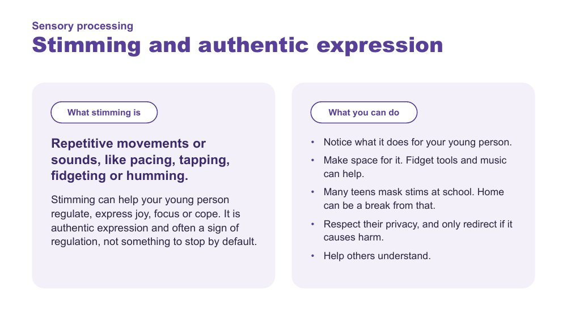 | Stimming and authentic expression  SUGGESTED TIME  3 min  CLOCK  10:29 - 10:32

Recognise stimming as authentic expression that often helps a young person regulate, and think about how to make space for it in the teenage years.
WHAT TO DO  - Link from the sensory profiles: many young people seek or manage sensory input through movement and sound.  - Explain what stimming is, using the left side of the slide: repetitive movements or sounds that can help your young person regulate, express joy, focus or cope.  - Name that stimming is authentic expression and often a sign of regulation, not something to stop by default.  - Walk through what parents can do on the right side of the slide, including the teen context: fidget tools and music, masking stims at school, and privacy.  - If people wish to, invite one or two examples of how stimming looks for their young person. | KEY MESSAGES  - Stimming is repetitive movement or sound that can help with regulation, joy, focus and coping.  - It is authentic expression and often a sign of regulation, not something to stop by default.  - Notice what it does for your young person, make space for it, respect their privacy, only redirect if it causes harm, and help others understand.

YOU MIGHT SAY
Pacing, tapping, fidgeting, humming, playing the same song on repeat. Most of us do something like this, like clicking a pen or jiggling a leg. For many Autistic young people, stimming is how the body settles, focuses or shows joy. If we stop it, we can take away something that was helping.

KEEP IN MIND
- There is no pressure to stop stimming. Avoid framing it as a behaviour to reduce or replace.
- Many teenagers mask their stims at school to fit in, and that takes energy. Home can be a place where they do not need to.
- Respect privacy: some young people prefer to stim where others cannot see. Follow their lead.
- If a stim causes harm, look for another way to meet the same need rather than simply stopping it.

Background Stimming is common among Autistic people. Many Autistic adults describe it as helping with regulation, focus and expressing emotion, including joy, and describe holding stims back as tiring. In the teenage years the pressure to fit in often increases, so stims may be hidden at school and released at home. This links to masking in Session 3.
Thread Follows sensory seeking on the sensory profiles slide, and links forward to masking in Session 3.

SESSION 2 | Understanding Autistic Experience: Sensory and Thinking | SLIDE 10 of 23

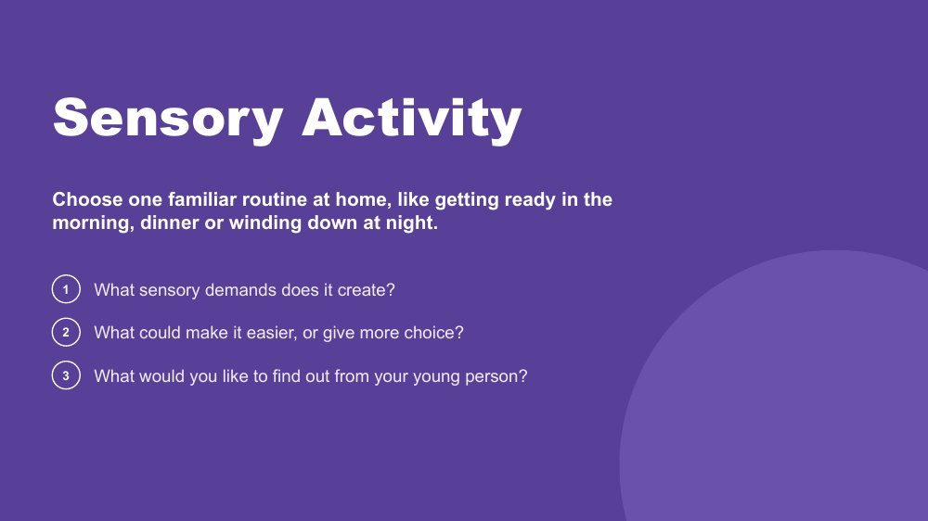 | Sensory activity  SUGGESTED TIME  4 min  CLOCK  10:32 - 10:36  GROUPING  Pairs or tables  WORKBOOK  Workbook - Sensory activity

Apply sensory thinking to one familiar routine at home.
WHAT TO DO  - Ask participants to choose one familiar routine at home, like getting ready in the morning, dinner or winding down at night.  - Work through the three questions on the slide.  - Invite pairs or tables to share, then take one or two examples from the room. | KEY MESSAGES  - Everyday routines carry sensory demands that are easy to miss.  - Small changes and more choice can make a routine easier.  - Your young person is a source of information about what the routine feels like, and many teenagers can tell you if they are asked in a way that suits them.

ACTIVITY | Pair or table discussion pairs or tables · 4 minutes
Choose one familiar routine at home, like getting ready in the morning, dinner or winding down at night. What sensory demands does it create? What could make it easier, or give more choice? What would you like to find out from your young person?
- Give a minute for each person to choose a routine.
- Pairs or tables talk through the three questions.
- Take one or two examples from the room.
Close: Name that looking at the sensory demands of a routine is a starting point for curiosity, not proof of what your young person feels.

KEEP IN MIND
- Keep the focus on the routine and its demands, not on the young person getting it wrong or the parent getting it wrong.
- Some teenagers prefer to talk side by side, in the car or by message rather than face to face. Asking in a way that suits them is part of the answer.

SESSION 2 | Understanding Autistic Experience: Sensory and Thinking | SLIDE 11 of 23

 | Thinking  SUGGESTED TIME  1 min  CLOCK  10:36 - 10:37

Introduce the thinking section.
WHAT TO DO  - Name that the session now moves from how the world arrives to how your young person's mind takes it in and where attention goes.  - Move straight to the detail-first brain. | KEY MESSAGES  - Present these as patterns participants may recognise, not assumptions about every Autistic young person.

SESSION 2 | Understanding Autistic Experience: Sensory and Thinking | SLIDE 12 of 23

 | The Detail-First Brain  SUGGESTED TIME  3 min  CLOCK  10:37 - 10:40

Introduce detail-first (bottom-up) processing and the strengths it produces.
WHAT TO DO  - Open with the contrast between filtering first and taking in the detail first.  - Use the images on the slide to show the whole picture building from the pieces.  - Move through the strengths slowly. For each one, invite the room to connect it to their young person, e.g. Pattern recognition, where do you see this? Deep memory, what does your young person know by heart? Honesty and directness, how does this show up? | KEY MESSAGES  - Autistic cognition builds from detail up - bottom-up processing.  - This connects to sensory intensity, literal language, and everything that follows.  - The strengths listed are genuine features, not compensations.  - Parents who leave with vocabulary for these strengths will notice and build on them actively.

YOU MIGHT SAY
Most brains filter first - they predict what is there based on expectation and fill in the rest. The detail-first brain does not filter first. It takes in what is actually there. Then it builds the whole picture from those pieces upward. That is bottom-up processing.
This is the architecture that connects sensory intensity, literal language, pattern recognition, and deep focus. They are not a list of separate Autistic traits. They are features of the same way of taking in the world.
Your young person may pick up on small details: a tiny change in routine, a background sound, an inconsistency in what someone said. They are not being pedantic. They are seeing accurately.
What this produces: pattern recognition, systems thinking, deep memory, logical precision, honesty and directness, depth of connection, intense engagement. These are not future potential. They are present now.

KEEP IN MIND
- Some parents in this room will not have heard their young person described with strengths-based cognitive framing before. The typical frame is "despite X they can Y". This is different. These are genuine features of how this brain works. The parent who names their young person's pattern recognition as a strength is doing something meaningful for their young person's identity and sense of self.

Background Some research suggests that Autistic perception relies more on incoming detail and less on top-down filtering. The practical implication: the environment is registered more fully, more specifically, and less pre-organised before reaching conscious awareness. This produces precision and depth. It also produces load: the same full page that generates pattern recognition also generates sensory overload.

SESSION 2 | Understanding Autistic Experience: Sensory and Thinking | SLIDE 13 of 23

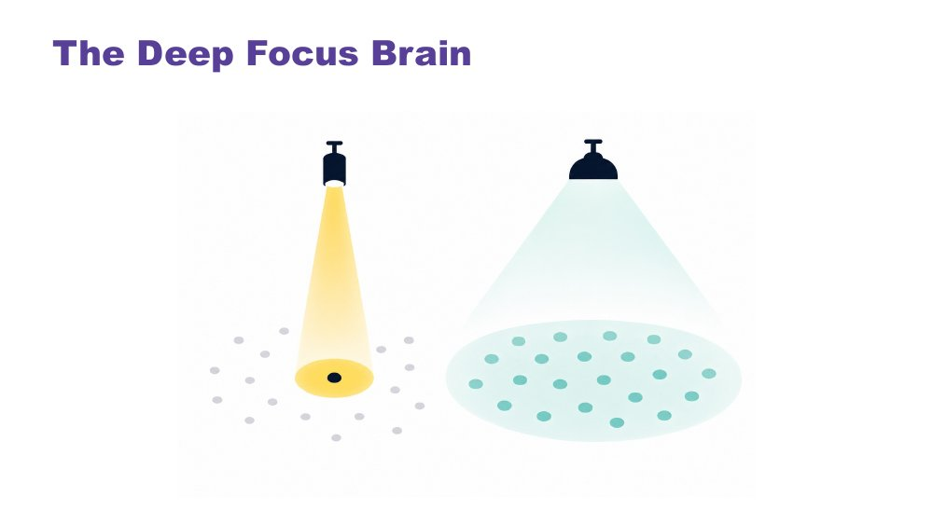 | The Deep Focus Brain  SUGGESTED TIME  2 min  CLOCK  10:40 - 10:42

Introduce monotropism: deep interests, transitions and flow.
WHAT TO DO  - Ask the room: do your thoughts travel across many different topics, or do they tend to go deep on one? Give a moment to reflect. Many parents will recognise this in themselves.  - Use the torch and floodlight image on the slide.  - Then name the key ideas: deep interests, transitions, flow.  - Use the concrete example of the young person being called to dinner. | KEY MESSAGES  - Monotropism: deep focus on fewer things at a time, not distraction or obsession.  - Deep interests can be a powerful route to learning, memory and genuine engagement (Murray, Lesser and Lawson, 2005).  - Transitions can take real effort, because attention is deeply invested in what your young person is doing.  - Flow is the positive expression of this architecture - the brain at its best.  - Named and described by Autistic people themselves.

YOU MIGHT SAY
The non-Autistic brain tends to spread attention across many things at once, like a floodlight. The Autistic brain tends to channel it fully into one thing at a time, like a torch beam. Neither is wrong. They illuminate different things.
Deep interests are not obsessions or fixations. They are the brain's most natural access to learning, memory, and joy.
Transitions can be hard because attention is deeply invested, not because your young person is being difficult. With warning and scaffolding this becomes more manageable. The effort involved is real.
Flow - full absorption, time disappearing - is this brain at its most powerful. It is worth protecting.
A young person absorbed in a game, a drawing, reading about a favourite topic, listening to the same song or watching the same series again is not stuck. The brain is doing what it does best: going deep. Asking that young person to stop and come to dinner is not a simple request. The tendrils are all the way in. Retracting them takes real effort and real time.

Background Monotropism was developed as a framework by Autistic researchers and advocates, and has been extended by Autistic community voices. It proposes that the core feature of Autistic attention is channelling into fewer things with greater depth, rather than distributing broadly. This explains deep interests, transition difficulty and the experience of flow. The tendril theory comic illustrates it practically: attention extends like tendrils into what the mind is engaged with; switching means retracting all of them, which takes time and costs something. This connects directly to the detail-first brain: one explains how the world arrives, the other where attention goes once it has. Monotropism: Murray, Lesser and Lawson (2005).
RESOURCES
- Tendril theory comic - https://eisforerin.com/2015/08/10/tendril-theory/

SESSION 2 | Understanding Autistic Experience: Sensory and Thinking | SLIDE 14 of 23

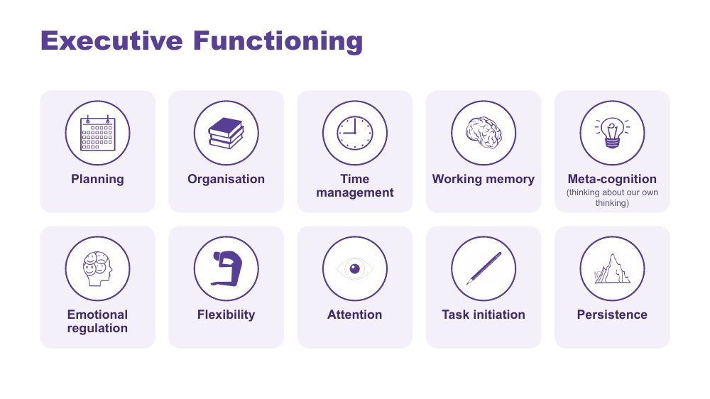 | Executive Functioning  SUGGESTED TIME  2 min  CLOCK  10:42 - 10:44

Make executive functioning visible as a set of everyday processes.
WHAT TO DO  - Briefly name the functions on the slide: planning, organisation, time management, working memory, meta-cognition (thinking about our own thinking), emotional regulation, flexibility, attention, task initiation and persistence.  - Explain that the next two slides show how two of these connect to the detail-first brain and the deep focus brain.  - Keep this as a map of processes, not a list of deficits.  - Name that the secondary years add executive demands: several teachers, a timetable, homework, assessment due dates and more to organise independently. | KEY MESSAGES  - Executive functioning includes the processes involved in starting, organising, sequencing and switching between tasks.  - Identifying the difficult part helps identify a useful support.  - Executive functioning is not the same as intelligence. A capable young person can still find it very hard to start, plan or organise a task.

SESSION 2 | Understanding Autistic Experience: Sensory and Thinking | SLIDE 15 of 23

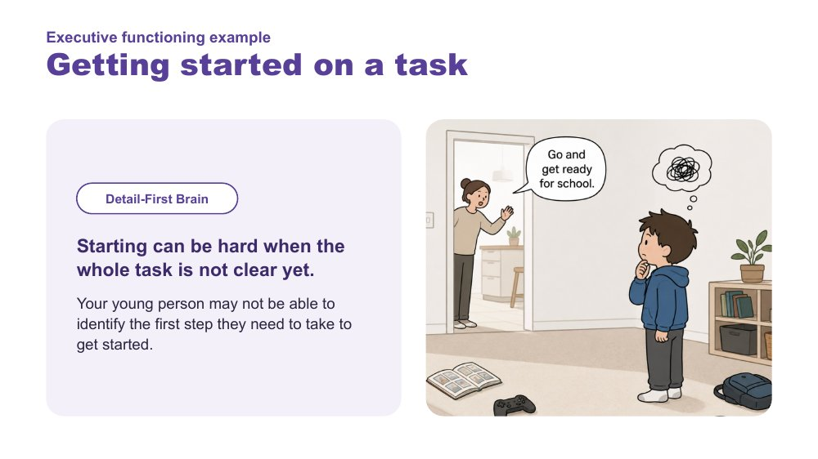 | Executive functioning example - Getting started on a task  SUGGESTED TIME  1 min  CLOCK  10:44 - 10:45

Link getting started to the detail-first brain.
WHAT TO DO  - Use the image on the slide.  - Explain that starting can be hard when the whole task is not clear yet: your young person may not be able to identify the first step.  - Give a secondary example, such as starting an assignment or a homework task when the instructions feel unclear.  - Ask what might help at home, such as working out the first step together or breaking the task into visible parts. | KEY MESSAGES  - Starting can be hard when the whole task is not clear yet.  - A practical support starts with understanding which part of the task is hard.

SESSION 2 | Understanding Autistic Experience: Sensory and Thinking | SLIDE 16 of 23

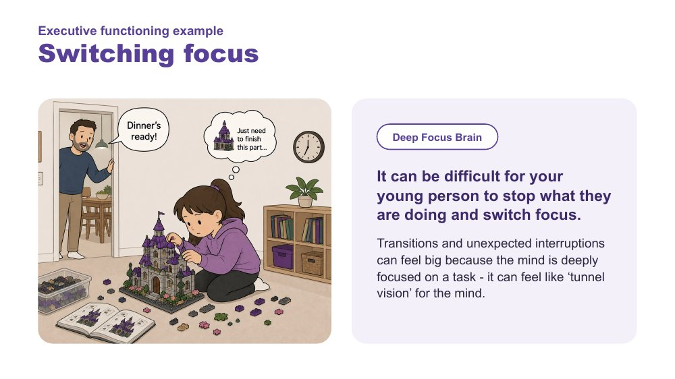 | Executive functioning example - Switching focus  SUGGESTED TIME  1 min  CLOCK  10:45 - 10:46

Link switching focus to the deep focus brain.
WHAT TO DO  - Use the image on the slide.  - Explain that stopping and switching can be difficult because the mind is deeply focused - it can feel like tunnel vision for the mind.  - Give a home example, such as being asked to stop a game to come to dinner or get ready to go out.  - Connect back to the torch beam: warning and time help. | KEY MESSAGES  - Starting and switching are different demands.  - Transitions and unexpected interruptions can feel big when the mind is deeply focused.

SESSION 2 | Understanding Autistic Experience: Sensory and Thinking | SLIDE 17 of 23

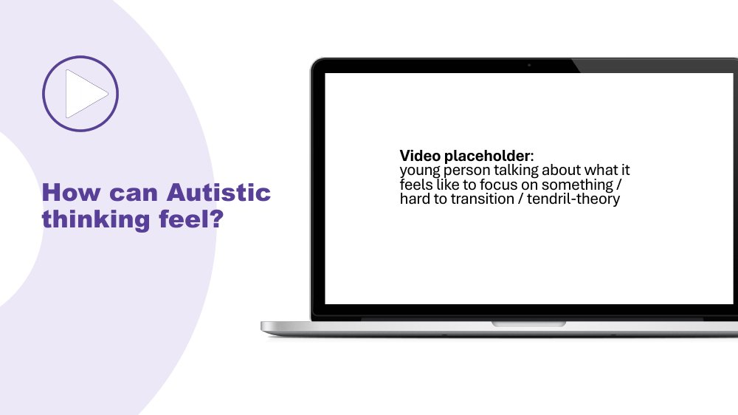 | How can Autistic thinking feel?  SUGGESTED TIME  2 min  CLOCK  10:46 - 10:48

Hear a first-person account of deep focus and changing focus.
WHAT TO DO
- Introduce the video as one young person's experience of focusing and transitioning.
- Play the video, then give a moment before moving on.

Thread Same pattern as the sensory clips: stop and hear from Autistic people directly.

SESSION 2 | Understanding Autistic Experience: Sensory and Thinking | SLIDE 18 of 23

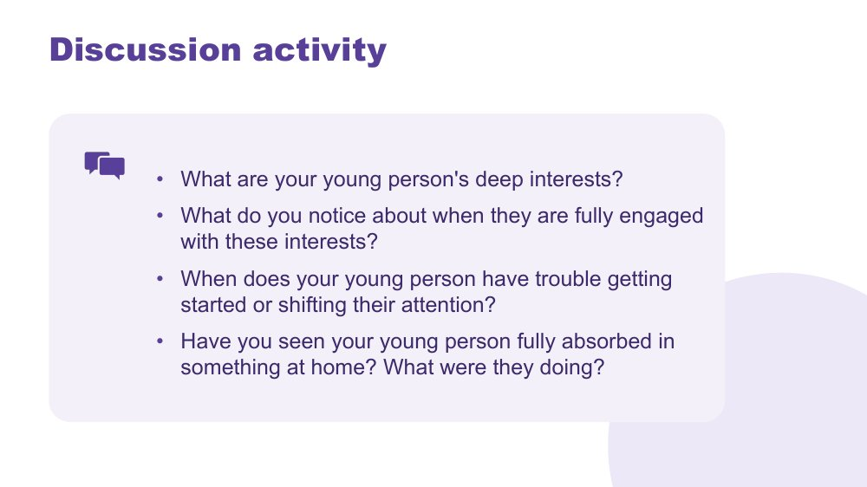 | Discussion activity - Your young person's thinking  SUGGESTED TIME  3 min  CLOCK  10:48 - 10:51  GROUPING  Pairs or tables  WORKBOOK  Workbook - Thinking discussion

Personalise the thinking concepts: move from "I understand this" to "I can see this in my young person".
WHAT TO DO  - Direct people to the questions on the slide.  - Invite pairs or table groups to share with each other before taking a few whole-room responses.  - Bring the room back with: What came up for people? Take 2 - 3 responses. You do not need to comment extensively on each; the room hearing each other is the consolidation.  - Close with the line below. | KEY MESSAGES  - The questions map onto the concepts: detail-first, deep interests, starting and switching, and flow.  - Parents who can name these things in their young person leave the room with something practical and immediate.  - The activity holds strengths alongside challenges: flow and deep interests sit alongside starting and shifting.

YOU MIGHT SAY
Everything you have just described, that IS the thinking brain at work. Noticing it is the beginning of working with it rather than against it.

ACTIVITY | Pair or table share pairs or tables · 3 minutes
What are your young person's deep interests? What do you notice when they are fully engaged with these interests? When does your young person have trouble getting started or shifting their attention? Have you seen your young person fully absorbed in something at home? What were they doing?
- Invite participants to choose the questions most relevant to them.
- Keep the pair or table share brief.
- Take 2 - 3 whole-room responses.
Close: Everything you have just described is the thinking brain at work.

KEEP IN MIND
- The facilitator's job here is to hold the space rather than add more content. What parents say to each other will likely do more work than the preceding slides.

Thread The last question, about flow, sets up the next question: what happens to that focus when your young person tries to communicate or connect? That is picked up in Session 3.

SESSION 2 | Understanding Autistic Experience: Sensory and Thinking | SLIDE 19 of 23

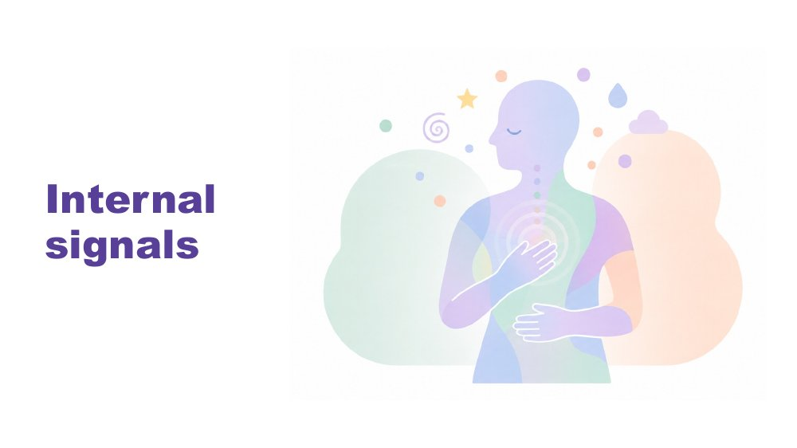 | Internal signals  SUGGESTED TIME  1 min  CLOCK  10:51 - 10:52

Return to interoception, parked earlier, as another part of the picture of your young person.
WHAT TO DO
- Remind participants of the "body's inside sense" flagged on the senses slide.
- Introduce internal signals as the next piece of the picture.

SESSION 2 | Understanding Autistic Experience: Sensory and Thinking | SLIDE 20 of 23

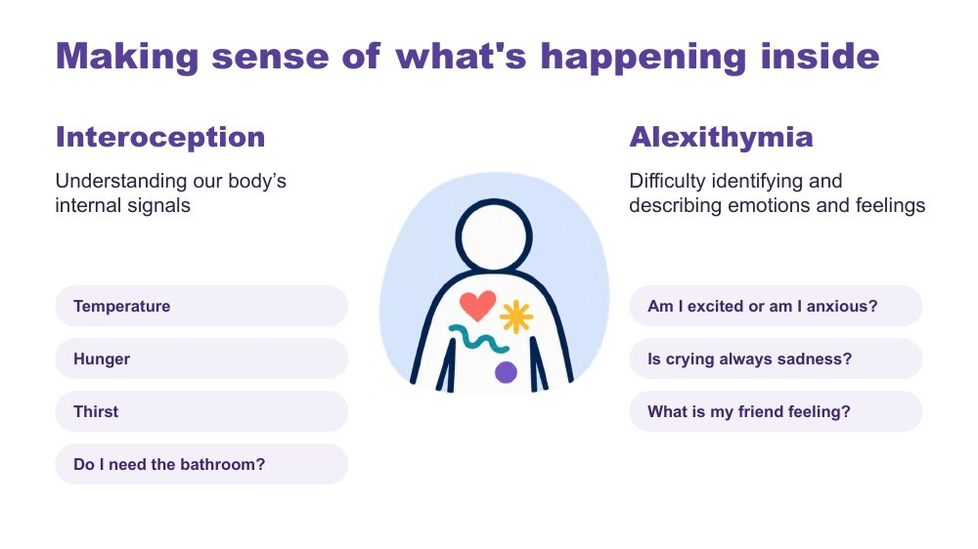 | Making sense of what's happening inside  SUGGESTED TIME  2 min  CLOCK  10:52 - 10:54

Distinguish noticing body signals (interoception) from identifying and describing emotions (alexithymia).
WHAT TO DO  - Use the slide wording: interoception is understanding our body's internal signals; alexithymia is difficulty identifying and describing emotions and feelings.  - Use the examples on the slide: temperature, hunger, thirst, do I need the bathroom? Am I excited or am I anxious? Is crying always sadness? What is my friend feeling?  - Give a home example: a young person who does not notice hunger or tiredness until they are very distressed, or who cannot tell whether a fluttery feeling is excitement or worry before a school camp or a party.  - Avoid diagnosing participants or their young people from the examples. | KEY MESSAGES  - Noticing body signals and understanding emotions are related, but they are not the same thing.  - A young person may need support to notice, interpret or communicate what is happening inside.

SESSION 2 | Understanding Autistic Experience: Sensory and Thinking | SLIDE 21 of 23

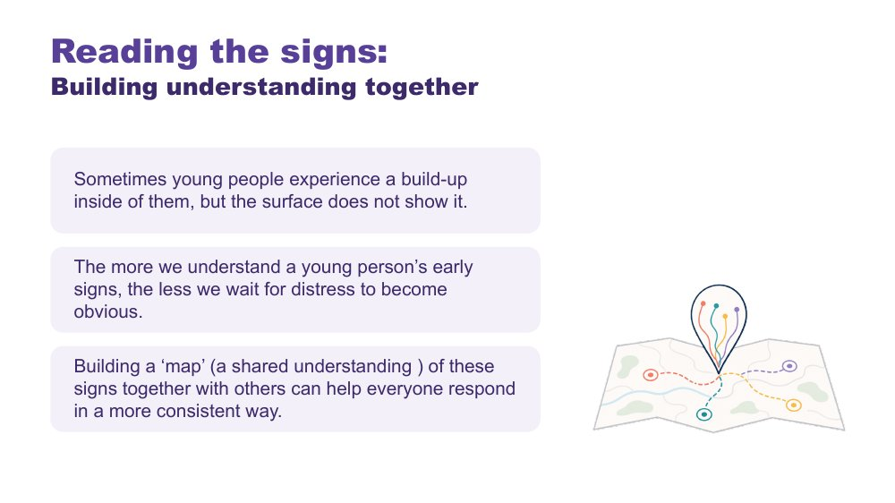 | Reading the signs: Building understanding together  SUGGESTED TIME  2 min  CLOCK  10:54 - 10:56

Explore how adults can notice early signs before distress becomes obvious.
WHAT TO DO  - Explain that sometimes a build-up is happening inside a young person even when the surface does not show it.  - Explain that the more we understand a young person's early signs, the less we wait for distress to become obvious.  - Introduce the idea of a shared map of these signs, built with others such as family members and school, and with your young person where they want to be involved, so everyone can respond more consistently. | KEY MESSAGES  - Early signs may be individual and subtle.  - Shared understanding helps people respond more consistently.

KEEP IN MIND
- Do not suggest that a parent missed signs or should have seen something coming. Many build-ups are not visible at all.

SESSION 2 | Understanding Autistic Experience: Sensory and Thinking | SLIDE 22 of 23

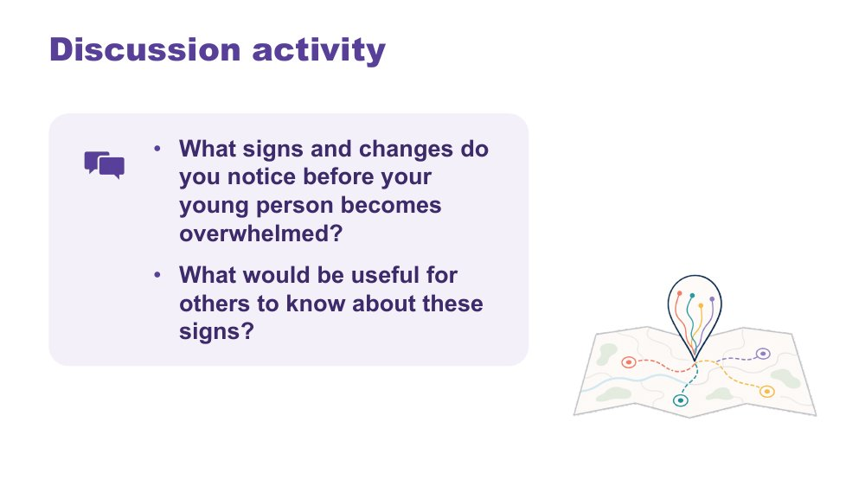 | Discussion activity - Reading the signs  SUGGESTED TIME  3 min  CLOCK  10:56 - 10:59  GROUPING  On your own, then tables  WORKBOOK  Workbook - Reading the signs

Help participants name their young person's early signs in words they could share with others.
WHAT TO DO  - Give quiet thinking time before sharing.  - Invite examples without requiring personal disclosure.  - Encourage descriptive language that could be shared with school or other carers. | KEY MESSAGES  - Early signs look different for each young person.  - Descriptive information helps home and school build a shared understanding.

ACTIVITY | Think, write and optional share on your own, then tables · 3 minutes
What signs and changes do you notice before your young person becomes overwhelmed? What would be useful for others to know about these signs?
- Give a minute of quiet writing time.
- Invite optional sharing at tables.
- Encourage descriptions of what can be seen or heard, rather than labels.
Close: Let participants know this map is useful to bring to conversations with school in Session 5.

KEEP IN MIND
- Many teenagers care about what is shared about them. Suggest parents check with their young person what they are comfortable for others, including school, to know.

Thread The early-signs map links to managing daily capacity (Session 3) and partnership with the school (Session 5).

SESSION 2 | Understanding Autistic Experience: Sensory and Thinking | SLIDE 23 of 23

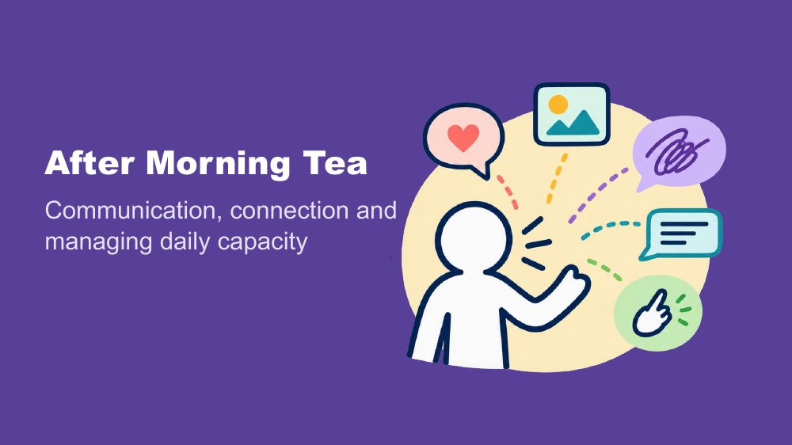 | After Morning Tea  SUGGESTED TIME  1 min  CLOCK  10:59 - 11:00

Wrap up Session 2 and introduce Session 3.
WHAT TO DO
- Summarise sensory experience, thinking and internal signals as pieces of the picture.
- Explain that after Morning Tea the picture continues with communication, connection and managing daily capacity.
- Invite participants to keep thinking about the same young person.
- Remind participants Morning Tea is 11:00 - 11:15.

SESSION  3 | 11:15 - 12:15 · 60 MINUTES · 21 SLIDES  Communication, Connection and Managing Daily Capacity

SESSION INTENT
Explore how your young person communicates, connects and manages changing daily capacity, including the pressure to mask in the teenage years, then close the morning by bringing the separate lenses back to the whole young person and positive Autistic identity. Parents map their young person's communication world, consider what knowledge should travel with them, and reflect on connection and the cost of appearing fine.
PARTICIPANTS LEAVE WITH
- Recognise the many ways their young person communicates, and that speech is one part of communication.
- Distinguish understanding from expressing, and name supports such as clear language, processing time and visual supports.
- Describe connection as two-way, and identify the kinds of connection their young person enjoys.
- Use the battery and spoon analogies to think about changing capacity and the cost of masking, including why masking can increase in the secondary years.
- Connect positive Autistic identity and belonging with their young person's wellbeing.

RUN SHEET
Clock | Segment | Slides | Minutes
11:15 - 11:16 | Welcome back and session opening | 1 | 1
11:16 - 11:41 | Communication: ways of communicating, communication network and supports | 2-9 | 25
11:41 - 11:55 | Connection: double empathy, being social and discussion | 10-13 | 14
11:55 - 12:01 | Managing daily capacity: batteries, spoons and fluctuating capacity | 14-16 | 6
12:01 - 12:12 | Masking, masking in the teenage years and discussion | 17-20 | 11
12:12 - 12:15 | Positive Autistic Identity and close before lunch | 21 | 3

PREPARE
☐ Workbooks and pens.
☐ Purple, blue and orange Post-it notes on each table, and wall or board space for notes grouped by colour.
☐ Three videos tested with sound: Communication experiences (slide 5), Being social (slide 11) and Masking (slide 17).
☐ Edited captions switched on and transcripts available for each video.
☐ Slide 21 closing script read through beforehand so it can be delivered slowly.
☐ Lunch arrangements confirmed so the close on slide 21 is not rushed.

SESSION 3 | Communication, Connection and Managing Daily Capacity | SLIDE 1 of 21

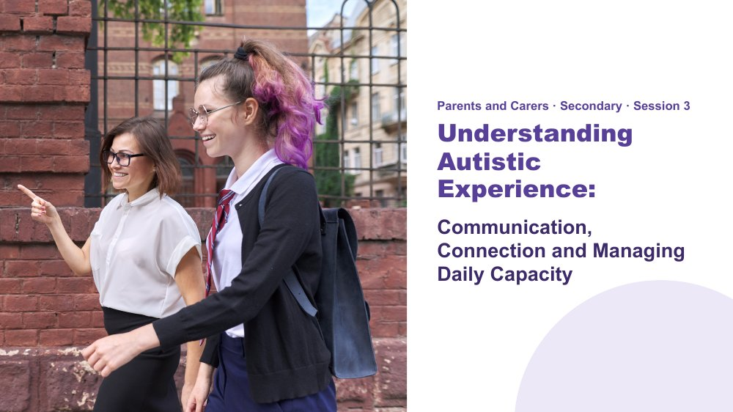 | Understanding Autistic Experience: Communication, Connection and Managing Daily Capacity  SUGGESTED TIME  1 min  CLOCK  11:15 - 11:16

Welcome participants back from morning tea and connect Session 3 with the sensory, thinking and internal-signal lenses from Session 2.
WHAT TO DO  - Welcome participants back from morning tea.  - Briefly connect sensory experience, thinking and internal signals with the three areas in this session: communication, connection and managing daily capacity.  - Explain that the session keeps building one whole picture of their young person rather than separate lists.  - Ask participants to keep their own young person in mind throughout. | KEY MESSAGES  - Communication, connection and capacity are shaped by the experiences already explored.  - Keep the individual young person in mind throughout the session.

KEEP IN MIND
- This session is tight. If you are running behind, cut the sharing in the Post-it activity (slide 7) to two or three notes read out, skip the optional visual supports question (slide 9), take one response only after each video and keep Social Interactions (slide 12) brief. Protect the close on slide 21.

Thread Sessions 2 and 3 build one picture of the young person. This session closes that picture on slide 21, Positive Autistic Identity, before lunch.

SESSION 3 | Communication, Connection and Managing Daily Capacity | SLIDE 2 of 21

 | Communication  SUGGESTED TIME  1 min  CLOCK  11:16 - 11:17

Open the communication section.
WHAT TO DO
- Name the first section: communication.
- Move straight to the warm-up on the next slide.

SESSION 3 | Communication, Connection and Managing Daily Capacity | SLIDE 3 of 21

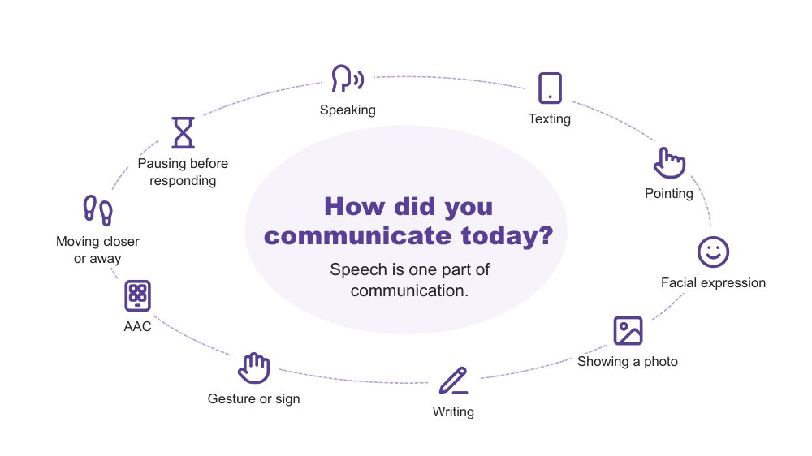 | How did you communicate today?  SUGGESTED TIME  2 min  CLOCK  11:17 - 11:19  GROUPING  Whole room

Warm up with participants' own everyday communication and show that speech is one part of communication.
WHAT TO DO  - Ask participants to think quietly of three ways they have communicated since waking up.  - Pause for about 20 seconds.  - Take only two or three responses. Reflect back the variety you hear, for example a text message, an emoji, a wave, a look, or taking a moment before answering.  - For families who have been told their young person needs to "use their words", offer this as a gentle reframe: pointing, a device, a look or moving away are all ways of communicating. | KEY MESSAGES  - Everyone communicates in many ways, every day. Speech is one part of communication.

YOU MIGHT SAY
Let's start with a quick, quiet think. Since you woke up this morning, how have you communicated? See if you can think of three different ways.
Would two or three people be happy to share one?
We all move between different ways of communicating, often without noticing. Every way on this slide is real communication. No way is more valid than another.

ACTIVITY | Quiet think with optional sharing whole room · 1 to 1.5 minutes
Silently think of three ways you have communicated since waking. Sharing is optional.
- Give about 20 seconds of quiet thinking time.
- Invite two or three people to share one way each.
Close: Reflect back the variety you heard: every way on the slide is real communication.

KEEP IN MIND
- Keep this brief. It is a warm-up, not a discussion.
- Do not use percentages or claims about how much of communication is spoken or non-spoken.

SESSION 3 | Communication, Connection and Managing Daily Capacity | SLIDE 4 of 21

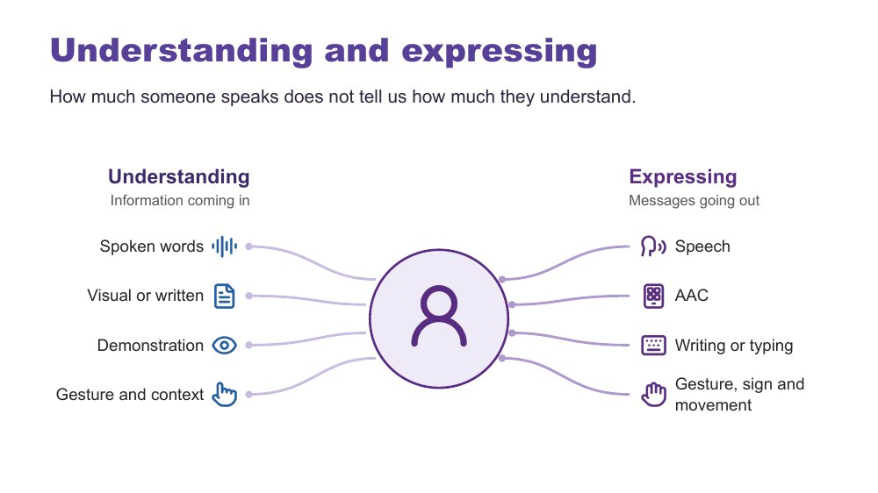 | Understanding and expressing  SUGGESTED TIME  2 min  CLOCK  11:19 - 11:21

Distinguish understanding (information coming in) from expressing (messages going out), and show that one does not predict the other.
WHAT TO DO  - Walk through the two sides of the slide: understanding, or information coming in, and expressing, or messages going out.  - Give the plain AAC explanation.  - Invite participants to think about what helps their young person understand, and what helps their young person express. | KEY MESSAGES  - How much someone speaks does not tell us how much they understand.  - Autistic people have varied communication profiles, and communication can change with the person, place, demands and how someone is feeling.  - Repeating words, phrases or scripts (echolalia and scripting) can be communication, and a way for your young person to process what is happening. Be curious about what it might mean.

YOU MIGHT SAY
Autistic people have varied communication profiles. Someone may express a great deal but need support to understand spoken information. Someone else may understand more than they can easily express. Communication can also change depending on the person, place, demands and how someone is feeling.
AAC means augmentative and alternative communication. It may include gesture, signs, a communication board or book, typing or a communication device. Some people use AAC alongside speech and some use it instead of speech.

KEEP IN MIND
- Do not assume fluent speech means full understanding. Do not assume limited speech means limited understanding.

Background Receptive communication means how a person receives and makes sense of information. Expressive communication means how a person shares messages, ideas, feelings and choices through any communication method. AAC means augmentative and alternative communication: ways to support speech or communicate without speech, such as signs, communication books, typing or a speech-generating device. Facilitator background only: gestalt language processing (GLP) is a term used in a proposed account of learning language through larger phrases or chunks. Echolalia means repeating words or phrases, immediately or later. They are not interchangeable terms. This session does not teach GLP or Natural Language Acquisition stages; explaining the framework and its evidence needs a separate discussion. Hutchins et al. (2024) questions the evidence for these categories and stages. This does not diminish the value of repeated or scripted language. Respond with curiosity, consider context and do not assume it is meaningless or something to stop. Families do not need a GLP label before communication is respected or supported.
RESOURCES
- Hutchins et al. (2024): https://doi.org/10.1177/23969415241249944

SESSION 3 | Communication, Connection and Managing Daily Capacity | SLIDE 5 of 21

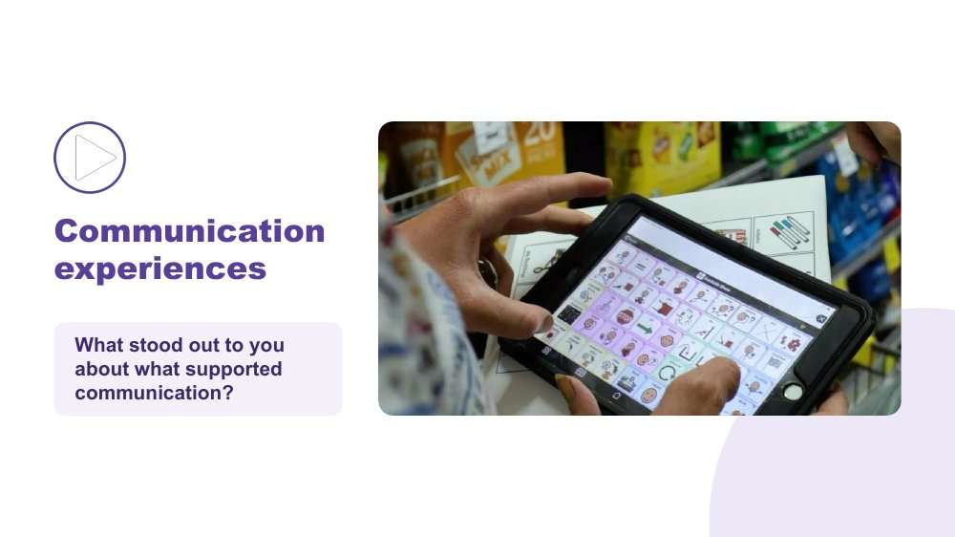 | Communication experiences  SUGGESTED TIME  4 min  CLOCK  11:21 - 11:25  GROUPING  Whole room

Hear first-person accounts of what supports communication.
WHAT TO DO  - Before the video, read the prompt: "As you watch, notice what supports communication. Choose one idea that stands out to you."  - Check captions are switched on.  - Play the video (keep the clip to around 2.5 minutes).  - After the video, click once to reveal the question and ask it.  - Take one response, or two if time allows. Use the optional prompts only if the room is quiet. | KEY MESSAGES  - There is no single Autistic communication profile. Autistic people describe what helps them communicate in many different ways.

YOU MIGHT SAY
What stood out to you about what supported communication?

ACTIVITY | Video and brief response whole room · 4 minutes including playback
What stood out to you about what supported communication?
- Optional prompt: What communication strengths did you notice?
- Optional prompt: What did another person do that helped?
- Optional prompt: What difference did the environment or available communication method make?
Close: Thank responses and move on without summarising the speakers.

KEEP IN MIND
- Let the voices in the video lead. Avoid summarising or generalising what speakers said.
- Use accurate, edited captions (not auto-generated only) and have a transcript available.
- If the video is inserted to play on click, the question appears on the following click.

Thread This is one of several points in the day where the room hears directly from Autistic people.

SESSION 3 | Communication, Connection and Managing Daily Capacity | SLIDE 6 of 21

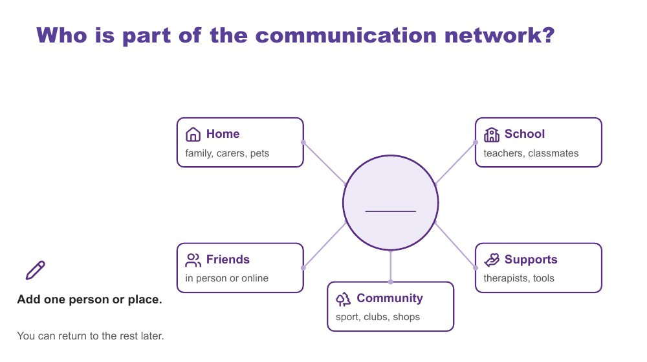 | Who is part of the communication network?  SUGGESTED TIME  3 min  CLOCK  11:25 - 11:28  GROUPING  Individual  WORKBOOK  Workbook - Who is part of the communication network?

Map the people and places in the young person's communication world, starting with one.
WHAT TO DO  - Ask participants to turn to "Who is part of the communication network?" in the Workbook.  - Allow about 1.5 minutes of quiet time to add one person or place. Offer to write for anyone who would like help.  - Share the points below while people write. | KEY MESSAGES  - Young people communicate with many people in many places, in person and online. Each person may see a different part of the communication picture.

YOU MIGHT SAY
Please turn to "Who is part of the communication network?" in your Workbook. Your young person is in the centre. Around them are home, school, friends, community and supports.
Think about who is part of your young person's communication network. Add one person or place now. You can return to the rest later.
You can write names, draw or use dot points.
You do not need to complete every box. A box can hold many people, one person, or nobody yet.
Different people may see different parts of your young person's communication. A grandparent, a coach, a teacher and a friend they game with online may each notice something different.
This activity is not about deciding who understands your young person best.
You can come back to this page with your young person, family members, educators or other communication partners.

ACTIVITY | Individual mapping individual · 3 minutes (about 1.5 minutes writing)
Add one person or place to your young person's communication network.
- Point to the network page in the Workbook.
- Give quiet writing time.
- Offer to scribe for anyone who wants help.
Close: Remind participants they can finish the page later, with their young person or others.

KEEP IN MIND
- Networks can be small or changing. Normalise empty boxes.
- The workbook belongs to the family. They decide what goes in it.
- In the secondary years, the network often includes several teachers, a year coordinator and friends online. Parents may not know everyone in it, and that is normal.

SESSION 3 | Communication, Connection and Managing Daily Capacity | SLIDE 7 of 21

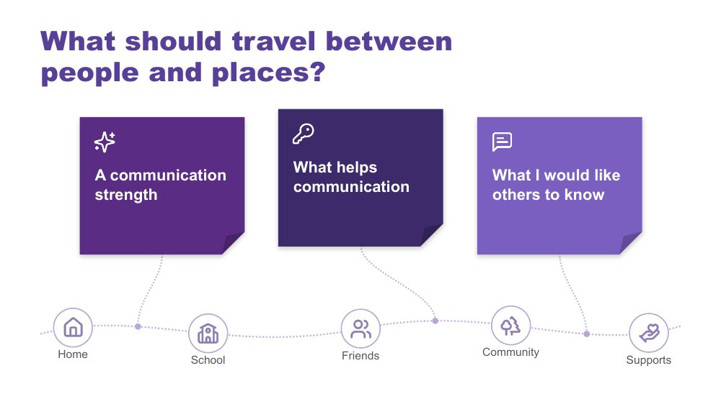 | What should travel between people and places?  SUGGESTED TIME  7 min  CLOCK  11:28 - 11:35  GROUPING  Individual, then whole room  WORKBOOK  Workbook - What should travel between people and places?

Identify the communication knowledge families hold that should travel with their young person between home, school and community.
WHAT TO DO  - Check purple, blue and orange Post-it notes are on each table and a wall or board space is ready, grouped by colour.  - Explain the three boxes, which match "What should travel between people and places?" in the Workbook.  - Allow about 3 minutes of writing, then about 4 minutes of optional sharing.  - Invite people to add a note to the board or read one out if they are comfortable.  - Notice themes on the blue notes. You will return to them on the next slide. | KEY MESSAGES  - Families hold valuable knowledge about communication. When that knowledge travels between home, school and community, young people do not have to start again with every new person.

YOU MIGHT SAY
Let's think about what should travel with your young person between people and places. The three colours match the three boxes in "What should travel between people and places?" in your Workbook.
Purple is a communication strength. Blue is something that helps communication. Orange is something you would like others to know.
You can write one note, two or all three. You can use your own young person or a made-up example. You can keep your notes private if you prefer.
If you are comfortable, add a note to the board or read one out.

ACTIVITY | Colour-coded Post-it notes with optional sharing individual, then whole room · 7 minutes (about 3 writing, about 4 sharing)
Purple: a communication strength. Blue: what helps communication. Orange: what I would like others to know.
- Writing: about 3 minutes.
- Sharing: about 4 minutes. Sharing is optional.
Bring the room back
- What similarities do you notice?
- What strengths might be missed if we look only for speech?
- Which supports change what other people do or provide?
- What information might help at school?
- Did another person's contribution prompt a new thought?
Close: Pick up the themes on the blue notes as you move into supporting communication.

KEEP IN MIND
- Do not ask individuals to share. Thank every contribution without ranking it.
- If a note names a young person or school, invite the writer to keep it.
- Many teenagers want a say in what is shared about them. Encourage parents to check with their young person what they are happy for others to know.

Thread The blue notes (what helps communication) lead into the three supports on the next slide.

SESSION 3 | Communication, Connection and Managing Daily Capacity | SLIDE 8 of 21

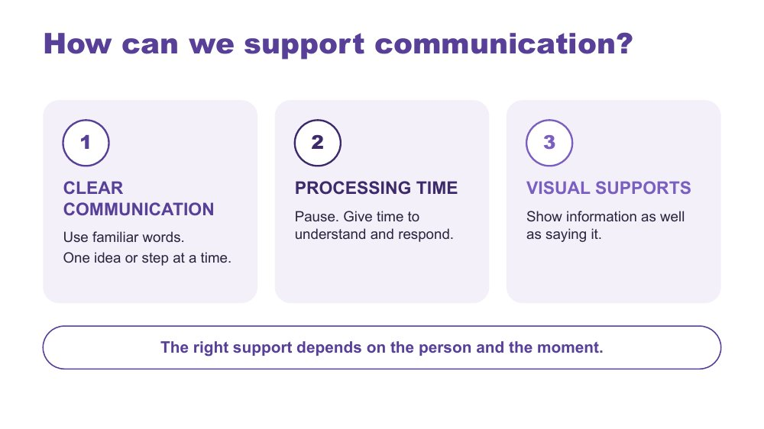 | How can we support communication?  SUGGESTED TIME  3 min  CLOCK  11:35 - 11:38

Introduce three ways to support communication in everyday life.
WHAT TO DO  - Name the three strategies on the slide.  - Link back to what participants wrote on the blue notes.  - Longer examples sit in the workbook. There is no activity on this slide. | KEY MESSAGES  - The right support depends on the person and the moment.

YOU MIGHT SAY
There are three strategies we can use. Clear communication means using familiar words and giving one idea or step at a time. Processing time means pausing so the person has time to understand and respond. Visual supports mean showing information as well as saying it. Let's look at what these can look like.

KEEP IN MIND
- These are options to match to the person, not a checklist or a guarantee.
- Keep AAC available and allow responses through the person's preferred methods, including refusal.
- Avoid filling every pause with more words.

Background Processing time is time to make sense of information, organise a response and communicate it. Clear communication means familiar, specific language in a form and amount the person can access. Communication partner guidance includes adapting language and allowing response time. AAC guidance also includes visual supports and access across settings (ASHA, n.d.; Brady et al., 2016).
RESOURCES
- ASHA AAC Practice Portal
- Brady et al. (2016)

SESSION 3 | Communication, Connection and Managing Daily Capacity | SLIDE 9 of 21

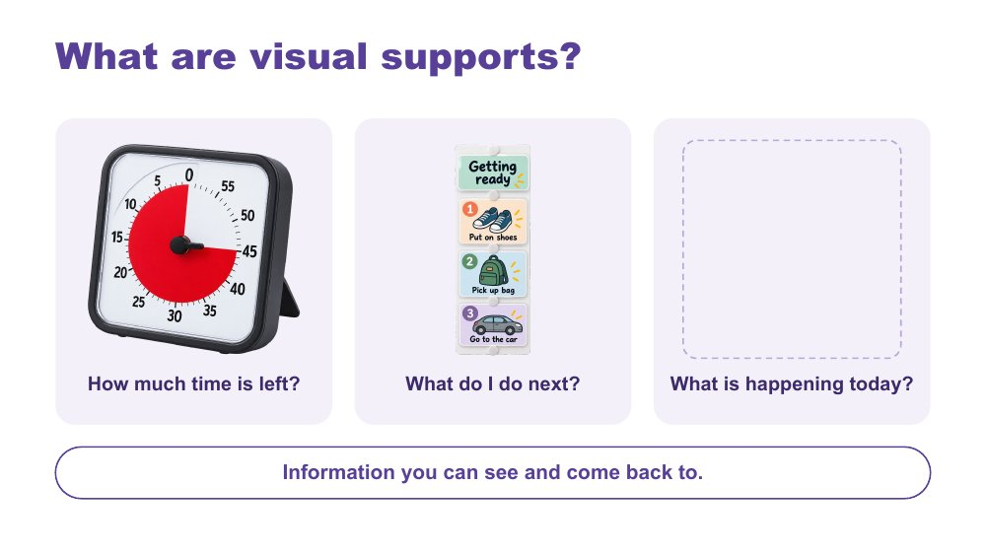 | What are visual supports?  SUGGESTED TIME  3 min  CLOCK  11:38 - 11:41  GROUPING  Whole room

Help parents recognise what visual supports are through familiar examples.
WHAT TO DO  - Walk through the three examples on the slide: timer, sequence, daily schedule.  - Connect to visual information participants already use themselves.  - If time allows, invite one brief example of visual information already used at home. This is an introduction, not another task to complete. | KEY MESSAGES  - Visual supports are information you can see and come back to.  - The useful format will be different for each person.

YOU MIGHT SAY
Visual supports help make information clear. They give us something to look at and come back to. This timer shows how much time is left. A sequence shows what to do next. A daily schedule shows what is happening today.
You might already use a calendar, shopping list or reminder on your phone. Many teenagers use their phone, a planner or the school's online portal in the same way. The useful format will be different for each person.
What visual information do you already use at home?

ACTIVITY | Optional brief sharing whole room · 1 minute
What visual information do you already use at home?
- Invite one brief example.
- Ask what made the visual helpful in that situation.
Close: Name clear language, processing time and visuals as ways of making a message easier to understand.

KEEP IN MIND
- A visual support offers information, not a condition for access to a preferred activity.
- Match the format to the person and invite their preferences. Avoid evaluating or prescribing a particular visual system.
- Visual supports and AAC can overlap, but they are not interchangeable. Keep the person's communication methods available.

Background Visual supports can include objects, real photos, written words or symbols, on paper or a device. Check that the person understands the information and can access it when needed. The written sequence is an example of accessible information, not a test of compliance. The images illustrate formats, not recommended products. Avery et al. (2025) reviews caregiver-implemented visual supports for people with developmental disabilities. ASHA's AAC Practice Portal describes visual schedules and other visual supports. Use this evidence to explain options, not to promise the same result for every person.
RESOURCES
- Avery et al. (2025)
- ASHA AAC Practice Portal

SESSION 3 | Communication, Connection and Managing Daily Capacity | SLIDE 10 of 21

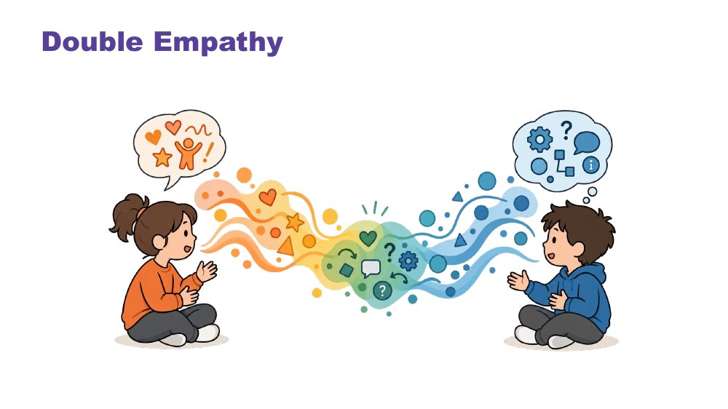 | Double Empathy  SUGGESTED TIME  3 min  CLOCK  11:41 - 11:44

Introduce connection as two-way: misunderstandings between people with different ways of experiencing and communicating happen in both directions.
WHAT TO DO  - Introduce the connection section and the double empathy idea.  - Use the image on the slide: two people with a stream of colour and symbols between them, each sending and receiving in their own way.  - Explain that misunderstandings can occur in both directions when people have different experiences or communication styles.  - Ask participants to keep this two-way frame in mind as the section moves into social interaction. | KEY MESSAGES  - Understanding is a shared responsibility.  - Connection can become easier when both people adjust and seek to understand.

YOU MIGHT SAY
When two people communicate differently, misunderstandings can happen on both sides. Often only one side gets the blame. Double empathy asks us to see it as a two-way gap that both people can work to bridge.
Many of you will already do this at home. You have learnt your young person's way of communicating, and they have learnt yours.

KEEP IN MIND
- Avoid locating all responsibility for the misunderstanding in the Autistic person.

Background The double empathy idea was put forward by Autistic researcher Damian Milton. It describes breakdowns in understanding between Autistic and non-Autistic people as a mutual problem arising from different ways of experiencing the world, rather than a deficit in the Autistic person.

SESSION 3 | Communication, Connection and Managing Daily Capacity | SLIDE 11 of 21

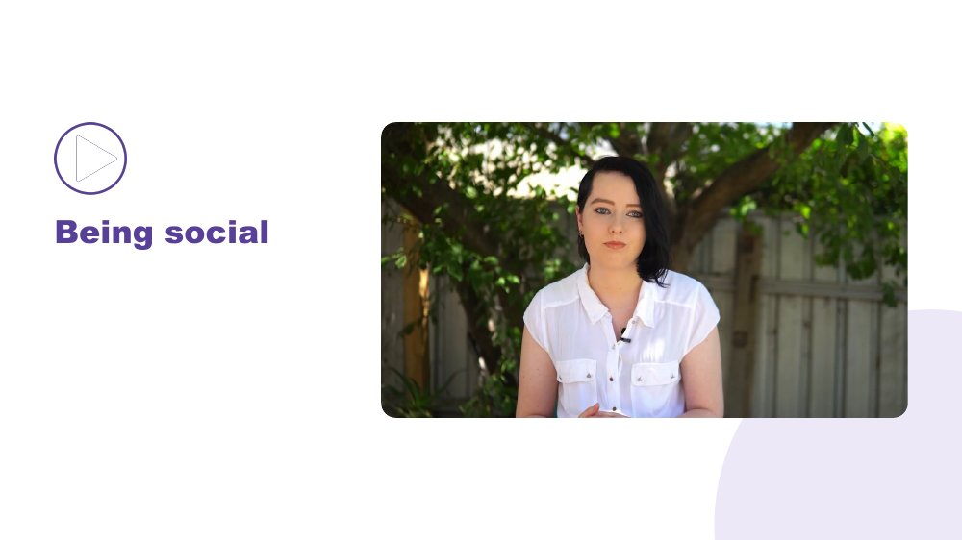 | Being social  SUGGESTED TIME  4 min  CLOCK  11:44 - 11:48

Share a first-person account of social interaction and connection.
WHAT TO DO  - Introduce the clip as one person's experience of being social.  - Check captions are on, then play the video.  - Allow a quiet pause before asking what participants noticed.  - Take one or two responses. | KEY MESSAGES  - Connection looks different for different people.

YOU MIGHT SAY
This is one person's experience of being social. As you watch, think about your own young person.

KEEP IN MIND
- Do not generalise the account to all Autistic people.

Thread Another point in the day where Autistic voices lead.

SESSION 3 | Communication, Connection and Managing Daily Capacity | SLIDE 12 of 21

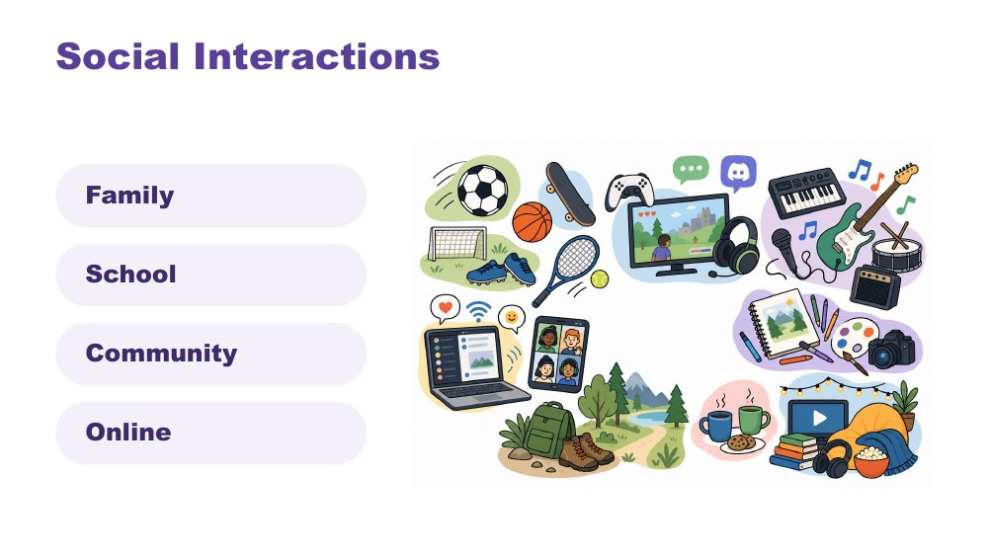 | Social Interactions  SUGGESTED TIME  2 min  CLOCK  11:48 - 11:50

Widen the picture of what social interaction can look like across family, school, community and online.
WHAT TO DO  - Name the four settings on the slide: family, school, community and online.  - Identify a range of ways a young person may interact, for example one-on-one, doing things alongside others such as gaming together, info dumping (sharing a lot about an interest), group chats and online communities, and irregular contact.  - Make connections to culture: families and communities have their own ways of being together.  - Invite participants to think of the forms of connection their young person already has. | KEY MESSAGES  - Connection can happen through conversation, shared interests, activity, quiet presence or online interaction.  - The most useful question is not whether a young person is social enough, but what kinds of connection work for them.

KEEP IN MIND
- Avoid framing any one form of interaction as the goal.
- Online connection can be real and important connection for many Autistic young people. Avoid treating it as less valid than time spent in person.

SESSION 3 | Communication, Connection and Managing Daily Capacity | SLIDE 13 of 21

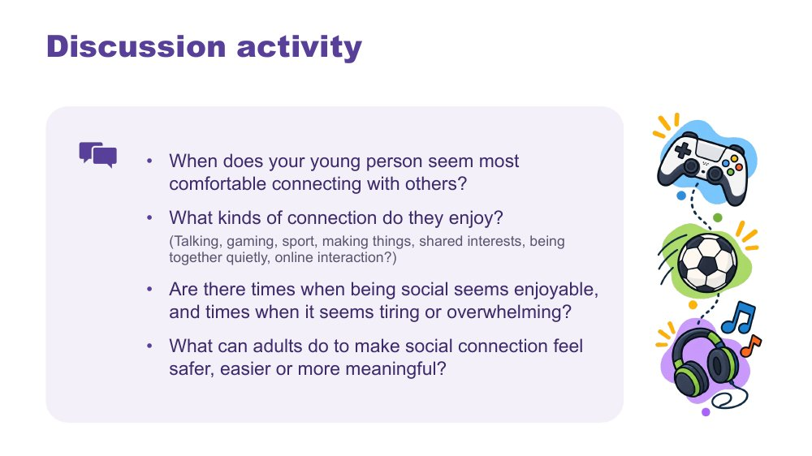 | Discussion activity: connection  SUGGESTED TIME  5 min  CLOCK  11:50 - 11:55  GROUPING  Tables  WORKBOOK  Workbook - Connection discussion

Explore the forms and conditions of connection the young person enjoys, and what adults can change.
WHAT TO DO  - Offer the examples on the slide: talking, gaming, sport, making things, shared interests, being together quietly and online interaction.  - Invite table discussion or private reflection.  - Take a small number of examples and keep the focus on the young person's preferences. | KEY MESSAGES  - Adults can change conditions around the young person.

ACTIVITY | Discussion or private reflection tables · 5 minutes
When does your young person seem most comfortable connecting with others?
- What kinds of connection do they enjoy?
- Are there times when being social seems enjoyable, and times when it seems tiring or overwhelming?
- What can adults do to make social connection feel safer, easier or more meaningful?
Close: Name that meaningful connection may look different across people, places and days.

KEEP IN MIND
- Some young people have few connections right now, and friendships can be hard in the teenage years. Keep the tone free of comparison.

SESSION 3 | Communication, Connection and Managing Daily Capacity | SLIDE 14 of 21

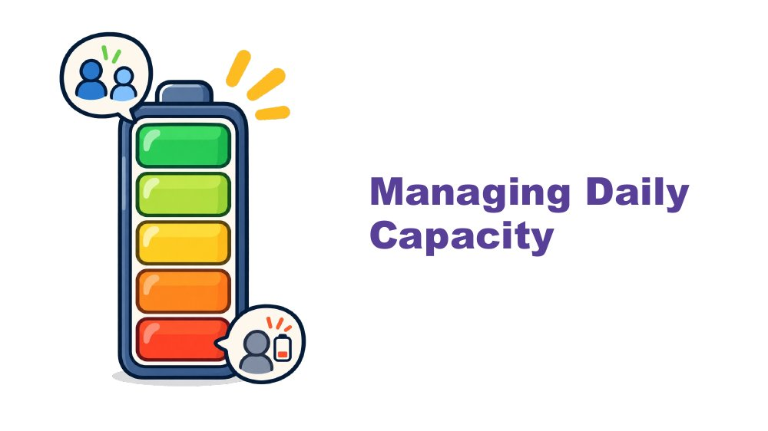 | Managing Daily Capacity  SUGGESTED TIME  1 min  CLOCK  11:55 - 11:56

Open the section on energy and changing capacity.
WHAT TO DO
- Name the section and link it to the connection discussion: being social can be enjoyable and tiring at the same time.

SESSION 3 | Communication, Connection and Managing Daily Capacity | SLIDE 15 of 21

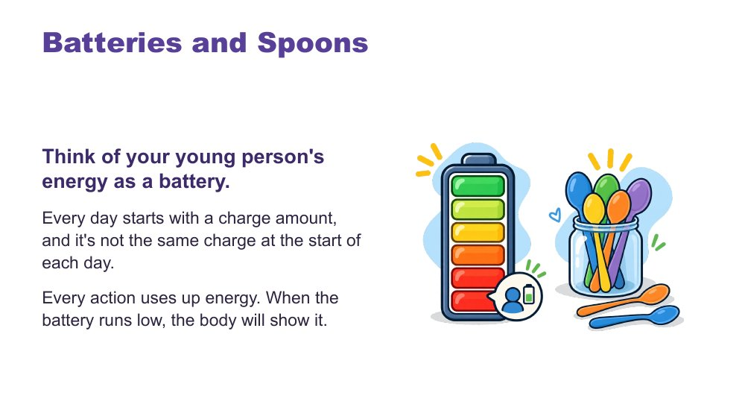 | Batteries and Spoons  SUGGESTED TIME  3 min  CLOCK  11:56 - 11:59

Introduce the battery and spoon analogies as practical ways to describe changing energy.
WHAT TO DO  - Read the slide text.  - Introduce the spoons idea used in the Autistic community.  - Finish on recharging: the right supports can restore some charge. | KEY MESSAGES  - Capacity is not the same every day.  - Every action uses up energy, and energy can be recharged.

YOU MIGHT SAY
Think of your young person's energy as a battery. Every day starts with a charge amount, and it's not the same charge at the start of each day. Every action uses up energy. When the battery runs low, the body will show it.
In the Autistic community, many like to describe this as having a set of spoons. Each action uses up one or some spoons. When spoons are low, actions are hard to manage.
You can recharge! The right supports can regain some battery charge or extra spoons.

KEEP IN MIND
- Present both analogies as optional ways to describe capacity, not measures of ability.

Thread The battery returns in Session 4 (the after-school crash and your own battery).

SESSION 3 | Communication, Connection and Managing Daily Capacity | SLIDE 16 of 21

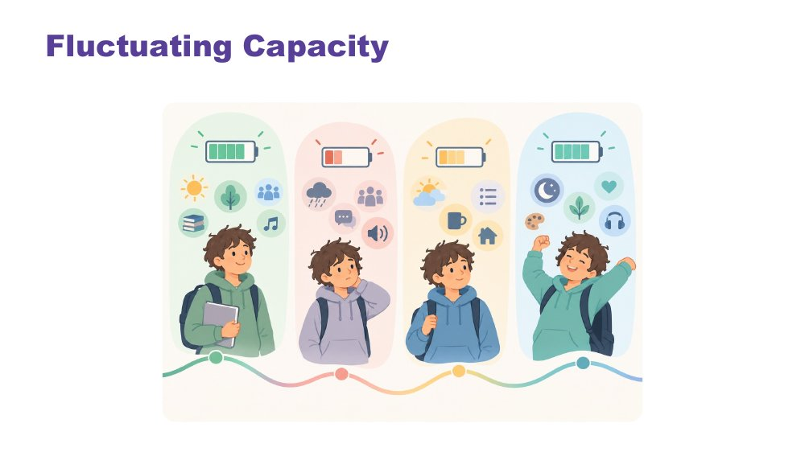 | Fluctuating Capacity  SUGGESTED TIME  2 min  CLOCK  11:59 - 12:01

Show that capacity changes from day to day and within a day.
WHAT TO DO  - Use the image to show battery levels changing across a day and across days.  - Invite participants to notice what costs their young person energy and what lightens the load. | KEY MESSAGES  - A demand may be manageable on one day and too much on another.  - Understanding load helps adults plan support without treating fluctuation as unwillingness.

YOU MIGHT SAY
Like all people, Autistic young people have good days and harder days. Their ability to manage school, social situations, communication, or daily tasks may change depending on stress, energy levels, sensory demands, and what else is happening in their life. In the secondary years, a timetable with several teachers, assessment due dates and friendships can all add to the load.

SESSION 3 | Communication, Connection and Managing Daily Capacity | SLIDE 17 of 21

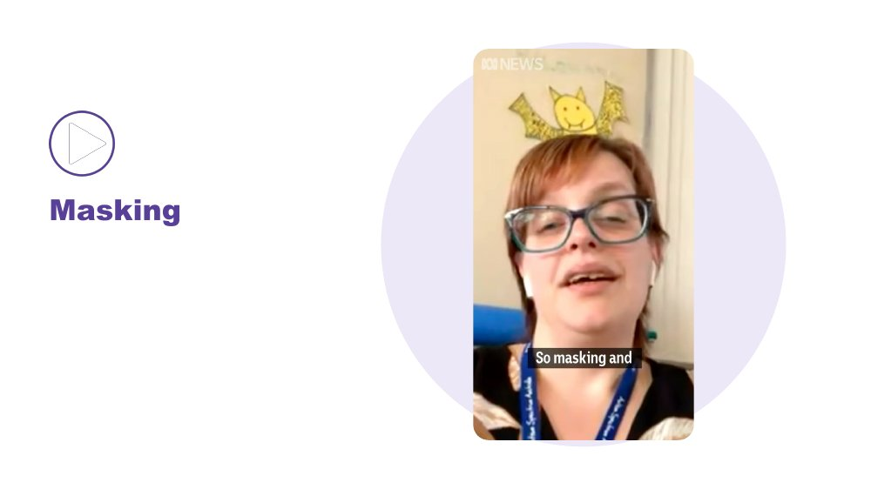 | Masking  SUGGESTED TIME  3 min  CLOCK  12:01 - 12:04

Introduce masking through a first-person account.
WHAT TO DO
- Link masking to batteries and spoons.
- Check captions are on, then play the video.
- Allow a moment of quiet afterwards.

YOU MIGHT SAY
There are other things that can impact our batteries or spoons. Let's watch a video about masking.

KEEP IN MIND
- Let the speaker's account lead. Do not generalise it to every Autistic young person.

SESSION 3 | Communication, Connection and Managing Daily Capacity | SLIDE 18 of 21

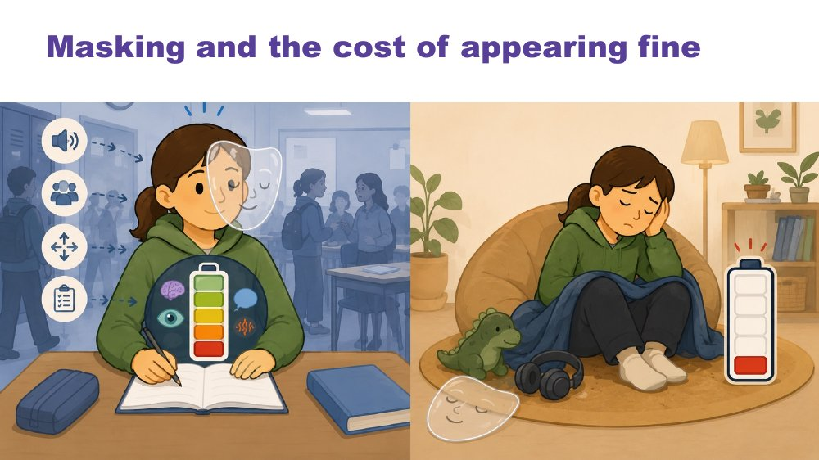 | Masking and the cost of appearing fine  SUGGESTED TIME  1 min  CLOCK  12:04 - 12:05

Contrast what others may see with what the young person may be carrying afterwards.
WHAT TO DO  - Describe the image: on the left the young person is managing at school, on the right the same young person at home with an empty battery.  - Name the effort that can sit behind appearing fine. | KEY MESSAGES  - Appearing fine does not always show the effort or load underneath.  - Changes to the environment may reduce the effort required.

Thread This sets up masking in the teenage years on the next slide, and the after-school crash in Session 4.

SESSION 3 | Communication, Connection and Managing Daily Capacity | SLIDE 19 of 21

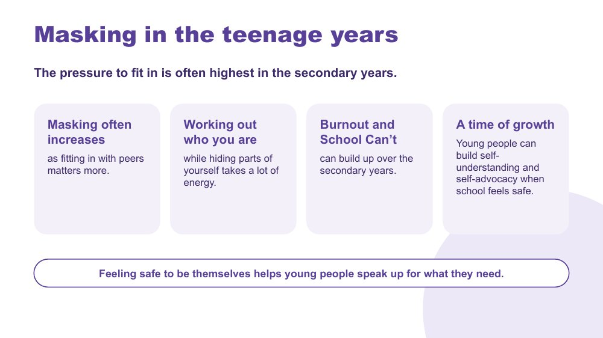 | Masking in the teenage years  SUGGESTED TIME  3 min  CLOCK  12:05 - 12:08

Explain why masking often increases in the secondary years, what it can cost, and what helps young people feel safe to be themselves.
WHAT TO DO  - Connect back to the masking video and the previous slide: same idea, and often higher stakes in the secondary years.  - Walk through the four points on the slide: masking often increases, working out who you are, burnout and School Can't, and a time of growth.  - Explain that fitting in with peers often matters more in the teenage years, and that working out who you are while hiding parts of yourself takes a lot of energy.  - Name burnout and School Can't plainly and without alarm. Let participants know they come back in Session 4.  - Finish on the hopeful point: when school and home feel safe, the secondary years can be a time of real growth in self-understanding and self-advocacy. | KEY MESSAGES  - The pressure to fit in is often highest in the secondary years.  - Masking often increases as fitting in with peers matters more.  - Working out who you are while hiding parts of yourself takes a lot of energy.  - Burnout and School Can't can build up over the secondary years.  - Feeling safe to be themselves helps young people speak up for what they need.

KEEP IN MIND
- This can be a heavy slide for families whose young person is currently in burnout or not attending school. Keep a steady pace, speak with respect and do not suggest anyone has caused it.
- Stay within what the workshop covers. If a parent raises mental health concerns, acknowledge them and suggest talking with their GP or another health professional.
- If a parent describes a young person in crisis, give them the support lines at the break (Kids Helpline 1800 55 1800, headspace at headspace.org.au, Lifeline 13 11 14; also on Session 5, slide 14) and follow up with them privately.

Thread Burnout and School Can't are developed in Session 4. Self-advocacy and young people taking part in their own meetings return in Session 5.

SESSION 3 | Communication, Connection and Managing Daily Capacity | SLIDE 20 of 21

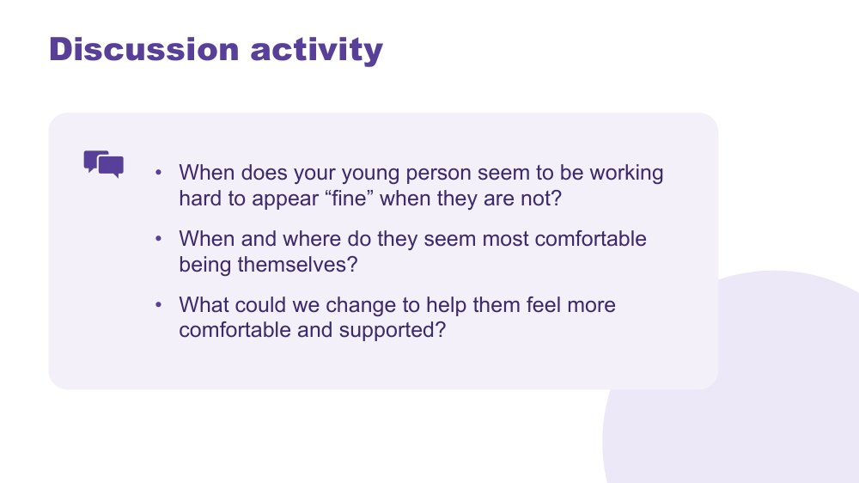 | Discussion activity: masking  SUGGESTED TIME  4 min  CLOCK  12:08 - 12:12  GROUPING  Individual, then tables  WORKBOOK  Workbook - Masking discussion

Consider where the young person works hard to appear fine, where they feel safest to be themselves, and what adults could change.
WHAT TO DO  - Give private thinking time before inviting discussion.  - Invite one practical change where participants are ready to share. | KEY MESSAGES  - Safety can look like having less need to perform or hide parts of oneself.

ACTIVITY | Private thinking, then discussion individual, then tables · 4 minutes
When does your young person seem to be working hard to appear "fine" when they are not?
- When and where do they seem most comfortable being themselves?
- What could we change to help them feel more comfortable and supported?
Close: Connect this discussion to the next slide by naming the value of knowing and being valued for who you are.

KEEP IN MIND
- Keep examples descriptive and avoid asking participants to prove that masking is occurring.
- Some parents may realise their young person has been masking for a long time. Acknowledge this gently and without blame.

SESSION 3 | Communication, Connection and Managing Daily Capacity | SLIDE 21 of 21

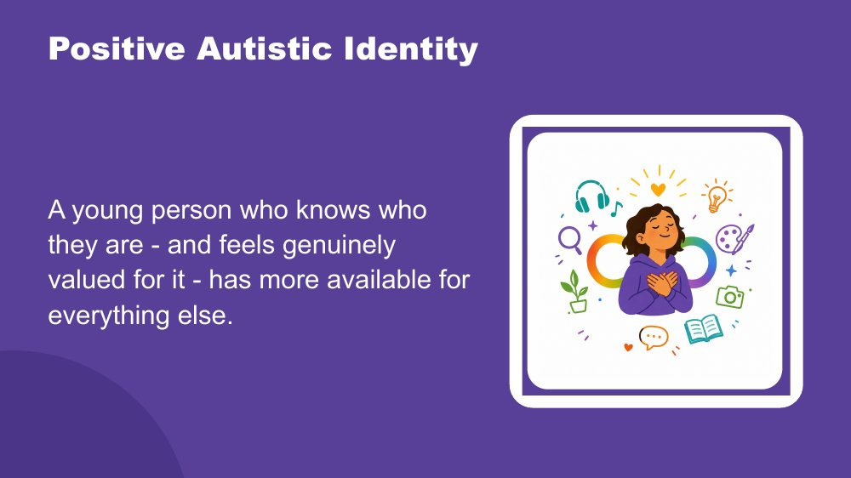 | Positive Autistic Identity  SUGGESTED TIME  3 min  CLOCK  12:12 - 12:15

Close Sessions 2 and 3 by bringing the separate lenses back to the whole young person, then break for lunch.
WHAT TO DO  - This is the closing slide of the morning. Deliver the close slowly, with purpose. Let the room settle before you begin.  - Read the opening paragraph slowly. It names everything the morning covered as one coherent picture, so parents can make the connections themselves.  - Leave the final sentence in the room.  - Pause. Let it land. Do not fill the silence.  - Then break for lunch. | KEY MESSAGES  - The cost is not just masking. It is managing the whole architecture of Autistic experience in a world not designed for it.  - Positive Autistic identity is a research-supported protective factor for mental health and wellbeing.  - Belonging is the precondition. When identity does not need to be managed on top of everything else, those resources become available for learning and connection.  - Agency is protective. Genuine choice over their own environment reduces cost directly.  - Autistic community connection is itself protective. Knowing other Autistic people share your experience matters.  - These are not extras. They are the conditions under which everything else becomes possible.

YOU MIGHT SAY
This morning, across Sessions 2 and 3, you have been building a picture of your young person.
How the world arrives through their senses, more fully, more specifically, less filtered. How their brain builds understanding from the detail up, focuses deeply, and thinks in ways that produce real and specific strengths. How their internal world works. How they reach toward other people, and what that costs when the conditions are not designed for them.
Managing all of that, every day, in a world that was largely built for a different nervous system, takes resources. Sensory management. Social interpretation. Executive effort. Communication across a gap. Holding it together when the signals inside are not arriving clearly. And sometimes, performing fine when fine is not what is happening.
A young person who knows who they are, and feels genuinely valued for it, has more of those resources available for everything else.
Research suggests what many Autistic adults describe: a positive sense of Autistic identity is linked with better mental health and wellbeing (Cooper, Smith and Russell, 2017; Corden, Brewer and Cage, 2021). Belonging is the precondition for all of it. When a young person does not need to spend resources managing their identity on top of everything else, those resources become available for learning, connection, and self-knowledge.
Agency matters too: genuine choice over how they communicate, where they sit, when they step back. And knowing that other Autistic people share their experience, that Autistic adults have found belonging and purpose, is protective in its own right.
Your young person is not alone in this. They are part of something.
The deepest thing you can do is support them to know themselves, and to know that who they are is worth knowing.

KEEP IN MIND
- Some parents will need a moment. That is the right outcome. Do not rush to lunch.

Background Research suggests that positive Autistic identity, knowing yourself as Autistic and valuing that, is associated with better mental health outcomes, reduced anxiety, and greater resilience. See Cooper, Smith and Russell (2017); Corden, Brewer and Cage (2021). This is distinct from general self-esteem. It is specifically the sense of Autistic identity as something to know and value, not manage or minimise, that provides protection. Belonging to Autistic peer networks may strengthen this effect. The goal is not for your young person to fit in. The goal is for your young person to know who they are, and to find the people and places where that is valued. The phrase "managing all of that, every day, in a world largely built for a different nervous system" names the real cost honestly without being too heavy. It is not about what is wrong with the world. It is about what is true, and what follows from that truth.
Thread This slide returns to the young person the room has been thinking about all morning, now seen with a much fuller picture: not a list of differences or difficulties, but a whole person whose experience makes sense when you understand what sits underneath. It echoes the coming-into-focus image that opened Session 2. The facilitator does not need to name this; the room will feel it.

SESSION  4 | 12:45 - 1:30 · 45 MINUTES · 14 SLIDES  Home and Community

SESSION INTENT
Use the morning's understanding for practical support at home in the teenage years. Parents and carers look at distress, overwhelm, burnout and School Can't as signs of unmet need and overload, then consider co-regulation, the after-school crash, homework and assessment, interests, growing independence, sleep and screens and their own capacity, finishing by sharing what works in their own homes.
PARTICIPANTS LEAVE WITH
- Describe distress, shutdown and meltdown as responses to overwhelm and unmet need, not choices.
- Recognise Autistic burnout and School Can't as signs of long-term overload.
- Name ways to help in the moment, including reducing input and co-regulation.
- Plan recovery after school and practical support for homework and assessment at home.
- Choose one small, supported step towards independence for their young person.
- Identify one practical idea to try at home, including one that looks after their own capacity.

RUN SHEET
Clock | Segment | Slides | Minutes
12:45 - 12:46 | Welcome back from lunch | 1 | 1
12:46 - 12:57 | Distress, overwhelm, burnout and School Can't, and what helps in the moment | 2-5 | 11
12:57 - 1:03 | Co-regulation and the after-school crash | 6-7 | 6
1:03 - 1:08 | Homework and assessment, and interests | 8-9 | 5
1:08 - 1:13 | Growing independence, sleep and screens | 10-11 | 5
1:13 - 1:20 | One step towards independence (activity) | 12 | 7
1:20 - 1:22 | Your own battery | 13 | 2
1:22 - 1:30 | Sharing what works and link to Session 5 | 14 | 8

PREPARE
☐ Participant Workbooks and pens on each table.
☐ Tables set for small-group sharing (slides 12 and 14).
☐ A visible timer for the two table activities (slides 12 and 14).
☐ Quiet space available: burnout and School Can't may be raised and some parents may need a moment.
☐ Information ready on where families can find further support, to give at a break if someone raises a current crisis.

SESSION 4 | Home and Community | SLIDE 1 of 14

 | Home and Community  SUGGESTED TIME  1 min  CLOCK  12:45 - 12:46

Welcome participants back from lunch and set the practical focus for the afternoon.
WHAT TO DO  - Welcome participants back from lunch.  - Name the shift from understanding Autistic experience this morning to everyday support at home and in the community.  - Explain that the ideas in this session are prompts for family judgement, not a single model of home life with a teenager.  - Invite participants to take what is workable for their young person and family and leave the rest. | KEY MESSAGES  - Home and community supports need to fit the real family.  - A practical plan begins with the young person's capacity, preferences and context, and gives them a say.

YOU MIGHT SAY
This morning was about understanding. This afternoon is about what that means for everyday life with a teenager. You know your family best, so take what fits and leave what doesn't.

Thread The afternoon builds on the batteries, spoons and masking content from Session 3.

SESSION 4 | Home and Community | SLIDE 2 of 14

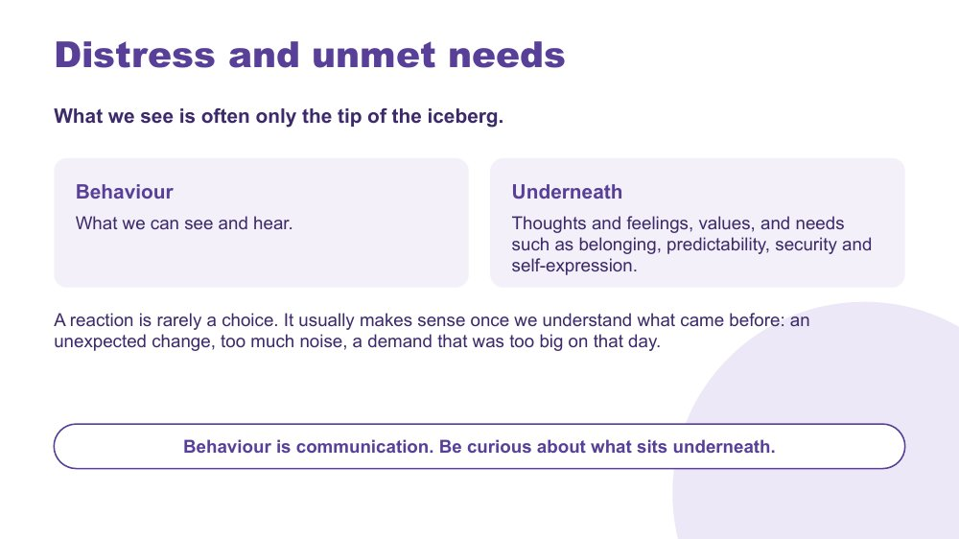 | Distress and unmet needs  SUGGESTED TIME  3 min  CLOCK  12:46 - 12:49

Frame distress as communication about needs, using the iceberg: what we see sits on top of feelings, values and needs.
WHAT TO DO  - Walk through the iceberg: behaviour is what we can see and hear; underneath are thoughts and feelings, values, and needs such as belonging, predictability, security and self-expression.  - Give a home example of what might come before a reaction: an unexpected change, too much noise, a demand that was too big on that day.  - Invite participants to think of a recent hard moment and what might have been underneath it. This is private thinking, not sharing. | KEY MESSAGES  - A reaction is rarely a choice. It usually makes sense once we understand what came before.  - Behaviour is communication. Be curious about what sits underneath.

YOU MIGHT SAY
What we see is often only the tip of the iceberg. Underneath are thoughts, feelings and needs we can't see straight away.
When we look back at what came before, a hard moment often starts to make sense. A change of plan, a long day of different teachers and rooms, a request that would be fine on another day.

KEEP IN MIND
- Some families are living with a lot of distress at home right now. Keep the tone free of blame for the young person or the parent.
- With teenagers, distress can look like anger, slammed doors or withdrawal. Keep the same curiosity about what sits underneath.
- Link back to the batteries and spoons from Session 3 rather than introducing new theory.

SESSION 4 | Home and Community | SLIDE 3 of 14

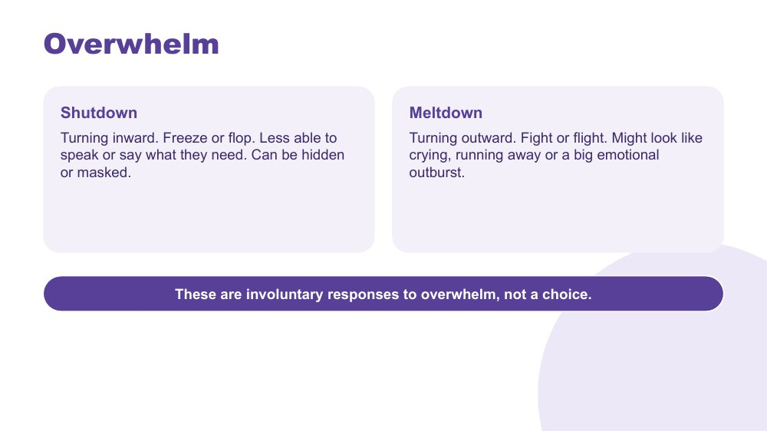 | Overwhelm  SUGGESTED TIME  2 min  CLOCK  12:49 - 12:51

Describe shutdown and meltdown as involuntary responses to overwhelm.
WHAT TO DO  - Explain shutdown: turning inward. Freeze or flop. Less able to speak or say what they need. It can be hidden or masked.  - Explain meltdown: turning outward. Fight or flight. It might look like crying, running away or a big emotional outburst.  - Point out that a shutdown can be easy to miss, especially if the young person is quiet, masking or goes to their room. | KEY MESSAGES  - Shutdowns and meltdowns are involuntary responses to overwhelm, not a choice.

YOU MIGHT SAY
Shutdown and meltdown are both what can happen when a young person's system is overwhelmed. One turns inward, one turns outward. Neither is a choice.
A shutdown can be quiet. A young person might go still, stop talking or disappear into their room. It can be easy to miss.

KEEP IN MIND
- Avoid describing meltdowns as tantrums, attitude or something the young person can stop on request.
- Parents may recognise hard experiences here, including meltdowns that feel bigger now their young person is physically bigger. Allow a pause and keep moving gently.

Thread Links to masking in the teenage years in Session 3: a young person who masks may shut down rather than melt down, and it may not show until later.

SESSION 4 | Home and Community | SLIDE 4 of 14

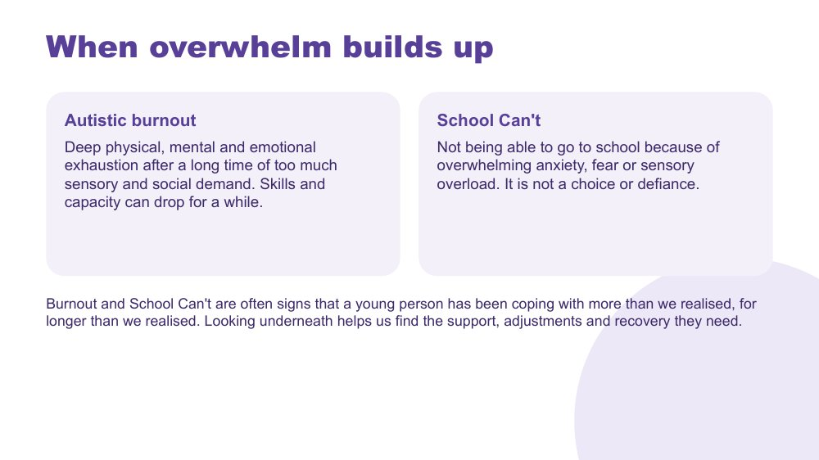 | When overwhelm builds up  SUGGESTED TIME  3 min  CLOCK  12:51 - 12:54

Explain Autistic burnout and School Can't as signs of long-term overload, not choice or defiance.
WHAT TO DO  - Explain Autistic burnout: deep physical, mental and emotional exhaustion after a long time of too much sensory and social demand. Skills and capacity can drop for a while.  - Explain School Can't: not being able to go to school because of overwhelming anxiety, fear or sensory overload. It is not a choice or defiance.  - Read the closing line on the slide. | KEY MESSAGES  - Burnout and School Can't are often signs that a young person has been coping with more than we realised, for longer than we realised.  - Looking underneath helps us find the support, adjustments and recovery they need.

YOU MIGHT SAY
Sometimes overwhelm doesn't come and go. It builds up over weeks or months, and the secondary years can add a lot: more teachers, more rooms, more homework, more going on with friends.
If your young person has lost skills they had, or can't get through the school gate, it is not because they aren't trying. It usually means they have been carrying too much for too long.

KEEP IN MIND
- Some families in the room may be in the middle of burnout or School Can't right now. Acknowledge how hard this is. Do not offer individual advice in the room; offer to talk at a break.
- Avoid 'school refusal' language, which suggests choice.
- Session 5 covers working with school. Point there rather than opening a school discussion now.
- If a parent describes a young person in crisis, give them the support lines at the break (Kids Helpline 1800 55 1800, headspace at headspace.org.au, Lifeline 13 11 14; also on Session 5, slide 14) and follow up with them privately.

SESSION 4 | Home and Community | SLIDE 5 of 14

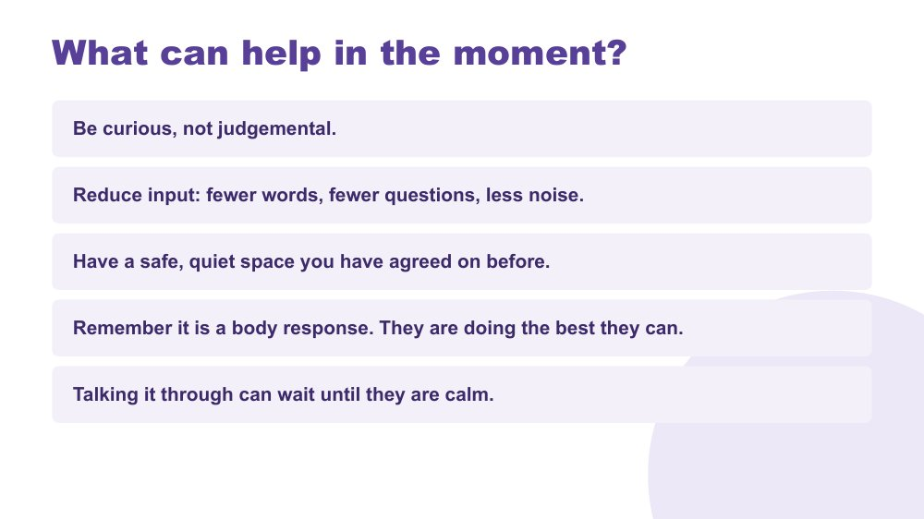 | What can help in the moment?  SUGGESTED TIME  3 min  CLOCK  12:54 - 12:57  WORKBOOK  Workbook - My young person's signs and what helps

Give practical ways to respond during overwhelm.
WHAT TO DO  - Walk through the five points on the slide.  - Emphasise reducing input: fewer words, fewer questions, less noise.  - Explain that a safe, quiet space works best when it has been agreed before, when everyone is calm. With a teenager, work it out together.  - Remind participants that talking it through can wait until the young person is calm. | KEY MESSAGES  - Be curious, not judgemental.  - It is a body response. They are doing the best they can.

YOU MIGHT SAY
In the moment, try fewer words, fewer questions and less noise.
The talking can come later. Once your young person is calm, that's the time to understand what happened, if they want to.

KEEP IN MIND
- Present these as options, not a script. Parents know what calms their own young person.
- Acknowledge that it is hard to stay calm when your young person is distressed. That leads into the next slide.

SESSION 4 | Home and Community | SLIDE 6 of 14

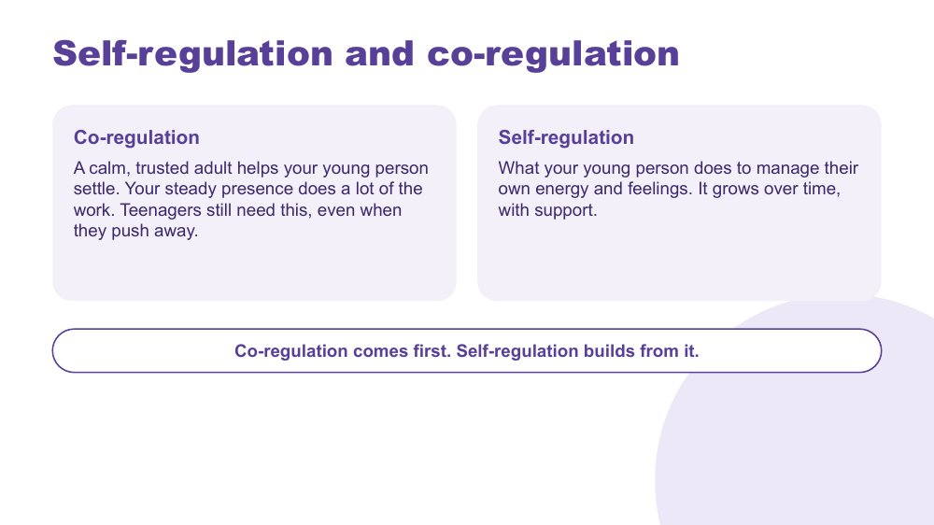 | Self-regulation and co-regulation  SUGGESTED TIME  2 min  CLOCK  12:57 - 12:59

Explain co-regulation as the foundation self-regulation grows from, and that teenagers still need it.
WHAT TO DO  - Explain co-regulation: a calm, trusted adult helps your young person settle. Your steady presence does a lot of the work.  - Point out that teenagers still need this, even when they push away. It may look different: sitting nearby, a drive, a quiet cup of tea.  - Explain self-regulation: what your young person does to manage their own energy and feelings. It grows over time, with support.  - Read the closing line. | KEY MESSAGES  - Co-regulation comes first. Self-regulation builds from it.  - Teenagers still need co-regulation, even when they push away.

YOU MIGHT SAY
Young people learn to settle with the help of a calm adult nearby. Your calm presence does a lot of the work, even when you don't say anything, and even when they tell you to go away.

KEEP IN MIND
- Some parents will hear this as pressure to always be calm. Say plainly that nobody manages this every time.
- Respect the teenager's need for space. Co-regulation can be quiet and nearby rather than close and talking.

Thread Your own capacity to co-regulate comes back on slide 13, Your own battery counts.

SESSION 4 | Home and Community | SLIDE 7 of 14

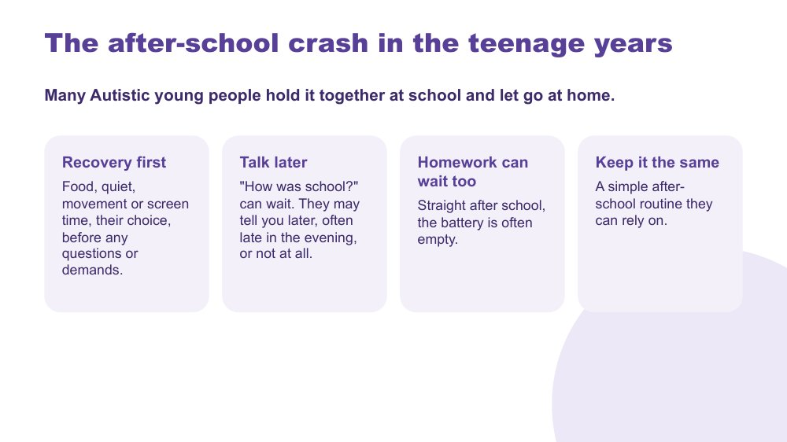 | The after-school crash in the teenage years  SUGGESTED TIME  4 min  CLOCK  12:59 - 1:03

Help participants recognise the after-school crash in the teenage years and plan recovery as part of the family routine.
WHAT TO DO  - Link to masking and the battery from Session 3: many Autistic young people hold it together at school and let go at home.  - Walk through the four ideas: recovery first, talk later, homework can wait too, keep it the same.  - Point out that in the teenage years the crash often gets bigger, not smaller: a longer day, more people and more masking.  - Invite participants to think privately about what changes they notice after school and what helps their young person recover. | KEY MESSAGES  - What happens after school can tell us about the load of the day.  - Recovery time can be a regular part of the family routine that does not have to be earned.  - A quiet car ride or time alone in their room is often part of how a young person recovers.

YOU MIGHT SAY
If your young person comes home and falls apart, or goes straight to their room, it doesn't mean home is the problem. Often it means home is where they feel safe enough to let go.
Recovery comes first. Food, quiet, movement or screen time, their choice, before questions or demands. They may tell you about their day later, often late in the evening, or not at all. That is okay.

KEEP IN MIND
- Introduce this as a pattern some families recognise, without assuming it applies to every young person.
- Some parents may have been told by school that their young person is fine at school. Acknowledge that both can be true.
- Parents who miss connection may hear this as 'leave them alone'. Name that connection in the teenage years often comes sideways: the late-night chat, a shared game, a drive.
- If withdrawal never eases or a parent is worried about their young person's wellbeing, offer to talk at a break about where to get support.

Thread Builds on masking in Session 3. What families see after school can be useful to share with school in Session 5.

SESSION 4 | Home and Community | SLIDE 8 of 14

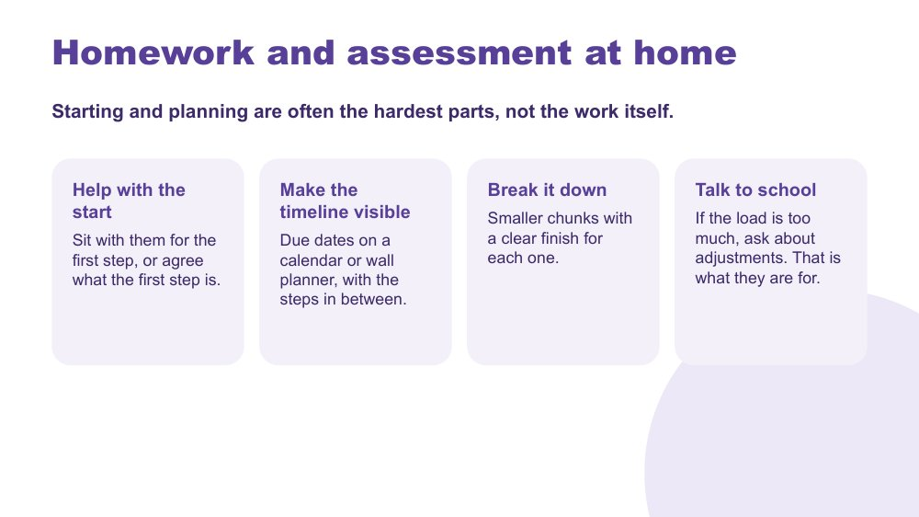 | Homework and assessment at home  SUGGESTED TIME  3 min  CLOCK  1:03 - 1:06

Give families practical ways to support homework and assessment without taking it over.
WHAT TO DO  - Read the opening line: starting and planning are often the hardest parts, not the work itself.  - Walk through the four ideas: help with the start, make the timeline visible, break it down, talk to school.  - Explain that sitting nearby while they start, doing your own thing, can make starting easier.  - Point out the last idea: if the load is too much, that is a conversation with school about adjustments, not a discipline problem at home. | KEY MESSAGES  - Starting and planning are often the hardest parts, not the work itself.  - You can help with the start, the timeline and the planning while the work stays theirs.  - If every task is a battle, the load may be wrong. Ask school about adjustments. That is what they are for.

YOU MIGHT SAY
A wall planner with due dates can take the place of asking every night.
Agree when homework happens, after recovery, and where it works best for them. Then keep it steady.

KEEP IN MIND
- Some parents are currently doing a lot of their young person's planning and organising, often at real cost. Acknowledge the care in that, and offer small ways to step back over time.
- Keep this to what helps at home. Adjustments and assessment arrangements are covered in Session 5.

Thread Links to executive functioning in Session 2 and leads to adjustments and Who to contact for what in Session 5.

SESSION 4 | Home and Community | SLIDE 9 of 14

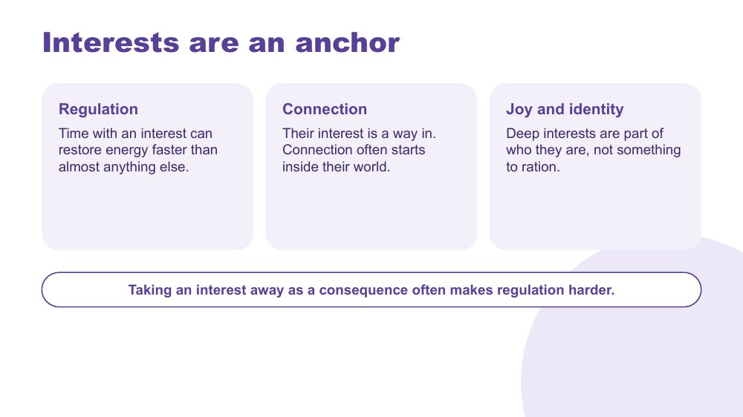 | Interests are an anchor  SUGGESTED TIME  2 min  CLOCK  1:06 - 1:08

Position deep interests as sources of regulation, connection, joy and identity in the teenage years.
WHAT TO DO  - Name the three ideas on the slide: regulation, connection, and joy and identity.  - Point out that for many teenagers, an interest is also where their people are, including online communities built on a shared interest.  - Read the line at the bottom about taking interests away as a consequence. | KEY MESSAGES  - Deep interests are part of who a young person is, not something to ration.  - Taking an interest away as a consequence often makes regulation harder.

YOU MIGHT SAY
Time with an interest can restore energy faster than almost anything else. It is also a way into your young person's world. You don't have to be good at their game to sit with them while they play.

KEEP IN MIND
- Avoid treating interests only as rewards or leverage.
- Worries about gaming and screen time may come up here. Acknowledge them and say they come back on the sleep and screens slide.

Thread Links to deep focus and interests in Session 2. Interests can also point towards future study and work in Session 5, Transition planning starts early.

SESSION 4 | Home and Community | SLIDE 10 of 14

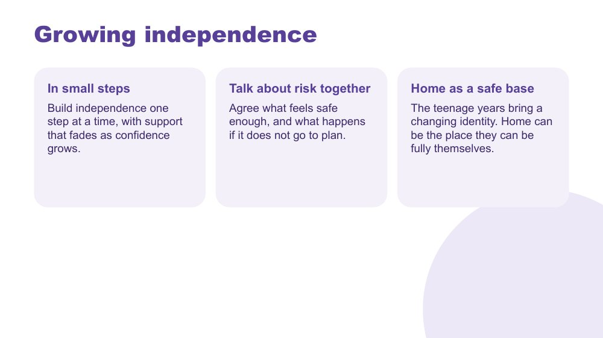 | Growing independence  SUGGESTED TIME  3 min  CLOCK  1:08 - 1:11

Help families think about building independence gradually, with risk talked through together and home as a safe base.
WHAT TO DO  - Walk through the three ideas: in small steps, talk about risk together, home as a safe base.  - Give some practical examples of small steps: setting their own alarm, managing some of their own money, one journey on their own, speaking for themselves at one appointment.  - Explain that the right size of step is different for every young person. For some, a small step this year is a real achievement. | KEY MESSAGES  - Independence grows one step at a time, with support that fades as confidence grows.  - Agree together what feels safe enough, and what happens if it does not go to plan.  - Home can be the place a young person can be fully themselves while their identity is changing.

YOU MIGHT SAY
Independence doesn't have to arrive all at once on a birthday. It can grow in small steps, with support that fades as they get more confident.

KEEP IN MIND
- Families of young people with higher support needs may feel left out of this. Say plainly that the steps look different for each young person and there is no timeline to meet.
- Keep the warmth: this is about a safe base, not a training program.

Thread Leads into the activity on slide 12, One step towards independence, and Adolescents in their own meetings in Session 5.

SESSION 4 | Home and Community | SLIDE 11 of 14

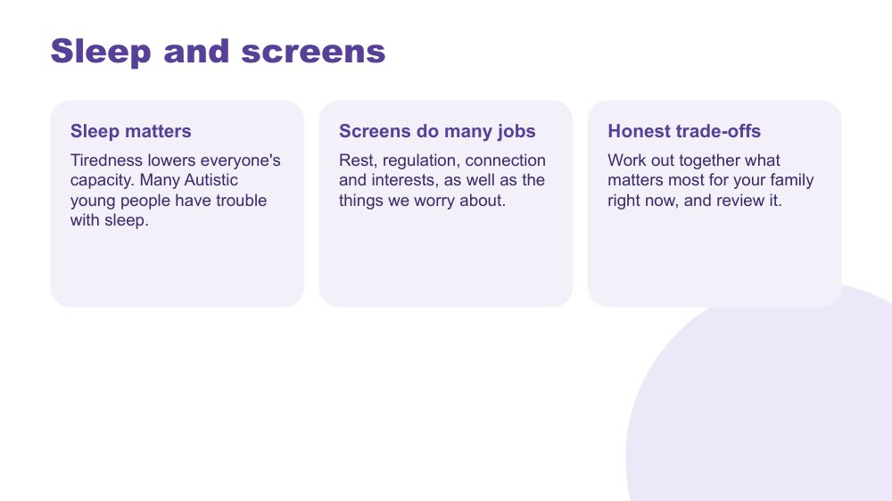 | Sleep and screens  SUGGESTED TIME  2 min  CLOCK  1:11 - 1:13

Talk honestly about sleep and screens as trade-offs families work out together, without judgement.
WHAT TO DO  - Walk through the three ideas: sleep matters, screens do many jobs, honest trade-offs.  - Explain that many Autistic young people have trouble with sleep, and tiredness lowers everyone's capacity.  - Name that screens are used for rest, regulation, connection and interests, as well as the things we worry about.  - Encourage families to work out together what matters most right now, and review it. | KEY MESSAGES  - Tiredness lowers everyone's capacity.  - Screens do many jobs. Look at what they are doing for your young person.  - An agreement worked out together, and reviewed, usually works better than a rule handed down.

YOU MIGHT SAY
Pick the few things that matter most for your family right now, and hold those steadily. Everything else can be talked about.

KEEP IN MIND
- Do not moralise about screens. Many parents have already heard a lot of advice and may feel judged.
- Families may raise online safety worries. Acknowledge them, keep to the principle of working it out together, and point to specialist online safety information at a break.

SESSION 4 | Home and Community | SLIDE 12 of 14

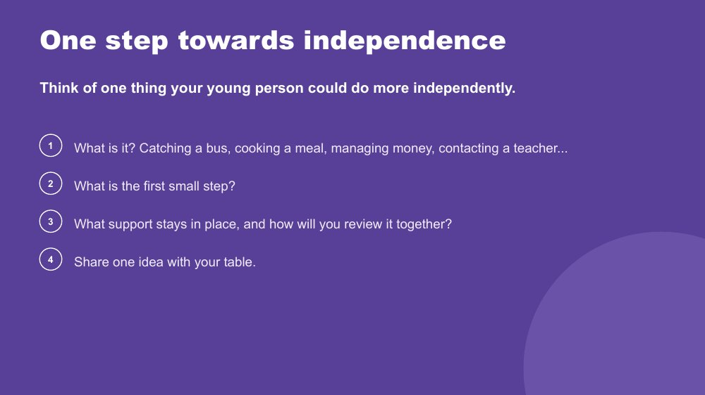 | One step towards independence  SUGGESTED TIME  7 min  CLOCK  1:13 - 1:20  GROUPING  Tables  WORKBOOK  Workbook - One step towards independence

Help each participant choose one small, supported step towards independence for their young person.
WHAT TO DO  - Read the prompt: think of one thing your young person could do more independently.  - Walk through the four steps on the slide.  - Give participants a minute of quiet thinking and writing, then share at tables.  - Allow about 7 minutes in total, including the quiet thinking time. | KEY MESSAGES  - Choose one step, sized for your young person.  - Plan the support that stays in place and when you will review it together.

YOU MIGHT SAY
Think of one thing your young person could do a little more on their own. It might be catching a bus, cooking a meal, managing money or contacting a teacher. Then think about the very first step.

ACTIVITY | Individual planning and table sharing tables · 7 minutes
Think of one thing your young person could do more independently.
- What is it? Catching a bus, cooking a meal, managing money, contacting a teacher...
- What is the first small step?
- What support stays in place, and how will you review it together?
- Share one idea with your table.
Bring the room back
- Invite one or two examples from the room.
Close: Suggest participants talk about the step with their young person, so it becomes something they choose too.

KEEP IN MIND
- Keep steps small and realistic. For some young people the first step is very small, and that is fine.
- Sharing is optional. A participant can listen and take ideas.

Thread Can become the 'one thing to try at home' in Session 6.

SESSION 4 | Home and Community | SLIDE 13 of 14

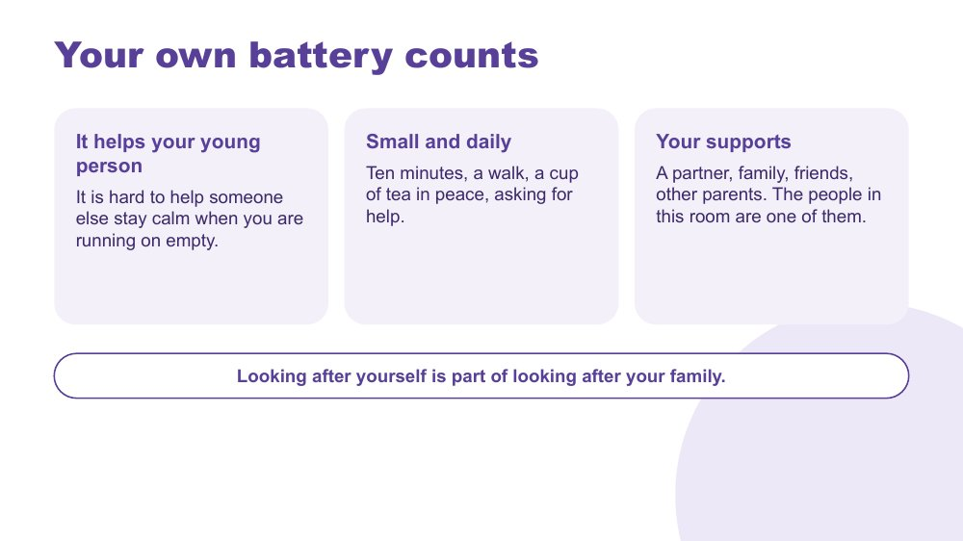 | Your own battery counts  SUGGESTED TIME  2 min  CLOCK  1:20 - 1:22  WORKBOOK  Workbook - My own battery

Include parent and carer capacity in family planning.
WHAT TO DO  - Connect to the battery from Session 3 and co-regulation on slide 6.  - Walk through the three ideas: it helps your young person, small and daily, your supports.  - Invite participants to think quietly about what helps them recharge and what could make this week a little lighter.  - Name the people in the room as one source of support. | KEY MESSAGES  - Looking after yourself is part of looking after your family.  - A small reduction in load is a valid practical action.

YOU MIGHT SAY
It is hard to help someone else stay calm when you are running on empty. That is still true with a sixteen-year-old.
This doesn't have to be big. Ten minutes, a walk, a cup of tea in peace, or asking someone for help.

KEEP IN MIND
- Keep the focus on small, realistic choices rather than idealised self-care.
- Some parents have very little support. Acknowledge this without suggesting they are doing something wrong.
- Looking after your own capacity is part of practical planning for the family.

SESSION 4 | Home and Community | SLIDE 14 of 14

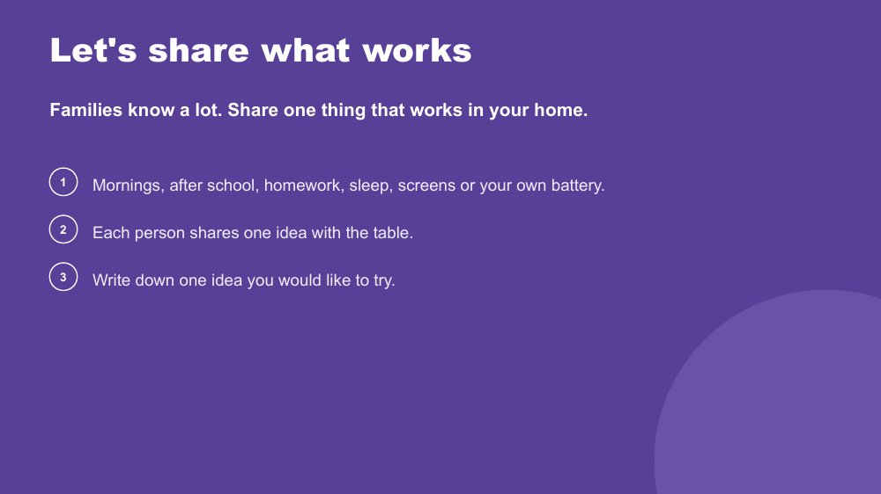 | Let's share what works  SUGGESTED TIME  8 min  CLOCK  1:22 - 1:30  GROUPING  Tables  WORKBOOK  Workbook - What works in our home

Draw on the knowledge in the room: each person shares one thing that works at home.
WHAT TO DO  - Read the opening line: families know a lot.  - Offer the topics: mornings, after school, homework, sleep, screens or your own battery.  - Each person shares one idea with the table. Set a timer for 8 minutes.  - Ask everyone to write down one idea they would like to try.  - To finish, ask participants to keep one thing they notice at home in mind as they move into the next session on partnership with school. | KEY MESSAGES  - Families know a lot. What works in one home can help another.  - What families notice at home can help shape a conversation with school.

YOU MIGHT SAY
You've heard a lot from us today. Now it's your turn. Share one thing that works in your home, big or small.

ACTIVITY | Table sharing tables · 8 minutes
Share one thing that works in your home.
- Choose a topic: mornings, after school, homework, sleep, screens or your own battery.
- Each person shares one idea with the table.
- Write down one idea you would like to try.
Close: Keep one home observation in mind for Session 5, Partnership with the School.

KEEP IN MIND
- Sharing is optional. A participant can listen and take ideas.
- Keep the table focused on what works rather than solving one family's situation.

Thread Leads into Session 5: what families notice at home can shape the next conversation with school.

SESSION  5 | 1:30 - 2:10 · 40 MINUTES · 16 SLIDES  Partnership with the School

SESSION INTENT
Help parents and carers bring their knowledge of their young person together with the knowledge held by school staff and support staff, with the young person at the centre and increasingly taking part. Participants look at what makes partnership work, rights at school, how power can shape a meeting, student voice, who to contact in a secondary school, young people in their own meetings and early transition planning, and they prepare for one purposeful conversation with school.
PARTICIPANTS LEAVE WITH
- Describe partnership as family, school staff and support staff working together with the young person at the centre.
- Name the key principles of effective collaboration and what useful consultation includes.
- Understand, in general terms, the Disability Discrimination Act and the Disability Standards for Education, including the school's duty to consult about adjustments, including for assessments.
- Recognise where power can sit in the home-school relationship and some practical ways to balance it.
- Know who to contact for what in a secondary school, and how young people can take part in their own meetings.
- Start thinking about transition planning for the senior years and after school.
- Prepare for one purposeful conversation with school, including how their young person will take part.

RUN SHEET
Clock | Segment | Slides | Minutes
1:30 - 1:35 | Opening and working in partnership | 1-3 | 5
1:35 - 1:41 | Effective collaboration and your rights at school | 4-5 | 6
1:41 - 1:49 | Power dynamics and activity | 6-7 | 8
1:49 - 1:53 | Student voice | 8 | 4
1:53 - 1:57 | Consultation literacy and who to contact for what | 9-10 | 4
1:57 - 2:00 | Adolescents in their own meetings | 11 | 3
2:00 - 2:03 | Partnership tools and other supports | 12-14 | 3
2:03 - 2:06 | Transition planning starts early | 15 | 3
2:06 - 2:10 | Prepare for a conversation with school | 16 | 4

PREPARE
☐ Sticky notes and pens on every table; butcher's paper on the wall headed Home, School and Solutions.
☐ Student voice video (Adon) tested with sound, captions on and transcript available.
☐ Participant Workbooks open to Session 5.
☐ Copies or a clear view of the Partnership tools shown on slide 12.
☐ The NCCD Meetings Tool Kit link (https://www.nccd.edu.au/wider-support-materials/meetings-toolkit) and the Department of Education plain-language guides for families.
☐ Helpline numbers on slide 14 checked as current.
☐ A quiet option for participants who find the power discussion difficult.

SESSION 5 | Partnership with the School | SLIDE 1 of 16

 | Partnership with the School  SUGGESTED TIME  1 min  CLOCK  1:30 - 1:31

Open the partnership session and connect it to what families have noticed at home.
WHAT TO DO  - Name the shift from what happens at home to how home and school can understand and act together.  - Ask participants to keep in mind one thing they noticed at home in Session 4 that school might need to know.  - Keep your young person at the centre of the conversation, and as a partner in it.  - Acknowledge that participants will bring very different school experiences, some helpful and some difficult.  - Remind the room that sharing is voluntary, and that schools and staff are not named in the whole group. | KEY MESSAGES  - Partnership is part of understanding and supporting your young person from the start.  - Your young person, your family and the school may each hold different parts of the picture.

KEEP IN MIND
- Some families are in a very hard place with their school right now. Acknowledge this without inviting detailed accounts in the whole group.

Thread Picks up what participants noticed at home in Session 4 (Home and Community).

SESSION 5 | Partnership with the School | SLIDE 2 of 16

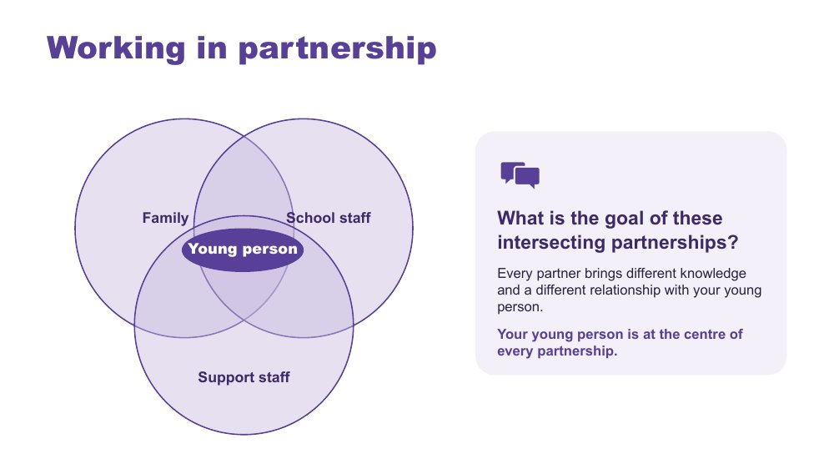 | Working in partnership  SUGGESTED TIME  2 min  CLOCK  1:31 - 1:33

Show where the partnerships around a young person intersect, with the young person at the centre of every one.
WHAT TO DO  - Introduce the diagram: family, school staff and support staff, with your young person at the centre.  - Explain that every partner brings different knowledge and a different relationship with your young person and with each other.  - Ask the group: What is the goal of these intersecting partnerships?  - Steer the discussion so the point is made that the young person is at the centre of every partnership.  - Ask who else might be part of the picture for their young person, such as a therapist, a tutor, a grandparent or an employer, and how the young person's own views can be included. | KEY MESSAGES  - Positive partnership keeps your young person at the centre.  - No single person holds the complete picture.  - Parents and carers bring knowledge of their young person that no one else has.

YOU MIGHT SAY
What is the goal of these intersecting partnerships?

KEEP IN MIND
- Use the diagram as a discussion prompt rather than a complete definition.

Thread Draws on 'You are the expert on your young person' from Session 1.

SESSION 5 | Partnership with the School | SLIDE 3 of 16

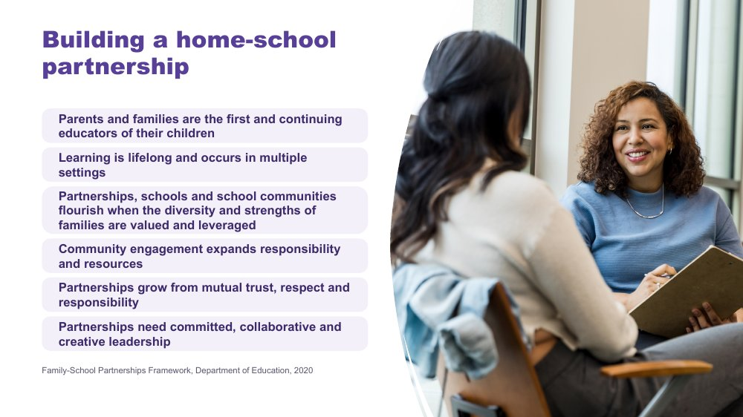 | Building a home-school partnership  SUGGESTED TIME  2 min  CLOCK  1:33 - 1:35

Use the Family-School Partnerships Framework principles to show what families can expect a partnership to look like.
WHAT TO DO  - Walk through the six Framework principles briefly.  - Draw attention to the first principle: parents and families are the first and continuing educators of their children.  - Position family knowledge and school knowledge as different, useful perspectives.  - Name what partnership looks like in practice: a shared purpose, respectful listening, your young person's voice, clear information, and agreed next steps with follow-up. | KEY MESSAGES  - Your knowledge of your young person and the school's knowledge are both needed from the beginning.  - Listening, clarity and shared next steps are things you can look for in practice.

KEEP IN MIND
- Avoid implying that agreement is needed before listening or respect are possible.

RESOURCES
- Family-School Partnerships Framework - Department of Education, Australian Government - https://www.education.gov.au/supporting-family-school-community-partnerships-learning/family-school-partnerships/family-school-partnerships-framework

SESSION 5 | Partnership with the School | SLIDE 4 of 16

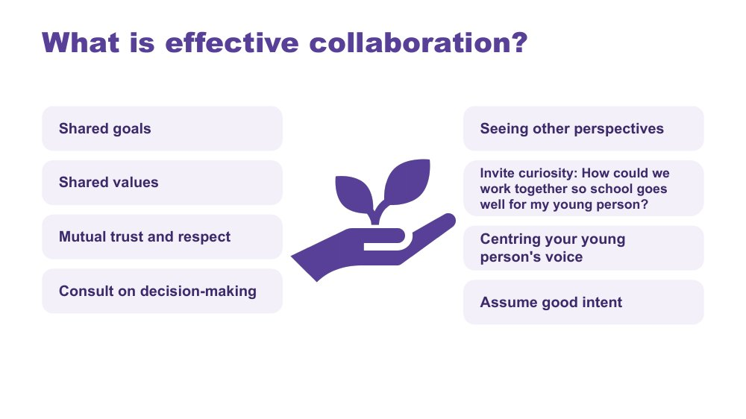 | What is effective collaboration?  SUGGESTED TIME  3 min  CLOCK  1:35 - 1:38

Name the collaboration principles that strong partnerships share, whoever is at the table.
WHAT TO DO  - Introduce why collaboration matters: in secondary school there are many teachers and staff, and many points where home and school need to work together.  - Explain that the key collaboration principles are the same across every partnership around your young person.  - Ask the group: What are some of the key principles for effective collaboration?  - Build the discussion to cover: shared goals, shared values, mutual trust and respect, consulting on decision-making, seeing other perspectives, inviting curiosity, centring your young person's voice and assuming good intent.  - Once the room has contributed, point to the list on the slide and pick up anything not yet mentioned. | KEY MESSAGES  - The same principles apply in every partnership around your young person.  - Starting from what you both want for your young person, and staying curious, can help even when a conversation is hard.

YOU MIGHT SAY
What are some of the key principles for effective collaboration?
How could we work together so school goes well for my young person?

KEEP IN MIND
- 'Assume good intent' can be hard to hear for families who have had poor experiences. Acknowledge that trust is built on both sides and is not the family's job alone. Where trust has been damaged, it may need rebuilding over time, and starting from what you both want for your young person can be an easier first step.

Background This slide was added by the team because it works well with all parties and helps shift perspectives.

SESSION 5 | Partnership with the School | SLIDE 5 of 16

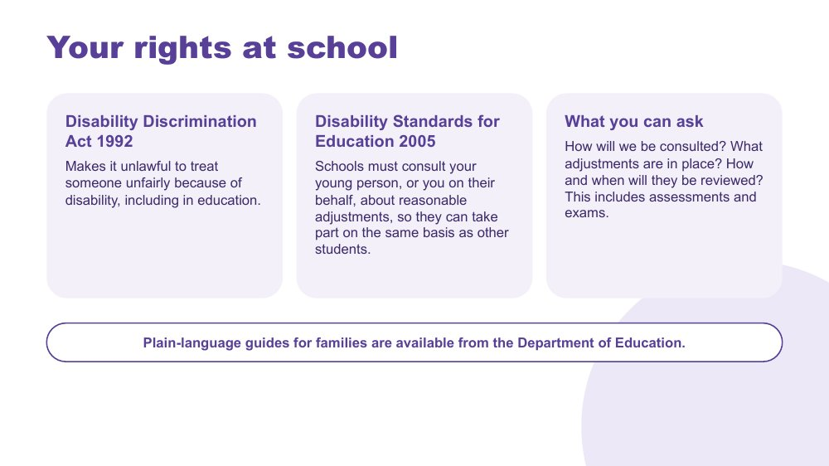 | Your rights at school  SUGGESTED TIME  3 min  CLOCK  1:38 - 1:41

Give general information about the Disability Discrimination Act and the Disability Standards for Education, and the questions families can ask.
WHAT TO DO  - Explain that the Disability Discrimination Act 1992 makes it unlawful to treat someone unfairly because of disability, including in education.  - Explain that under the Disability Standards for Education 2005, the school must consult your young person, or you on their behalf, about reasonable adjustments, so your young person can take part on the same basis as other students.  - Walk through the three questions families can ask: How will we be consulted? What adjustments are in place? How and when will they be reviewed? Point out that this includes assessments and exams.  - Point to the plain-language guides for families from the Department of Education.  - State clearly that this is general information, not individual legal advice. | KEY MESSAGES  - The school must consult your young person, or you on their behalf, about adjustments. This is a requirement under the Standards.  - You can ask how you will be consulted, what adjustments are in place and when they will be reviewed.  - Adjustments can apply to assessments and exams. Ask early, especially as the senior years get closer.

KEEP IN MIND
- Do not give advice on individual situations or disputes. Point participants to the plain-language guides and the support pathways on slide 14.
- Keep the tone informative rather than adversarial. Knowing your rights supports partnership.

RESOURCES
- Disability Standards for Education 2005 (Cth) - https://www.legislation.gov.au/Latest/F2005L00767

SESSION 5 | Partnership with the School | SLIDE 6 of 16

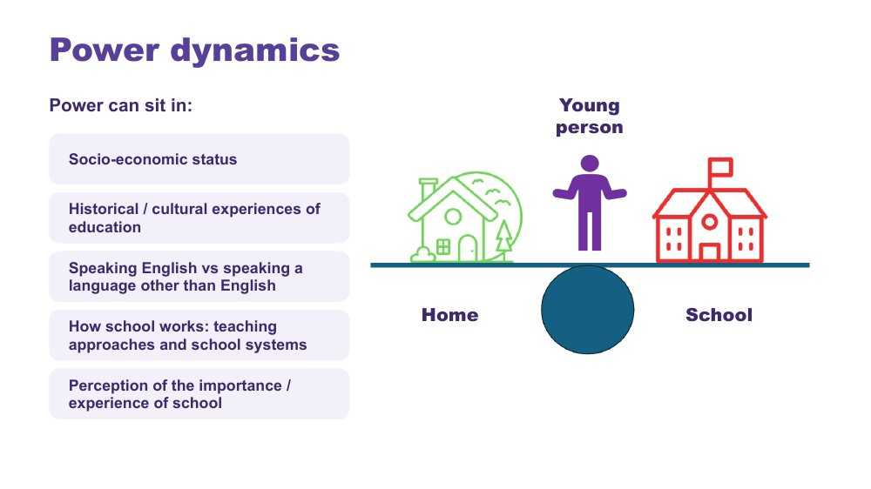 | Power dynamics  SUGGESTED TIME  2 min  CLOCK  1:41 - 1:43

Help participants notice how agendas, language, authority and decision-making can shape a school conversation.
WHAT TO DO  - Introduce the seesaw: school, home and your young person.  - Name where power can sit: socio-economic status, historical and cultural experiences of education, speaking English or another language, how school works (teaching approaches and school systems), and how important school is seen to be.  - Ask the power questions below to look at how meetings work, not to blame anyone.  - Invite participants to think about where school language, timing or process has made it harder for them to take part. | KEY MESSAGES  - Power sits in meeting structures, language and decision pathways, as well as in people.  - Naming an imbalance can help you plan for a more balanced conversation.

YOU MIGHT SAY
Who sets the agenda?
Whose knowledge is heard?
Who can make decisions?
Is your young person included in a way that works for them?
What could change about the process?

KEEP IN MIND
- Keep sharing voluntary and avoid detailed complaints about identifiable schools or staff in the whole group.

SESSION 5 | Partnership with the School | SLIDE 7 of 16

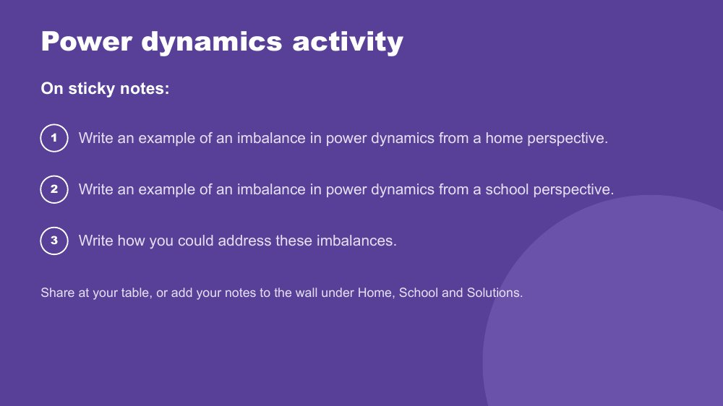 | Power dynamics activity  SUGGESTED TIME  6 min  CLOCK  1:43 - 1:49  GROUPING  Table groups  WORKBOOK  Workbook - Power dynamics

Help participants reflect on real and perceived power imbalances in the home-school relationship, and look for ways to address them.
WHAT TO DO  - Make sure every participant has sticky notes and a pen.  - Direct participants to the three instructions on the slide.  - Choose a sharing option that suits the room (see steps).  - Support tables to look for solutions rather than place blame.  - Take feedback from a few participants at the end. | KEY MESSAGES  - Power can be structural, historical, cultural, conscious and unconscious.  - Status can be felt as an imbalance of power, regardless of anyone's intent.

ACTIVITY | Sticky note reflection table groups · 6 minutes
Where do power imbalances sit in the home-school relationship, and how could they be addressed?
- On one sticky note, write an example of an imbalance in power dynamics from a home perspective.
- On a second, write an example from a school perspective.
- On a third, write how you could address these imbalances.
- Option 1: share your notes with your table.
- Option 2: add your notes to the butcher's paper on the wall under Home, School and Solutions.
Bring the room back
- Who sets the agenda?
- Whose knowledge is heard?
- Who can make decisions?
- What could change about the process?
Close: Ask participants to keep one idea from the Solutions column for their conversation plan on slide 16.

KEEP IN MIND
- This may be painful for some participants who have felt powerless in dealings with school. Acknowledge this, and guide the group towards solutions rather than blame.
- Asking for a school perspective is not asking families to excuse poor practice. It helps them plan a conversation that is more likely to work.

Background Educators work inside the culture of education, including shared acronyms such as NAPLAN, NCCD and IEP, which families may not know. Some people naturally give teachers higher status, which can be a cultural or personal attitude. External providers and professionals can also affect the power dynamic around an Autistic young person.
Thread The solution chosen here carries into the conversation plan on slide 16 and the Session 6 take-home actions.

SESSION 5 | Partnership with the School | SLIDE 8 of 16

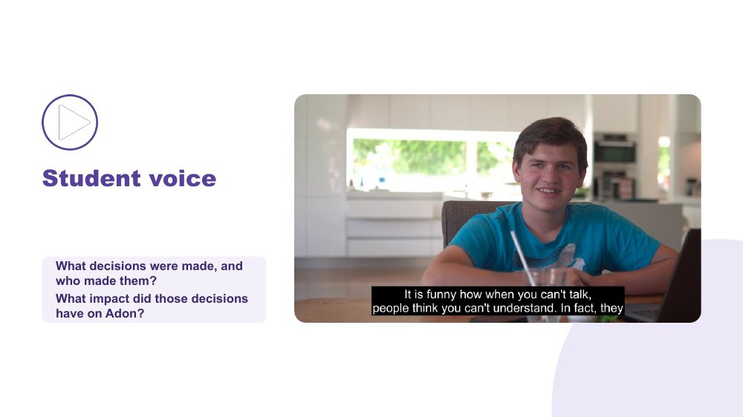 | Student voice  SUGGESTED TIME  4 min  CLOCK  1:49 - 1:53  WORKBOOK  Workbook - Student voice

Show what can happen when a young person is not listened to or consulted, and why your young person's voice belongs in decisions about them.
WHAT TO DO  - Introduce the video as an example of a young person who is not listened to or consulted at school.  - Ask participants, while watching, to pay attention to what decisions were made and who made them.  - Play the video.  - Ask the group: What impact did those decisions have on Adon?  - Connect to participants' own young people: how are their views asked for and heard, at home and at school? | KEY MESSAGES  - Young people should have a say in decisions about them, in the way they communicate.  - Ask your young person in a way that works for them: What helps? What's hard? What should your teachers know?  - Their views can go to school in their own words, in writing, or through a trusted adult.  - This builds self-advocacy, which matters more and more through secondary school.

YOU MIGHT SAY
While watching, pay attention to what decisions were made and who made them.
What impact did those decisions have on Adon?

KEEP IN MIND
- Some parents may recognise their own young person's experience in the video. Allow a moment before moving on.

Thread Links to multimodal communication in Session 3 and leads to Adolescents in their own meetings on slide 11.

SESSION 5 | Partnership with the School | SLIDE 9 of 16

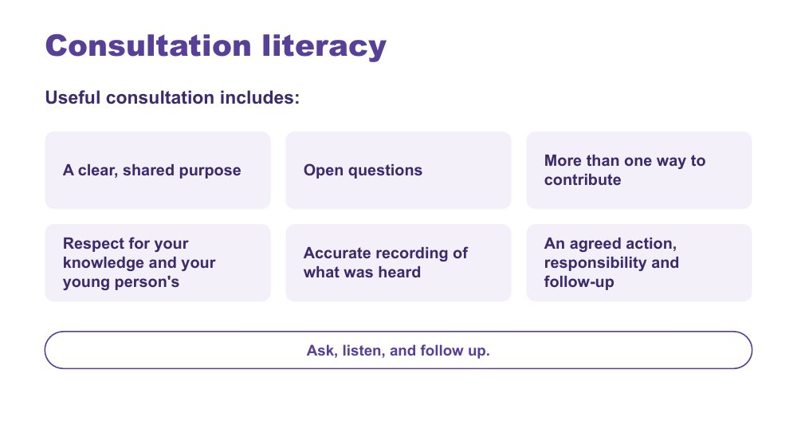 | Consultation literacy  SUGGESTED TIME  2 min  CLOCK  1:53 - 1:55  WORKBOOK  Workbook - Consultation checklist

Show families what useful consultation includes, so they can recognise it and ask for it.
WHAT TO DO  - Walk through what useful consultation includes.  - Frame the list as a check families can use before and after a school meeting.  - Make the point: ask, listen, and follow up. | KEY MESSAGES  - Ask, listen, and follow up.  - Useful consultation includes an agreed action, who is responsible and when it will be followed up.

Thread Links back to the Disability Standards for Education on slide 5: consultation is a requirement.
RESOURCES
- Australian Education Research Organisation (2024). Engaging with families of children with disability: Schools practice guide - https://www.edresearch.edu.au/guides-resources/practice-guides/engaging-families-children-disability-schools-guide

SESSION 5 | Partnership with the School | SLIDE 10 of 16

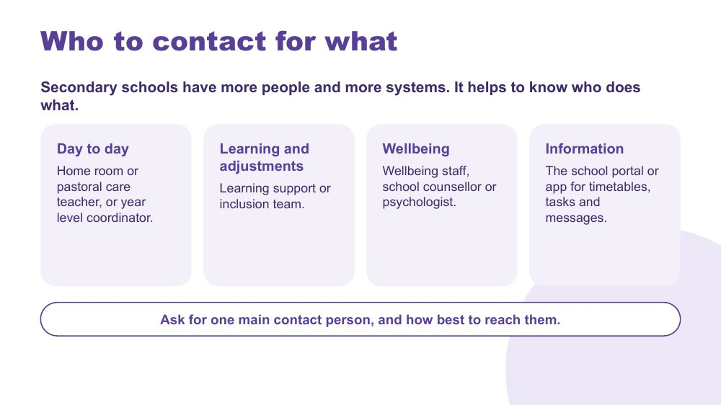 | Who to contact for what  SUGGESTED TIME  2 min  CLOCK  1:55 - 1:57  WORKBOOK  Workbook - Who to contact for what

Help families find their way around a secondary school: who to contact about what, and how.
WHAT TO DO  - Read the opening line: secondary schools have more people and more systems.  - Walk through the four areas: day to day, learning and adjustments, wellbeing, information.  - Explain that the names of roles differ between schools. Families can ask the school who does what.  - Encourage families to ask for one main contact person, and how best to reach them.  - Suggest that learning the school portal or app together with their young person can also be a step towards independence. | KEY MESSAGES  - It helps to know who does what.  - Ask for one main contact person, and how best to reach them.  - A short written follow-up ('As we discussed...') helps everyone remember what was agreed.

YOU MIGHT SAY
In primary school there was often one teacher who knew them well. In secondary school there might be six or more, so it helps to build one strong relationship and go through that person.

KEEP IN MIND
- Some schools do not have a clear coordinator or contact role. Suggest starting with the staff member who knows and understands their young person best.
- Avoid naming or comparing particular schools.

Thread Links to homework and assessment in Session 4: if the load is too much, this slide shows who to talk to.

SESSION 5 | Partnership with the School | SLIDE 11 of 16

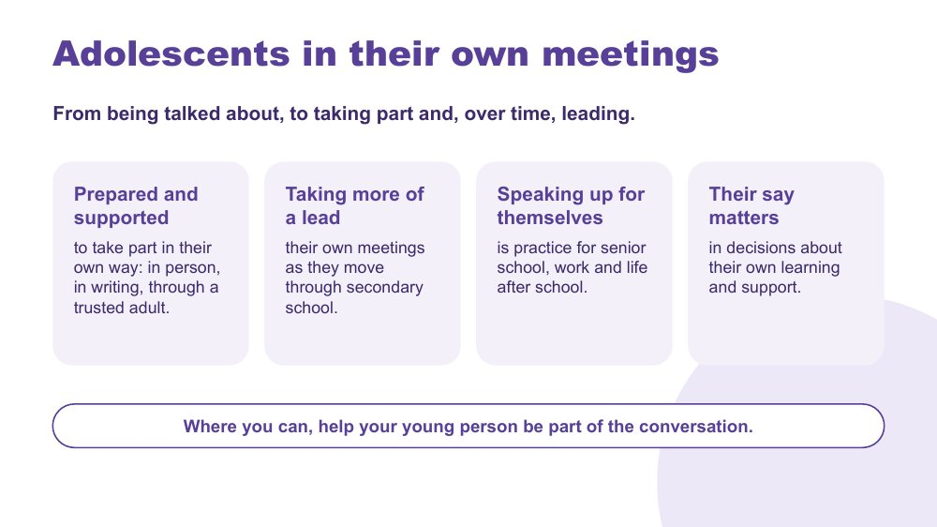 | Adolescents in their own meetings  SUGGESTED TIME  3 min  CLOCK  1:57 - 2:00

Show how young people can move from being talked about, to taking part and, over time, leading their own meetings.
WHAT TO DO  - Read the opening line: from being talked about, to taking part and, over time, leading.  - Walk through the four points: prepared and supported, taking more of a lead, speaking up for themselves, and their say in decisions about their own learning and support.  - Explain that taking part can happen in many ways: in person, in writing, or through a trusted adult.  - Suggest agreeing beforehand with their young person what they want said, what they will say themselves, and how they can signal that they need to leave.  - Read the closing line. | KEY MESSAGES  - Where you can, help your young person be part of the conversation.  - Taking part is prepared and supported, and can happen in their own way.  - Speaking up for themselves is practice for senior school, work and life after school.

YOU MIGHT SAY
Preparation makes a big difference. Before the meeting, talk with your young person about what they want said, what they would like to say themselves, and what their signal is if they need a break.

KEEP IN MIND
- This is not about making young people attend meetings. Taking part is gradual and chosen. If a young person does not want to attend, gather their views beforehand in a way that works for them.
- Where a young person says no to a support, that view belongs in the meeting too.

Thread Builds on Student voice (slide 8) and Growing independence in Session 4.

SESSION 5 | Partnership with the School | SLIDE 12 of 16

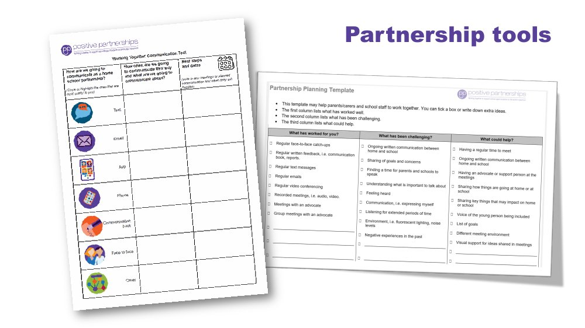 | Partnership tools  SUGGESTED TIME  1 min  CLOCK  2:00 - 2:01

Show the Partnership tools and how families can use them to prepare for and follow up a school meeting.
WHAT TO DO  - Show the Partnership tools and briefly explain how each one is used.  - Frame the tools as supports for consultation, not replacements for listening and your young person's voice. | KEY MESSAGES  - Tools can help a conversation, alongside listening and your young person's voice.

SESSION 5 | Partnership with the School | SLIDE 13 of 16

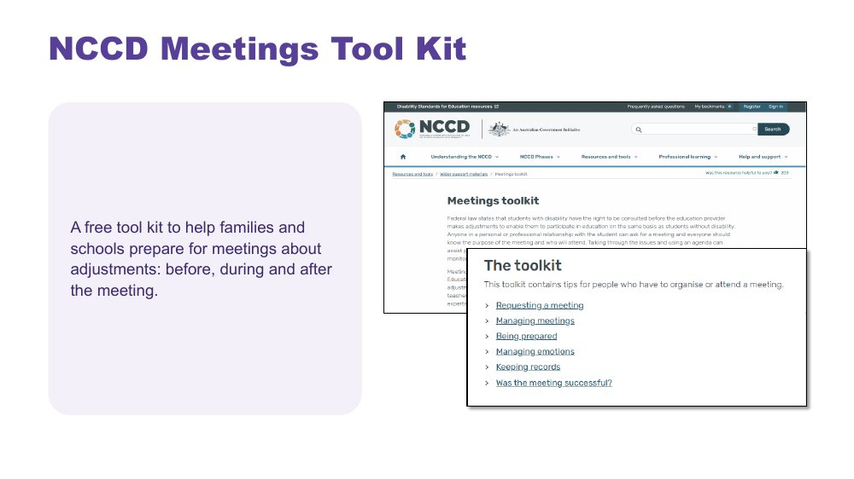 | NCCD Meetings Tool Kit  SUGGESTED TIME  1 min  CLOCK  2:01 - 2:02

Introduce the NCCD Meetings Tool Kit as a free resource that can make meetings about adjustments clearer.
WHAT TO DO  - Explain that the Tool Kit helps make the meeting purpose, consultation process, possible adjustments, evidence and next steps clear.  - Explain that schools follow the processes used in their school or system, and families can ask who is responsible for what and how follow-up will happen.  - Point families to the Tool Kit on the NCCD website: https://www.nccd.edu.au/wider-support-materials/meetings-toolkit | KEY MESSAGES  - The Tool Kit can help families know what to expect before, during and after a meeting about adjustments.

KEEP IN MIND
- Do not explain NCCD in detail. If asked, talk about levels of adjustment and point to the official NCCD information.

RESOURCES
- NCCD Meetings Tool Kit - https://www.nccd.edu.au/wider-support-materials/meetings-toolkit

SESSION 5 | Partnership with the School | SLIDE 14 of 16

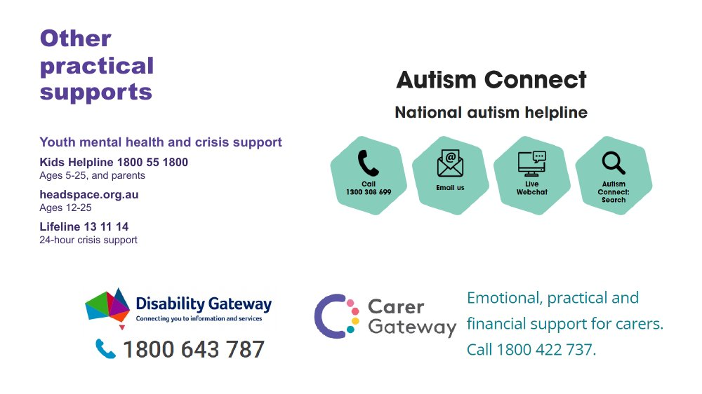 | Other practical supports  SUGGESTED TIME  1 min  CLOCK  2:02 - 2:03

Point families to national helplines and support pathways, including youth mental health and crisis support.
WHAT TO DO  - Briefly introduce Autism Connect (the national autism helpline), Disability Gateway and Carer Gateway.  - Note that Carer Gateway offers emotional, practical and financial support for carers.  - Point out the youth mental health and crisis support lines: Kids Helpline (1800 55 1800, ages 5-25, and parents), headspace (headspace.org.au, ages 12-25) and Lifeline (13 11 14).  - Leave the slide up so participants can note or photograph the numbers. | KEY MESSAGES  - Help is available beyond today, for your young person and for you.

KEEP IN MIND
- Check phone numbers and services are current before delivery.

RESOURCES
- Disability Gateway - 1800 643 787
- Carer Gateway - 1800 422 737
- Autism Connect national autism helpline - contact details as shown on the slide
- Kids Helpline - 1800 55 1800 (ages 5-25, and parents)
- headspace - headspace.org.au (ages 12-25)
- Lifeline - 13 11 14

SESSION 5 | Partnership with the School | SLIDE 15 of 16

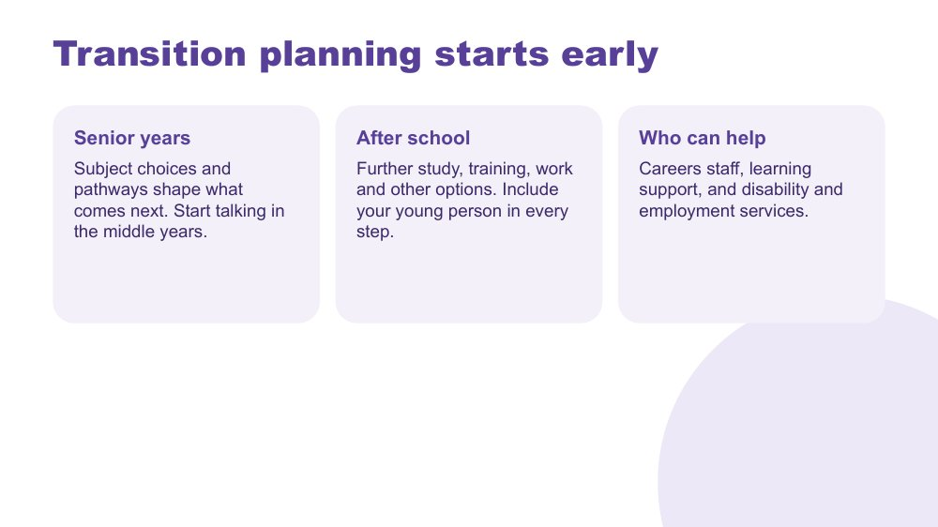 | Transition planning starts early  SUGGESTED TIME  3 min  CLOCK  2:03 - 2:06

Encourage families to start thinking about the senior years and life after school early, with their young person included.
WHAT TO DO  - Walk through the three ideas: senior years, after school, who can help.  - Explain that subject choices and pathways shape what comes next, so it helps to start talking in the middle years.  - Name the range of options after school: further study, training, work and other options. Make sure every young person is included, whatever their support needs.  - Point out that a young person's interests can point the way.  - Name who can help: careers staff, learning support, and disability and employment services. | KEY MESSAGES  - Start talking about the senior years in the middle years.  - Include your young person in every step.  - Starting early helps keep options open.

YOU MIGHT SAY
You don't need to have it all worked out. Starting early just means more options stay open, and your young person has more time to work out what they want.

KEEP IN MIND
- This topic can bring pressure or worry. Keep it gentle and focused on keeping options open.
- Families of young people with higher support needs should hear their options named with equal respect, including supported employment and community participation.
- Keep to general principles. State-specific pathways and NDIS matters are for the participant pack or specialist services.

Thread Interests from Session 4 can point towards study and work.

SESSION 5 | Partnership with the School | SLIDE 16 of 16

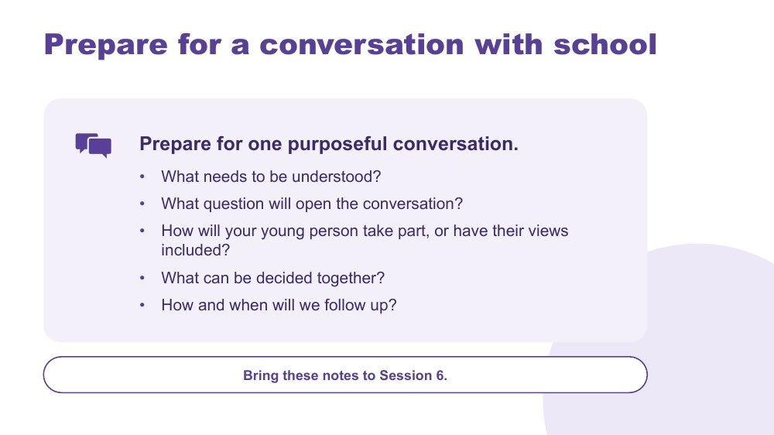 | Prepare for a conversation with school  SUGGESTED TIME  4 min  CLOCK  2:06 - 2:10  GROUPING  On your own  WORKBOOK  Workbook - Prepare for a conversation with school

Help each participant prepare for one purposeful conversation with school, to carry into the Session 6 take-home actions.
WHAT TO DO  - Ask participants to think of a real or likely conversation with school.  - Invite them to work through the prompts on the slide privately.  - Encourage short notes rather than a full meeting plan.  - Ask participants to carry one idea from the power activity into their plan.  - Encourage participants to think about talking with their young person about the conversation before it happens.  - Keep sharing optional, particularly where the situation is sensitive. | KEY MESSAGES  - Prepare for one purposeful conversation.  - A small, specific next step is enough.

YOU MIGHT SAY
Bring these notes to Session 6.

ACTIVITY | Private planning on your own · 4 minutes
Prepare for one purposeful conversation.
- What needs to be understood?
- What question will open the conversation?
- How will your young person take part, or have their views included?
- What can be decided together?
- How and when will we follow up?
Close: Ask participants to circle the question they will open with and keep these notes for Session 6.

Thread Feeds the second of the three small things in Session 6: one thing you would like school to know, understand or support, and the sentence you will open with.

SESSION  6 | 2:10 - 2:30 · 20 MINUTES · 7 SLIDES  Full Circle

SESSION INTENT
Bring the day together around the whole young person. Participants return to belonging, capacity and joy, choose three small things to take home, find ways to stay connected with other families and Positive Partnerships, give feedback and leave with one small next step.
PARTICIPANTS LEAVE WITH
- Use belonging, capacity and joy to judge whether a change supports their young person to flourish.
- Choose one thing to try at home, one thing to share with school and one strength to tell their young person this week.
- Know where to find continued connection and learning after the workshop.
- Complete the workshop feedback.

RUN SHEET
Clock | Segment | Slides | Minutes
2:10 - 2:14 | Return to the whole young person | 1-2 | 4
2:14 - 2:22 | Bringing it all together: three small things | 3 | 8
2:22 - 2:25 | Connections and resources | 4-5 | 3
2:25 - 2:30 | Feedback and farewell | 6-7 | 5

PREPARE
☐ Participant Workbooks open to Session 6 (Three small things).
☐ Titles and dates for the family webinars and deep dives, once confirmed (slide 4 shows "Titles and dates to confirm").
☐ Link and QR code for the online Community of Practice, once available (slide 4 shows "Link and QR code TBA").
☐ The feedback link (TBA) and QR code added to slide 6 and tested; paper or verbal alternative available.
☐ Local follow-up and contact arrangements confirmed.
☐ Protected time: at least 4 minutes for feedback.

SESSION 6 | Full Circle | SLIDE 1 of 7

 | Full Circle  SUGGESTED TIME  2 min  CLOCK  2:10 - 2:12

Open the final session and return to the young person participants described at the start of the day.
WHAT TO DO  - Name this as a short, practical closing session.  - Invite participants to look again at the three things they wrote about their young person in Session 1.  - Invite one or two people to look back at the one thing they wanted to know from Session 1 and say what has shifted, or what has been answered. Keep this to 1 to 2 minutes.  - Explain that they will choose a few small actions to carry forward, not a long list.  - Keep the closing grounded rather than adding new content. | KEY MESSAGES  - The day comes back to your young person as a whole person.  - One or two small steps are more useful than a long list.

Thread Returns to 'What I love and value about my young person' and the one thing participants wanted to know from Session 1.

SESSION 6 | Full Circle | SLIDE 2 of 7

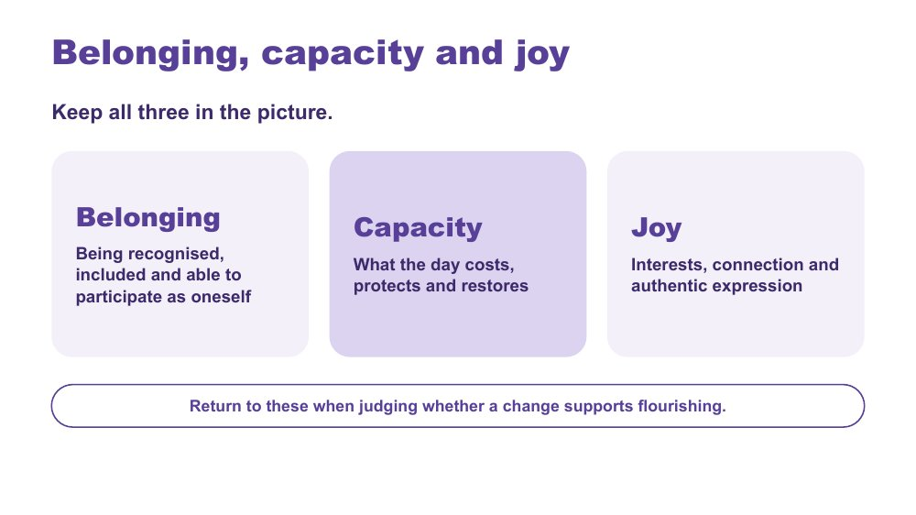 | Belonging, capacity and joy  SUGGESTED TIME  2 min  CLOCK  2:12 - 2:14

Bring the day together through belonging, capacity and joy.
WHAT TO DO  - Present belonging, capacity and joy together, as connected ideas.  - Belonging: being recognised, included and able to participate as oneself.  - Capacity: what the day costs, protects and restores.  - Joy: interests, connection and authentic expression.  - Point to the last line on the slide: return to these three when judging whether a change supports flourishing. | KEY MESSAGES  - Belonging, capacity and joy matter as much as getting through the day.  - A change at home or at school can be checked against all three.

YOU MIGHT SAY
Keep all three in the picture.

KEEP IN MIND
- Avoid presenting school results, quiet compliance or doing things alone as the only signs that a young person is doing well.

Thread Capacity picks up the batteries, spoons and fluctuating capacity from Session 3 (what uses up your young person's energy and what helps them recharge) and your own battery from Session 4; joy picks up interests as an anchor from Session 4.

SESSION 6 | Full Circle | SLIDE 3 of 7

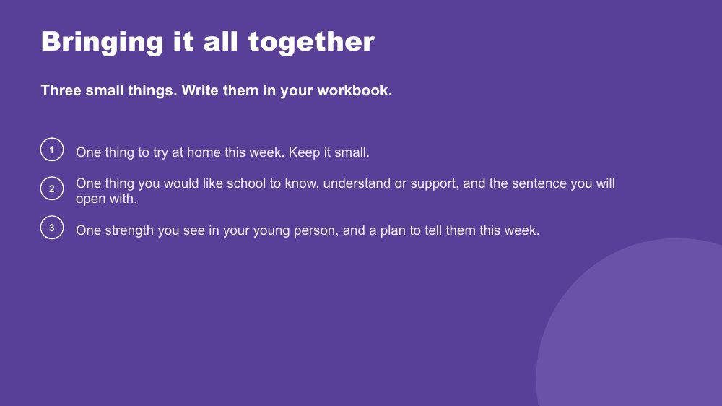 | Bringing it all together  SUGGESTED TIME  8 min  CLOCK  2:14 - 2:22  GROUPING  On your own  WORKBOOK  Workbook - Three small things

Help each participant choose three small, specific actions across home, school and their young person's positive identity.
WHAT TO DO  - Introduce the three small things on the slide.  - Allow quiet writing time in the Workbook.  - Encourage participants to keep each action small enough to start this week.  - For the school item, point participants back to their notes from Session 5, slide 16.  - Invite one or two people to share if they wish; sharing is optional. | KEY MESSAGES  - A useful action can be small and specific.  - The three prompts connect home, school and your young person's positive identity.

ACTIVITY | Individual reflection and action planning on your own · 8 minutes
Three small things. Write them in your workbook.
- One thing to try at home this week. Keep it small.
- One thing you would like school to know, understand or support, and the sentence you will open with.
- One strength you see in your young person, and a plan to tell them this week.
Close: Invite participants to keep their notes somewhere they will see them after the workshop.

KEEP IN MIND
- Some families are going through a very hard time. If someone cannot think of an action today, that is fine. Naming a strength may be enough.
- Some participants may choose to tell their young person privately, or in a message, rather than out loud. Any way that suits them is fine.

Thread Draws together the Session 4 ideas to try at home (including the step towards independence), the Session 5 conversation plan and the Session 1 strengths.

SESSION 6 | Full Circle | SLIDE 4 of 7

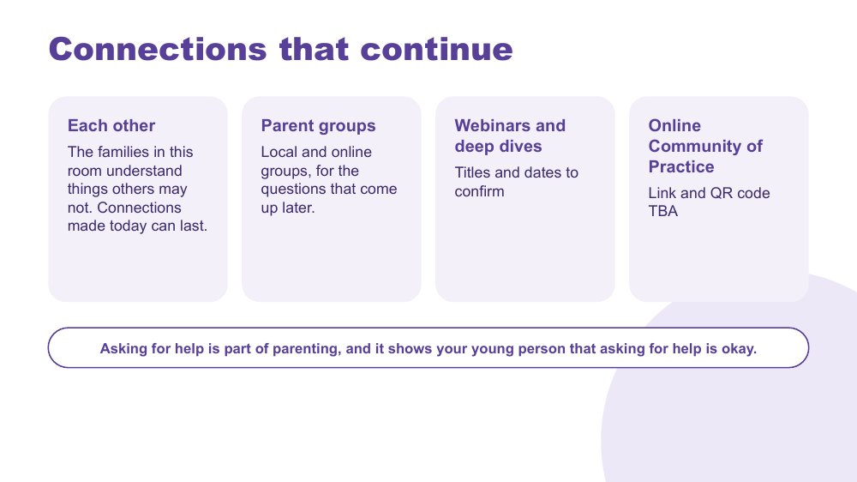 | Connections that continue  SUGGESTED TIME  2 min  CLOCK  2:22 - 2:24

Point participants towards continued connection with other families, parent groups, family webinars and the online Community of Practice.
WHAT TO DO  - Name the four options on the slide: each other, parent groups, webinars and deep dives, and the online Community of Practice.  - Invite participants to swap contact details with others at their table if they would like to.  - Explain how to access the webinars and the Community of Practice.  - Avoid implying that every option will suit every family.  - Read the last line on the slide: asking for help is part of parenting. It also shows your young person that asking for help is okay. | KEY MESSAGES  - Connection after today can come through other families, parent groups or online.  - Choose the kind of connection that fits you.

YOU MIGHT SAY
Asking for help is part of parenting, and it shows your young person that asking for help is okay.

SESSION 6 | Full Circle | SLIDE 5 of 7

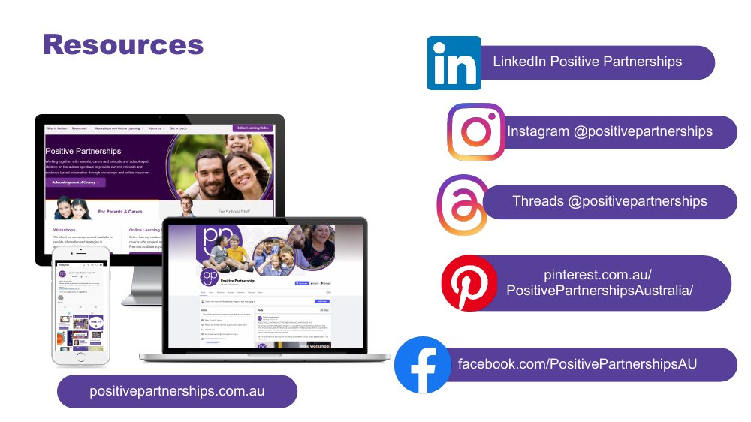 | Resources  SUGGESTED TIME  1 min  CLOCK  2:24 - 2:25

Show where to follow Positive Partnerships online.
WHAT TO DO
- Leave the slide up briefly so participants can note or photograph the handles.
- Mention that the website has resources for families on many of today's topics.

RESOURCES
- Positive Partnerships website - positivepartnerships.com.au
- Facebook - facebook.com/PositivePartnershipsAU
- Instagram - @positivepartnerships
- Threads - @positivepartnerships
- LinkedIn - Positive Partnerships
- Pinterest - pinterest.com.au/PositivePartnershipsAustralia/

SESSION 6 | Full Circle | SLIDE 6 of 7

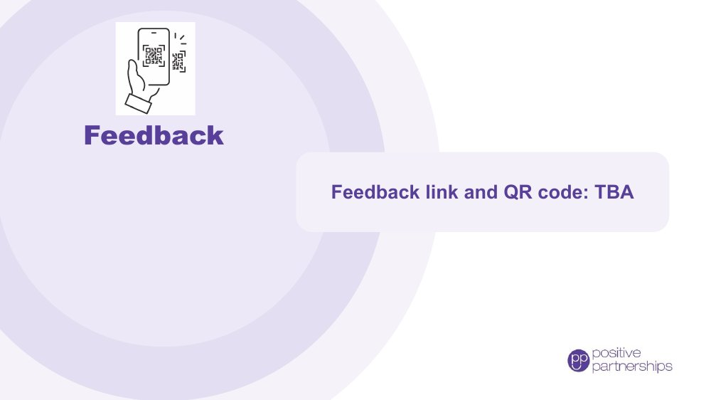 | Feedback  SUGGESTED TIME  4 min  CLOCK  2:25 - 2:29

Collect participant feedback on the workshop.
WHAT TO DO
- Explain why feedback is collected and how it helps shape future workshops for families.
- Show how to access the form, using the feedback link (TBA) and QR code.
- Allow protected time for completion in the room.
- Offer an alternative for anyone who cannot use the online form.

KEEP IN MIND
- The slide shows a placeholder: add the feedback link (TBA) and QR code before delivery.

RESOURCES
- Feedback link and QR code: TBA

SESSION 6 | Full Circle | SLIDE 7 of 7

 | Good luck on your journey  SUGGESTED TIME  1 min  CLOCK  2:29 - 2:30

Close warmly and return participants to their young person and one small next step.
WHAT TO DO  - Thank participants for their time, their questions and what they shared about their young people.  - Invite them to stay curious and keep their young person at the centre.  - Remind participants to take their Workbook with their three small things.  - State the follow-up and contact arrangements. | KEY MESSAGES  - Stay curious.  - Keep your young person at the centre.  - Take one small next step and include the people who know your young person well. Small changes can be adjusted as you go.

